## JavaScript is the interactive glue between HTML and CSS

JavaScript is the third of the "magic trio": HTML5/CSS/JavaScript. It is the only programming language a browser can run (without installing any plugins or extensions), and it's a real standard of the Web (even if not standardized by the W3C).

### Why do we call it "the interactive glue between HTML and CSS"?

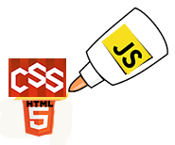

Actually, this description does not do justice to JavaScript, which can do far more than just act as glue. JavaScript can be run outside of the browser (on a nodeJS interpreter on a remote server, or in scripts run by the operating system), but for this intro course, we will focus on "JavaScript" in the browser (an advanced course about "server side JavaScript" is on its way at W3Cx).

So, in the browser, JavaScript lies between HTML and CSS and will be used together with these two languages. Let's take a look at two small examples:

#### Example 1: Push the button to modify the heading of the page.

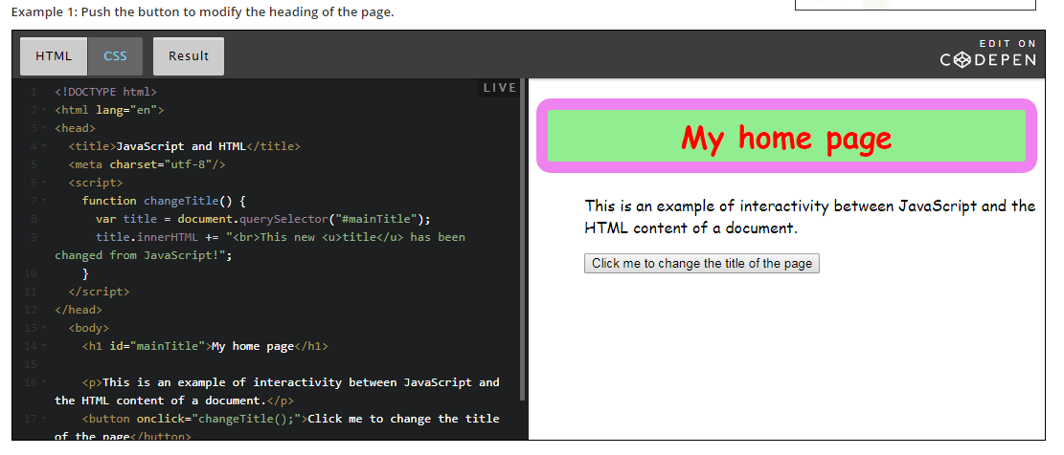

#### Example 2: Push another button to modify the CSS style (color, background-color, border) of a paragraph in the page.

We will take a detailed look at how these examples work in the subsequent parts of the course. These examples are just here to show you how JavaScript can interact with the HTML content and the CSS styles of a Web document.

Notice that in these examples, the JavaScript code is located in the HTML of the document.

## History of JavaScript

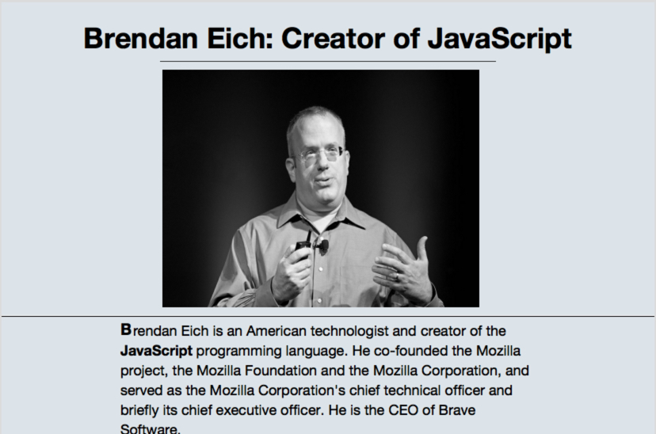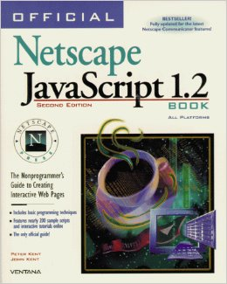



JavaScript was born in 1995 as part of the work of Brendan Eich's team at [Netscape](https://en.wikipedia.org/wiki/Netscape) (the ancestor of [Mozilla](https://www.mozilla.org/)). At that time, Netscape, in association with Sun MicroSystems, provided popular server and client-oriented solutions ([Netscape Navigator](https://en.wikipedia.org/wiki/Netscape_Navigator), ancestor of [Firefox](https://en.wikipedia.org/wiki/Firefox)) which depended on Java. (Sun Microsystems,  the company that created the Java programming language, no longer exists, having been bought by Oracle Corporation in 2009.)



But Netscape realized that Java wasn't a suitable language for in-browser use. Netscape thought of JavaScript at the beginning, as a lightweight Java.

JavaScript was initially inspired by Java, but in fact only some naming conventions remained the same. We highly recommend not even trying to look for similarities - this is actually a bad way to start learning JavaScript! We'd rather just say that the only real commonality between these two languages is their names. If you are coming to this course from Java, leave the Java thinking behind!

JavaScript quickly became a success following its first appearance in [Netscape Navigator 2 in March 1996](http://cybernetnews.com/cybernotes-history-of-web-browsers-opera-netscape-firefox-and-ie/), and it was quickly integrated into other popular browsers. Microsoft also created its own version named JScript (and shipped it with Internet Explorer 3 in 1996).

### Is JavaScript an important language to learn? What about Java, PHP, C#, Python, Ruby and all the others?

JavaScript is the only programming language you can run in your browser. Without JavaScript there would be no games, no fancy dynamic HTML forms, no interactive maps, no Gmail, no YouTube, no Twitch TV, no Netflix....

JavaScript is integrated into nearly every popular Web browser and is probably the most frequently used language in the world. More than 90% of Web documents now use JavaScript too.

Every computer, smartphone, and tablet uses JavaScript many times a day within the browser and even as native code! Indeed, some applications are compiled from their JavaScript/HTML/CSS version into "classic" applications that can be run without a browser. This compilation step can give an extra performance boost, the NetFlix application, or Office 365 are such applications.

In the beginning, JavaScript was invented to work not only on the client side (in Web browsers) but also on the server side (on the Netscape HTTP Web server back in 1995).

In recent years this trend has returned, thanks to the appearance of the Node.js server/JavaScript interpreter. It's common to see JavaScript applications running on a remote Web server. This particular use of JavaScript will be covered by another course that will be proposed by W3Cx, but mastering JavaScript basics is highly recommended before trying to learn JavaScript server side programming.

### JavaScript is an interpreted language

JavaScript is an interpreted (or just-in-time compiled) language, which means that the code is converted into a machine language at, or just before, runtime. The most popular JavaScript engines are:

* + [SpiderMonkey](https://developer.mozilla.org/fr/docs/SpiderMonkey) (included in Mozilla Firefox)
  + [JavaScriptCore](https://developer.apple.com/reference/javascriptcore) (included in Apple Safari)
  + [Chrome V8](https://developers.google.com/v8/) (included in Google Chrome, in the Node.js server)
  + [Chakra](https://github.com/Microsoft/ChakraCore) (included in Microsoft Internet Explorer and now in the Microsoft Edge browser)

## The best way to learn JavaScript

## What is the best method to learn JavaScript?

### FIRST: learn by looking at and tweaking the code in the examples

Well, there is no definitive answer to this question, but I'd recommend firstly looking at small examples, tweaking them and trying to guess what they do. You will rapidly discover that you can learn a lot just by modifying a few lines of JavaScript code, even if you do not understand the whole thing.

During module 1, we will give you some basics:

* + How to write a simple HTML/CSS/JS page,
  + Suggest some regular source code editors to use,
  + How to use online environments that run in the browser, and offer an "instant preview" of your creations. These tools are generally not suited for full scale projects, but are really valuable for testing and learning.
  + We will present many examples (some short and some bigger ones) that will show what can be done with JavaScript. We strongly encourage you to tweak them, look at the code, download them on your hard disk, etc. Even if you do not understand everything, have a go at modifying them; further down this page we outline such an exercise.
  + Over the coming weeks we will be revisiting the examples, and discussing them in greater detail and with fuller explanations.

### SECOND: take some time to carefully read the sections titled "What you've learnt / let's detail ...."

During the course, we will provide extra "reference pages" that will detail some important parts of the language. For example, in a later section this week we will explain the concepts of "variables", "values", "operators", "output", etc.

### Here is an example - we provide some clues, but it's your job to tweak it!

Here is an example that uses an external JavaScript library useful for plotting math functions. Look at the JavaScript code (click on the JS button) and try to guess where the function is specified, where the range for the x and y values is set, etc. Notice that you can use your mouse wheel to zoom in/out the function plot.

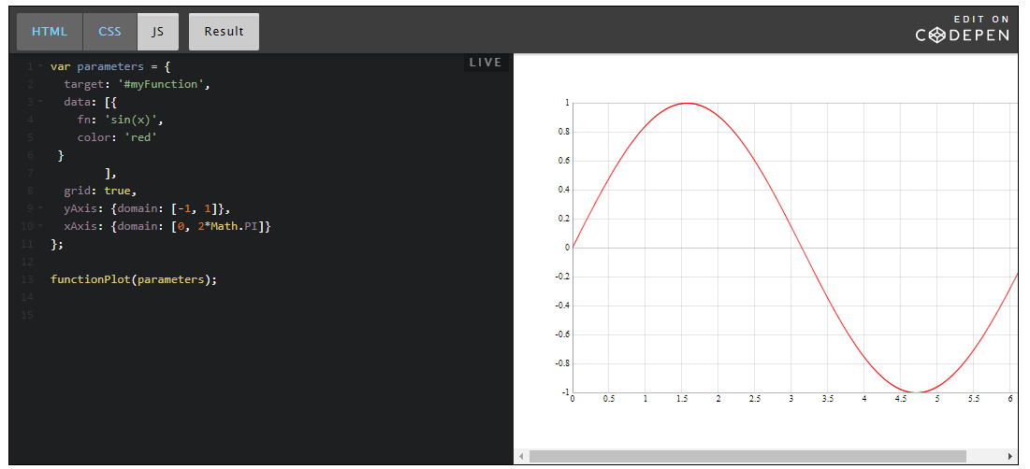

By looking at this example (HTML and JS code), you will notice a few things:

Two lines in the HTML code that correspond to the inclusion in the document of some external JavaScript code:

1. <script src="https://d3js.org/d3.v3.min.js"></script>
2. <script src="https://mauriciopoppe.github.io/function-plot/js/function-plot.js"></script>

We will examine this soon in a later section of the course, but, in brief, it means that we will use the d3js plotting library that is apparently located at [https://d3js.org](https://d3js.org/) (try to visit the site), and another from github (a famous repository for open source contributions), and located in the github account of a person named "mauriciopoppe", the repository is named "function plot". A rapid search will give [this URL](http://mauriciopoppe.github.io/function-plot/) as the home page of the "function plot JavaScript library".

Then, looking at the JavaScript code of the example (click the JS button on the CodePen example), we see:

1. functionPlot(**{**
2. **target: '#myFunction',**
3. **data: [{**
4. **fn: 'sin(x)',**
5. **color: 'red'**
6. **}],**
7. **grid: true,**
8. **yAxis: {domain: [-1, 1]},**
9. **xAxis: {domain: [0, 2\*Math.PI]}**
10. **}**);

Ok, the syntax looks strange if you are not used to JavaScript, but I bet that you guessed that the function plotted is "sin(x)", that the color of the curve is "red", that the range of the x values is [0, 2\*PI], and the range of the y values is [-1, 1].

**Your job:**

* 1. try to plot sin(x^2),
  2. try to change the domain for the x and y values,
  3. try to change the color of the curve, etc.

To do this:

* + Edit directly the JS code in the embedded example, after a few seconds, you should see the updated result in the "Results" tab,
  + ...or just click on the "Edit on CodePen" title on the top right of the embedded example, then change  the code. Normally you should see the results of your modifications as soon as you stop typing (we call this "live coding"). (Here is [an example of what you can obtain](http://codepen.io/w3devcampus/pen/dvpEPZ) as a result).

**What can you guess from this example?**

**A function call**

You can think of this code in this way:

1. functionPlot(...);

Where the "..." corresponds to some sort of parameter. When you see a name followed by two parentheses (maybe with something in between) followed by a ";", this is "**a function call**".

*A function* is a piece of code defined somewhere else, that can accept *parameters* (the "thing" between the parentheses), and that will do something. In our case the function's name is "functionPlot" and we can assume (or we read the documentation of the library) that the goal of this function is to plot a mathematical function, as its name tells us.

**Function parameters**

The "thing" between parentheses is what we call "the parameters of the function": the data we pass to the function so that it can plot different math functions, with different colors, with different ranges for the x and y values, with or without a grid, etc.

Let's have a look at the parameters we used in our example (the ones you tweaked). They are in bold in the source code we saw earlier:

1. {
2. **target**: '#myFunction',
3. **data**: [{
4. fn: 'sin(x)',
5. color: 'red'
6. }],
7. **grid**: true,
8. **yAxis**: {
9. domain: [-1, 1]
10. },
11. **xAxis**: {
12. domain: [0, 2\*Math.PI]
13. }
14. }

**JavaScript object**

In JavaScript you can have simple values like: 2, 5, "hello", "3.14", and you may also encounter more "structured" values that we call "objects". In week 3 we will address JavaScript objects, but for the moment we will just present them through examples, without too much detail.

A JavaScript object can be defined by two braces with a set of properties/values inside, separated by a comma. Here is a simple object:

1. {
2. givenName: "Michel",
3. familyName: "Buffa"
4. }

We use the ":" separator between the property name and its value. We use a comma between two properties, and we omit the comma after the last property (or before the ending brace).

In our examples, the properties of the object that is passed as a parameter to the functionPlot(...) call are in bold.

They are respectively:

* + **target**: the CSS selector that corresponds to the HTML element that will contain the plot. Look at the HTML code (<div id="**myFunction**"></div>), the id value corresponds to target: "#**myFunction**" in the object.
  + **data**: this is where we indicate the value of the function(s) to be plotted. We talk about this in greater detail below.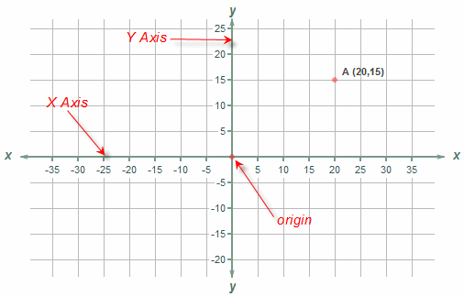
  + **grid**: this can be true or false (we call these "boolean values") and indicates whether or not we want a grid to be drawn in the background.
  + **xAxis**: the value specifies the domain (range) for the x values...
  + **yAxis**: the value specifies the domain (range) for the y values...

Notice that after each property (color, grid, etc.) there is a ",". Notice that between the name of the properties and the value there is a ":", etc...

**Embedded objects**

If we look at the values of the xAxis and yAxis properties, they are also objects.

1. xAxis: {
2. domain: [0, 2\*Math.PI]
3. }

The data object is even more complicated:

1. data: [{
2. fn: 'sin(x)',
3. color: 'red'
4. }],

Instead of containing another object like xAxis or yAxis, it contains another sort of object, but inside brackets! **In JavaScript, brackets are used to create *arrays*** of "things" (multiple, enumerable things). In this example, the array contains one single object that has two properties:

* + fn: the value of the function to be plotted, in this case sin(x),
  + color: the color of the curve

**In arrays, the different elements are separated by commas.** Let's try to plot an additional function in our example. We will add f(x) = cos(x) to our example, with a different color:

1. data: [
2. {
3. fn: 'sin(x)',  // First function
4. color: 'red'
5. },
6. {
7. fn: 'cos(x)',  // second function
8. color: 'blue'
9. }
10. ]

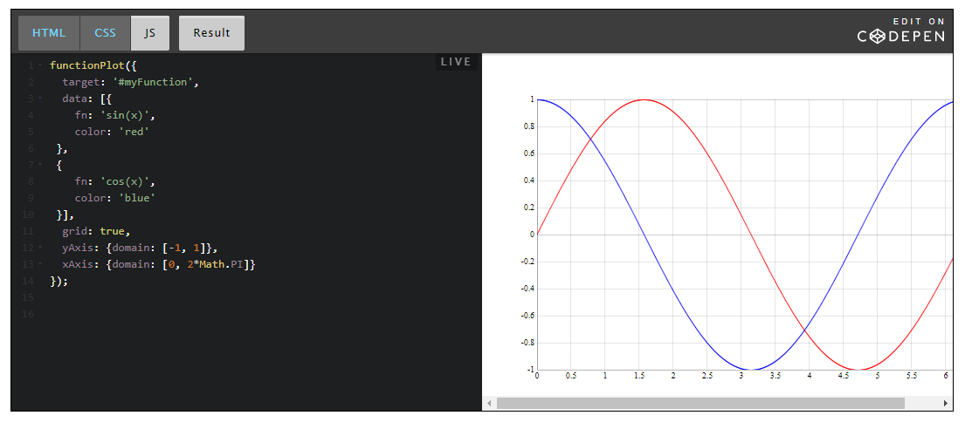

## What can be done with JavaScript

### FIRST: interact with the HTML and CSS content of a document, respond to events

We have already seen three examples in previous parts of this week's course material.

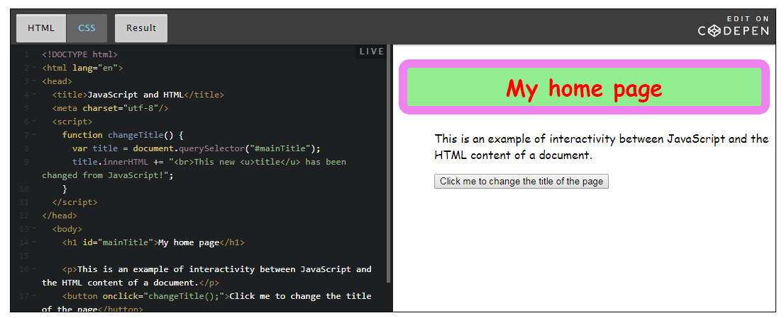

This first example used **the selector API** for selecting a particular element in the document (the main title) and ***the DOM API*** for modifying its content.

* + An API is an ***application programming interface***. In the case of JavaScript, the DOM API is implemented natively by the browser, and you can call several functions/methods or access properties of the DOM:  an object that represents the document (the Web page).

It uses **the selector API** to target a particular part of the DOM (in our case, the main title of the page), the HTML element with an id attribute equal to "mainTitle". The selector API uses the same syntax as CSS to select elements in the document. In our case, "#mainTitle" is a selector value that means "the element whose id is equal to mainTitle".

1. var title = document.querySelector("#mainTitle");

It uses **the DOM API** to change the HTML content of the selected element:

1. title.innerHTML = "This new title has been changed from JavaScript!";

**It listens to click events** in order to call the changeTitle() function when we click on the button:

1. <button **onclick="changeTitle();**">Click me to change the title of the page</button>

And it executes the whole action (changing the title text) in*a function* (a block of code that is executed only when we call it by adding a parenthesis after its name, followed by a semi colon):

1. **function changeTitle()** {
2. var title = document.querySelector("#mainTitle");
3. title.innerHTML = "This new title has been changed from JavaScript!";
4. }

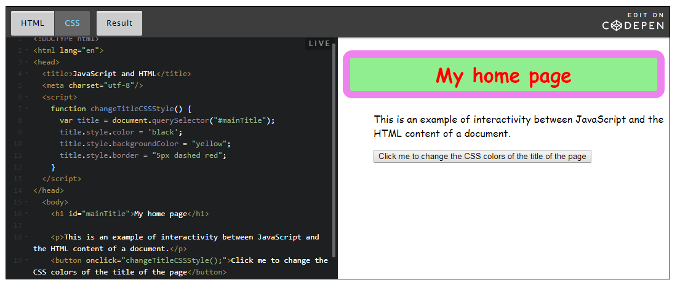

The second example is nearly the same except that we changed the name of the function, and instead of using the DOM API to update the text content of the main title, **we use its style property to change its look and feel. Using the style property is a way of altering the CSS property values of this HTML element.**

1. function changeTitleCSSStyle() {
2. var title = document.querySelector("#mainTitle");
3. **title.style.color = 'black';**
4. **title.style.backgroundColor = "yellow";**
5. **title.style.border = "5px dashed red";**
6. }

title is in reality what we call "an object" and style is a property of the title object. The style is an object as well and has attributes that correspond to the different CSS properties we set. For example, style.color returns the color that element has set on it. By calling title.style.color = "yellow"; you can apply the style change dynamically.

Some of you may be wondering what happens when the CSS property being set has a hyphen. The syntax has to be different here, because, for example, if you write title.style.background-color, JavaScript will try to subtract color from the title.style.background notation, which is not what you want to happen. To stop this problem from occurring, all the CSS properties are written out in CamelCase: the CSS name background-color becomes backgroundColor, text-size becomes textSize, border-color becomes borderColor etc.

### SECOND: use numerous APIs in addition to the DOM and selector APIs: multimedia, drawing, animating, geolocation, webcam, etc.

Your browser comes with a lot of different "libraries" that are called "standards APIs" for "application programming interfaces". Such APIs are "W3C standards" and are present in all Web browsers that follow the Web Standards. You will have APIs for manipulating multimedia (audio and video), geolocation (getting the longitude and latitude), orientation (on mobile devices), accessing the webcam or the microphone, etc. In a later section we will provide a set of examples that use some of the most useful APIs provided by your Web browser.

Example of an HTML page that embeds an interactive Google Map:

Complete example code is at “Code” folder.

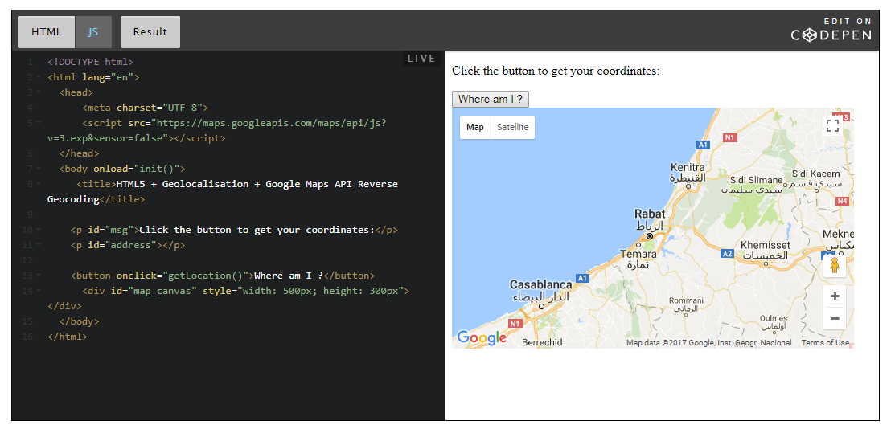

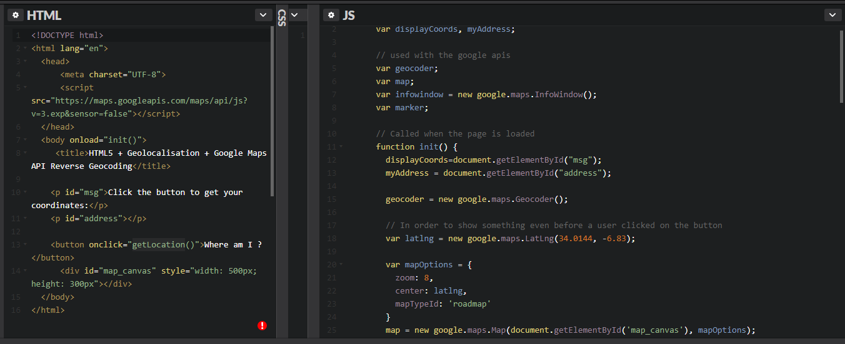

### THIRD: work with remote data / speak with a remote HTTP Web server

You can also download or upload data from your browser to a remote Web server. When this is done from JavaScript the popular term to describe such operations is "AjaX" (Asynchronous JAvascript and Xml), even though XML is not used in any examples you'll see in this course (XML is a language for describing structured data that was very popular a few years ago).

Here is an example that will display the current and past members of famous rock bands:

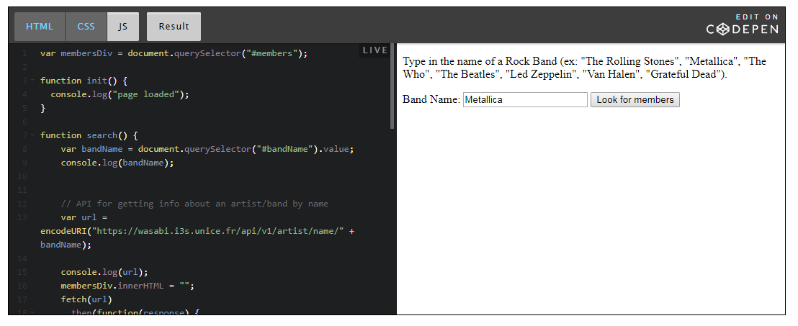

## Where to put JavaScript code?

### JavaScript code can be located in different places

* 1. In your HTML code between <script> and </script> tag
  2. In local files, usually ending with the .js prefix (i.e: in a script.js file), and included using, for example, a syntax such as: <script src="style.js"></script> tag
  3. In external files located on the Web, using their URLs, also using the <script src="http://www.aserver.com/..../js/script.js"></script> tag

Here are some examples:

#### 1 - The JavaScript code is included in an HTML file using the <script>...</script> tag

##### First variant: in the <body>..</body> of the HTML document

Typically:

1. <body>
2. ...
3. <script>
4. var x = 2;
5. // show a message in the body of the html document
6. document.body.innerHTML += "<b>JavaScript code executed. The value of the variable x is: " + x + "</b>";
7. // also print a message in the devtool console
8. console.log("JavaScript code executed");
9. </script>
10. ...
11. </body>

Old JavaScript examples may use a type attribute:   
<script **type="text/javascript"**>.   
**The type attribute is now obsolete and should be ignored.**

##### Second variant: in the <head>...</head> of the document

In this example, the <script>...</script> element is placed in the <head>..</head> section of an HTML page.

This time, we placed a JavaScript function that is invoked (called) when a button is clicked:

1. <head>
2. **<script>**
3. **function addSomeText() {**
4. **// append a message in the body of the html document**
5. **document.body.innerHTML += "<br>Function executed!";**
6. **}**
7. **</script>**
8. </head>
9. <body>
10. <button **onclick="addSomeText();"**>Click me to call a JavaScript function that will add
11. some content to this document
12. </button>
13. </body>

#### 2 - Put the JavaScript code in local .js files

Putting JavaScript code in external scripts files is easy, and offers many advantages:

* 1. It separates HTML and code (and also CSS code, if you use external CSS files)
  2. It makes HTML and JavaScript easier to read and maintain
  3. JavaScript files can be reused more easily in other projects
  4. Cached JavaScript files can speed up page loads

A typical example:

1. <head>
2. ...
3. <link rel="stylesheet" href="css/style.css">
4. **<script src="js/script.js"></script>**
5. </head>

**To use an external JavaScript file:**

* 1. In the HTML, put the name of the script file in the src (source) attribute of a <script> tag, like in the typical example above,
  2. JavaScript files must end with the .js extension,
  3. Do no use any <script>...</script> tag in a .js file!
  4. Using an external JavaScript file with <script src="..."></script> is 100% equivalent to using <script>...</script>with the file content between the opening and closing tags.
  5. It's possible to use more than one JavaScript file, just use multiple <script src="..."></script>

Example that uses more than one JavaScript file:

1. <head>
2. ...
3. <link rel="stylesheet" href="css/style.css">
4. **<script src="js/script1.js"></script>**
5. **<script src="js/script2.js"></script>**
6. **<script src="js/anotherOne.js"></script>**
7. **...**
8. </head>

##### A typical HTML/CSS/JS project folder structure, when working with external local files

It is good practice to locate CSS files in a css subfolder, and JavaScript files in a js subfolder.

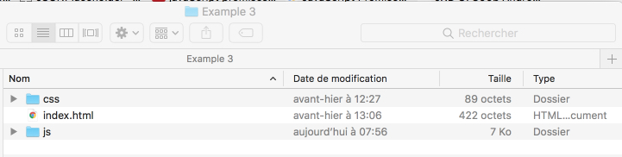

In this example, we have just one CSS file and one JavaScript file:

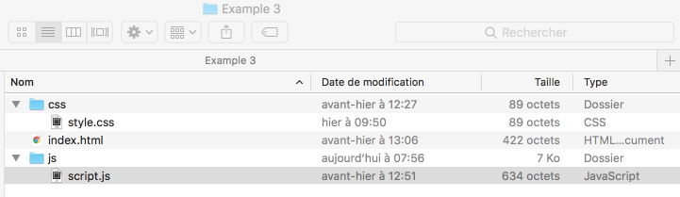

Content of the index.html file:

1. ...
2. <head>
3. ...
4. **<link rel="stylesheet" href="css/style.css">**
5. **<script src="js/script.js"></script>**
6. </head>
7. <body>
8. <h1>Example 3: JavaScript and CSS in local files!</h1>
9. <button **onclick="addSomeText();**">Click me to call a JavaScript function that will add some content to this document</button>
10. </body>
11. </html>

Content of the js/script.js file (JavaScript file):

1. function addSomeText() {
2. document.body.innerHTML += "<p>Function executed!</p>";
3. }

Content of the style.css file:

1. p {
2. color:green;
3. }

### 3 - Use external references to JavaScript files/libraries located on the Web

External JavaScript libraries (they are just big JS files) can be also referenced with a full URL, like in this example:

1. <script src="https://cdnjs.cloudflare.com/ajax/libs/paper.js/0.22/paper.js"></script>

Here, we just included in our HTML document the excellent [paperJS](http://paperjs.org/" \t "_blank) library that can be used to make fancy animations in the HTML canvas element - we will use it later in the course.

Once the library is included, the JavaScript code you will write can call functions located in this library. This "reuse existing" work made by others is really common when working on JavaScript projects.

Here is a running example that uses the paperJS library, included using an external URL:

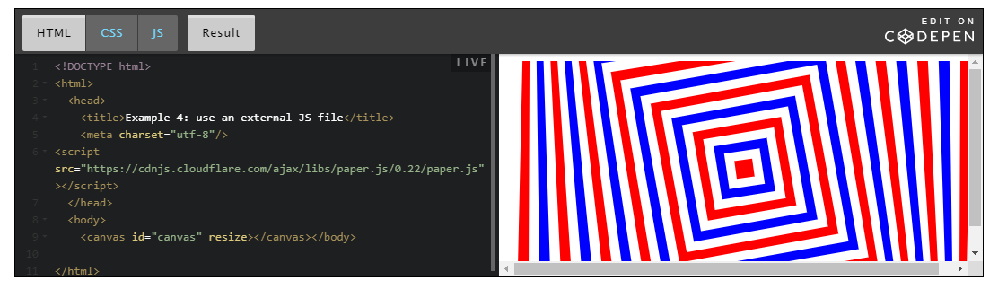

## How to debug JavaScript

## How to debug JavaScript

### You will make errors!

When you are developing a Web Application that contains JavaScript code, you will make errors.

Repeat after me: "I WILL MAKE ERRORS!" ; "I WILL MAKE ERRORS!"

So there will be error messages, and you will need to print messages for debugging your code. We will see more advanced debugging techniques at different points in this course, but for the moment, let's see the basics of JavaScript debugging: seeing error messages in the devtool console, or in the "console tab" of your source code editor.

We will not look at the JavaScript syntax here, but more at "JavaScript in the browser", how it works, how to start writing code, etc.

First of all, you need to find a way to debug your code and see errors. If your work does not produce any results, you need to know why!

### Your Swiss army knife: your browser devtools, especially the devtool console!

For this you will use **the dev. tools of your browser**. Press *F12* (or ctrl-shift-i) in Windows or *cmd-alt-i* in MacOS to open the dev. tools, then go to the console tab: **this is where errors will be displayed**, or messages of your own (use the console.log(string) JavaScript function in the JavaScript code embedded in your html page). In the console, you will be able to type any JavaScript command.

|  |
| --- |
| <!DOCTYPE html>  <[**html**](http://december.com/html/4/element/html.html) **lang="en**>    <[**head**](http://december.com/html/4/element/head.html)>    <[**meta**](http://december.com/html/4/element/meta.html) charset=utf-8 />    <[**title**](http://december.com/html/4/element/title.html)>Web Audio API</[**title**](http://december.com/html/4/element/title.html)>    <[**script**](http://december.com/html/4/element/script.html)>     console.log("Some JavaScript code has been executed");    </[**script**](http://december.com/html/4/element/script.html)>    </[**head**](http://december.com/html/4/element/head.html)>    <[**body**](http://december.com/html/4/element/body.html)>      <[**h1**](http://december.com/html/4/element/h1.html)>JavaScript debugging using the dev tool console</[**h1**](http://december.com/html/4/element/h1.html)>    </[**body**](http://december.com/html/4/element/body.html)>  </[**html**](http://december.com/html/4/element/html.html)> |

The simplest way to add JavaScript code in an HTML page is to use the <script>...</script> element.

**The code in this example is executed sequentially when the page is loaded**: the JavaScript code is executed before the browser could see the rest of the page (as the <script></script> is located before the <body>).

The H1 element, for example, does not exist in the Document Object Model, and has not yet been displayed when the JavaScript code is executed. If we move the <script></script> at the end of the document, then the H1 would have been built before the JavaScript code is executed.

The only line of code we have is console.log("Some JavaScript code has been executed");

And if we run it standalone and use the dev. tool console:

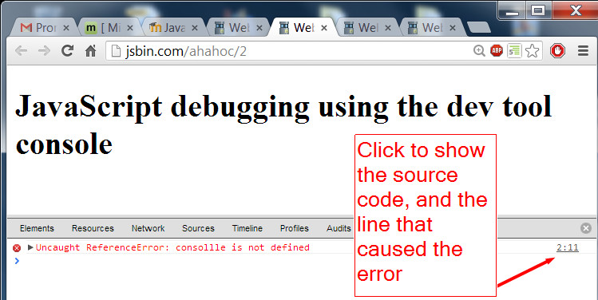

And if we click on the line number to the right, the dev. tool shows the source code centered on the line that caused the error:

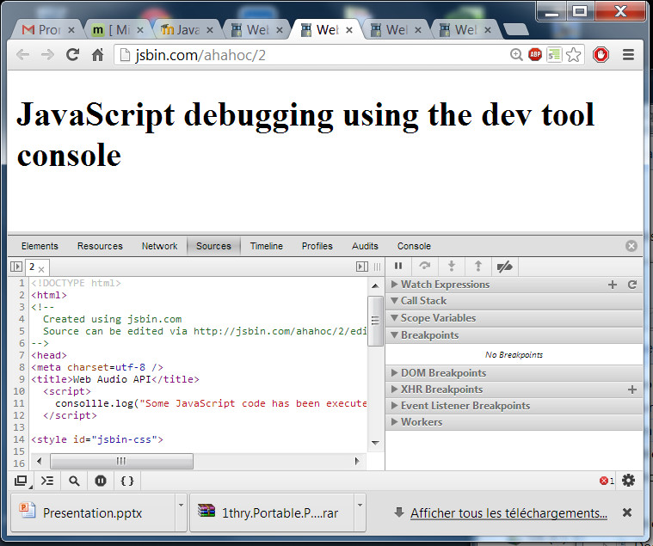

Without such tools, debugging JavaScript code is impossible. So you need to look at some basic tutorials on how to use the dev. tools of your browsers, since they differ from one another in the way they work - although the principles remain the same.

## Let's create a small HTML/CSS/JS project together

Topic

We will write a small, interactive HTML page that will use some HTML input fields for indicating the name of a math function we'd like to plot, the ranges for the x and y values, the color of the curve etc.

We will first write this application online, using the JsBin.com editor, then we will do the same thing using the CodePen online editor, then, using a regular source code editor and .html, .css and .js files.

**Here is what the resulting Web page will look like:**

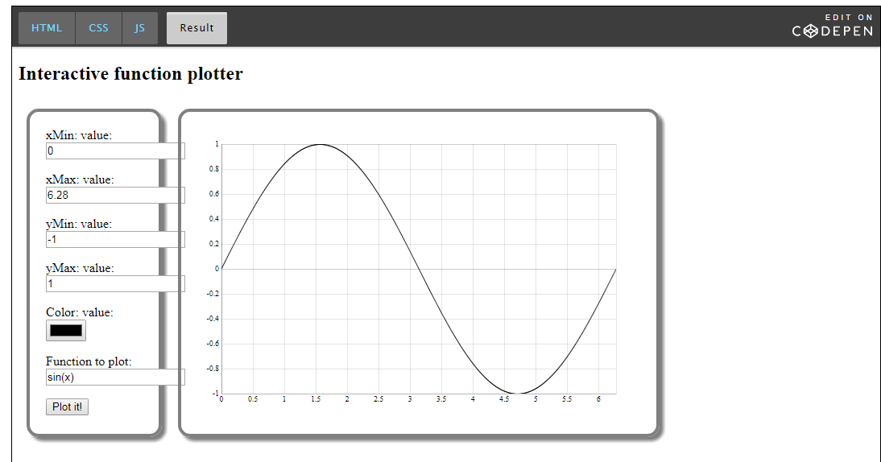

Note:

SAFARI users: here is a version that comes with a polyfill for the <input type="color"> element

This HTML element is not yet implemented in Safari (only in the Technical preview version).

So, if you want to see a color picker, [try this version on CodePen](https://codepen.io/w3devcampus/pen/rwNmPB?editors=1000)!

We just added three lines in <head> of the HTML part, to include spectrum.js, the polyfill, and jQuery, that is used by this polyfill.

## JavaScript variables and values

In most of the examples that we have seen together we've used the concept of "variable", and we have used them to "store values". It's time to take a break and talk about them :-)

### Variables

#### Introduction

In order to remember a value, programming languages share the concept of "variables". When you write programs, you will need to store values in the computer's memory. By saving these values in "variables", by giving them a "name" (we call it an identifier), you can reuse them later for display, for computations, etc.

#### Create (declaring) a variable

With JavaScript versions < 5 (prior to 2015), there was a single way to create (we say "declare") a variable: using the **var** keyword, but with the subsequent versions (called ES2015/ES2016 or JavaScript 6/7) we can also use the keyword **let** (this has some subtle differences, which we'll explain later in the course when we will talk about "functions").

JavaScript is weakly typed. Each variable is declared with the keyword **var** or **let**. So you are not required to specify the type of variable you are creating. **After the keyword "var" and a space, just give the name of the variable.**

Example:

1. var myVar;
2. let x;

The first letter of a variable can only be "$", "\_", "a" to "z", or "A" to "Z". The other characters in a name must be any of these, or numeric digits. The name is case sensitive. **So variables "myVar" and "MyVar" are different variables.**

There are some reserved names that you can't use as a variable name: boolean, if, delete, var, function, etc. as they are reserved words of the JavaScript language.

#### Give a value to a variable (assign a value to a variable)

A value can be assigned to a declared variable, or even directly in the variable declaration. For this, we use the equal character, also called "the assignment operator".

Example:

(notice at line 4 one way to introduce comments in your code: start a line with "//"!)

1. var myValue;
2. myValue = 78;
4. // With the ES2015 syntax. BTW, lines staring with // are comments!
5. let myNumber = 1.34;

At line 2, we are not saying that "myValue" and "78" are the same, we're saying "hey, I want to store the value 78, and I'm putting it in a variable whose name is "myValue". It's like giving an id to a location somewhere in the memory of the computer.

Using the id "myValue", we store 78 into a memory location identified by the name "myValue": a variable, or if you prefer, a value that can vary over time if we assign a new value to the variable "myValue" (for example by executing myValue = 5;).

You can also declare many variables at once by separating them with a comma. Always end each instruction line with a semi colon.

Example:

1. var myNumber1, myNumber2 = 34, myNumber3;
3. // Or with the ES2015 syntax, you can also use "let"
4. let x = 1, y = 3, z = 12;

#### Try the devtool console - you can type code in there too!

Reminder: you can always open the devtool console using F12 on windows, or ctrl-shift i, or cmd-alt-i on other computers.

If we copy and paste the variable declarations from the previous example, and type myNumber2 in the devtool console, it will display 34 (while myNumber1 will have an undefined value):

1. > var myNumber1, myNumber2 = 34, myNumber3;
2. undefined
4. > // Or with the ES6 syntax you can also use "let"
5. undefined
7. > let x=1, y=3, z=12;
8. undefined
10. > x;
11. 1
13. > z;
14. 12
15. > myNumber2;
16. 34
18. > myNumber1;
19. undefined

Imp note – when a variable is undefined

Image that explains how you can try JavaScript code in the devtools console:

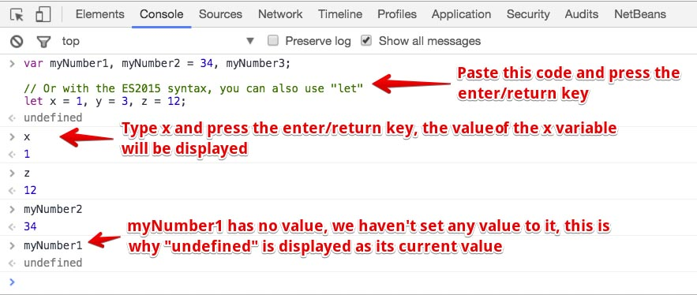

If you try to use a variable that has never been declared, you will receive an error message:

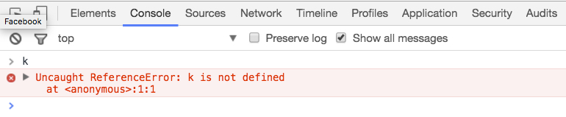

#### Name conventions for variables

The JavaScript community has some conventions about naming variables:

* + - **The camelCase notation is preferred**: mySpaceShip, sumOfAllGrades, etc.
    - **For a variable, the first letter is lowercase and each first letter of each word is capitalized**. Example: var myVariableName

Example:

1. var myModel;
2. // ES2015 syntax
3. let michelBuffaAge = 51;

Most JavaScript examples you will find are written in the camelCase format. For harmony in the code source, it is a good idea to keep this convention. Sometimes, you will see the snake\_case naming convention, which separates each word of a variable with an underscore.

### Constants

Constants are variables that cannot be modified after a value has been set.

**The naming convention is to use uppercase letters with underscores.**

**Example: var TIME\_LIMIT = 50;**

With JavaScript 5, constants were declared as normal variables, using the **var** keyword, and there were no verifications by the JavaScript interpreter forbidding you to modify them after you assigned a value to them.

With ES2015/2016 it is recommended that you use the keyword **const** instead of **var** to declare them. This means that an error will be raised if you try to change their value in the future.

Example:

1. var TIME\_LIMIT;
3. // ES2015 Syntax
4. const MAX\_GRADE = 20;

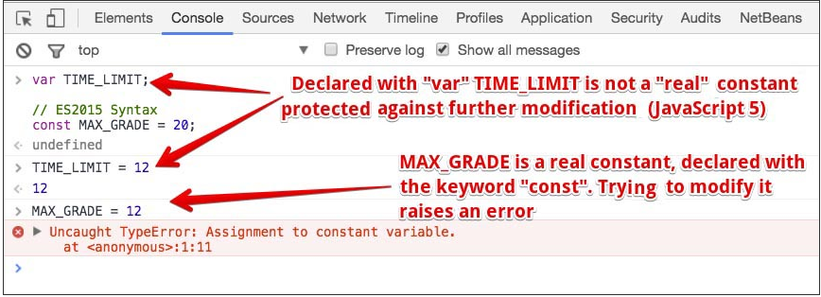

### Summary

Here are a set of examples (using the let keyword, but they would also work with var):

1. let a;
2. let thisIsAVariable;
3. let and\_this\_too; // but **does not respect the usual naming convention**
4. let mix12three;
5. // invalid!
6. let 2three4five; // **can't start with a digit!**
8. let a = 1
9. let v1, v2, v3 = 'hello', v4 = 4, v5;
11. // Beware with lowercase / uppercase
12. let case\_matters = 'lower';
13. let CASE\_MATTERS = 'upper';

Note :-

An undefined variable is:

A variable that has been declared but not initialized

### Scope of JavaScript variables

#### 1 - JavaScript 5 / ES5 scopes, with the var keyword

**JavaScript 5 / ES5 has the var keyword for declaring variables.**

**JavaScript 5 / ES5 has two scopes:** **1) a global scope** for declaring global variables, and**2) a function scope** for declaring variables that are local to a function.

Furthermore, like in most programming languages, inside a function, **a local variable masks a global variable that has the same name.**

See examples below.

##### 1.1 - Global scope / global variable

Global variables are variables declared outside of functions. They can be used anywhere in the code.

Here is an example: 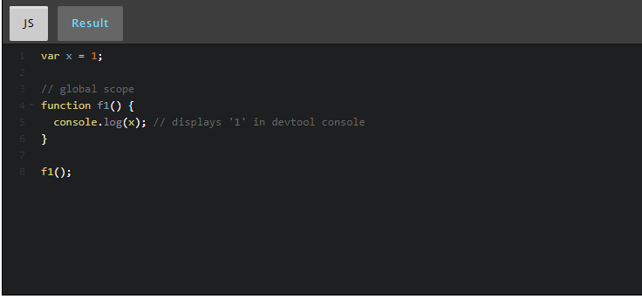

##### 1.2 - Local scope / local variable (also called function scope)

Variables declared with the keyword var in a function, are said to be "local to the function". They "mask" any global variable that may have the same name.

**When a variable is declared in a function, we also call it simply "a local variable"**, as opposed to "a global variable". **In JavaScript 5 (and this is not common in programming languages), local variables are local to the function.** They can be used anywhere inside the function.

Most programming languages have local variables that are limited to the block of instructions between '{' and '}' that contains the variable declaration. We call these variables "block variables". This is the case with variables declared with the let keyword  introduced by JavaScript 6 / ES6. See examples at the end of this section.

Example of a local variable declared in a function, that is NOT local to the block, but to the whole function: 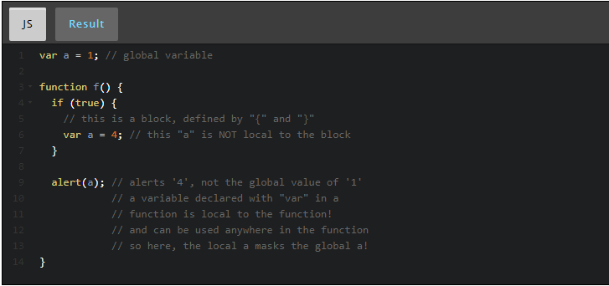

Here is another example that shows the differences between global and local variables, and highlights the "masking" of global variables by local variables when they share the same name. 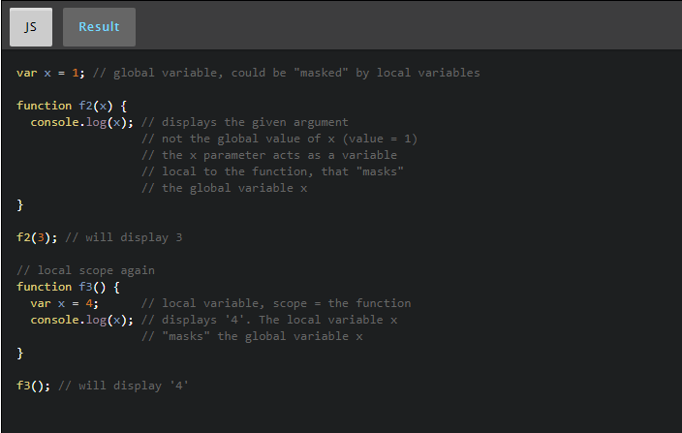

##### 1.3 Never declare a variable without the keyword var!

JavaScript is sometimes an overly permissive language. We can make stupid errors that turn out to be very hard to detect. One such error occurs when we forgot to use the var keyword while declaring a local variable.

In JavaScript 5 / ES5, a variable declared in a function without the var keyword, makes it a global variable.

**GOOD PRACTICE: in JavaScript 5 / ES5, always use the keyword var when declaring a global or a local variable.   
  
Better: use the keyword let if you target browsers that support JavaScript 6 or above.**

Here is an example that shows what happens when you forget to use var or let while declaring a local variable: 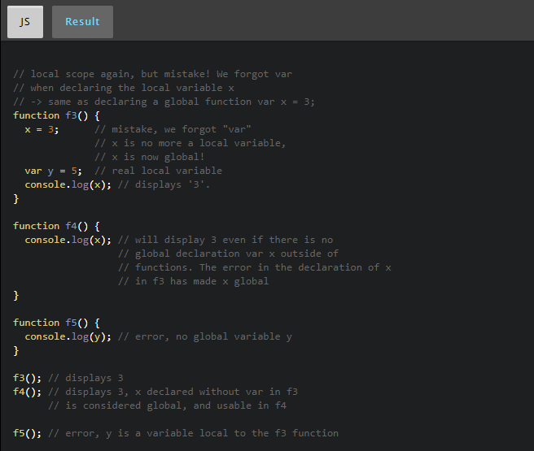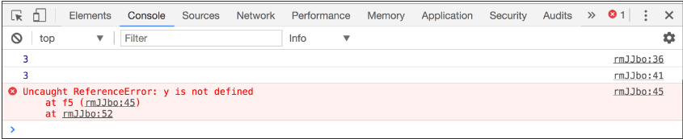

**2 - JavaScript 6 / ES6 scopes, with the let keyword**

**JavaScript 6 / ES6 has the let keyword for declaring variables, and the const keyword for declaring constants.**

**JavaScript 6 / ES6 has two scopes:** **1) a global scope** for declaring global variables, and**2) a block scope** for declaring variables between { and }. This is similar to what we find in many other programming languages such as Java, C# etc.

Furthermore, like in most programming languages, inside a block, **a local variable masks other variables located in higher scopes (global or in another block that contains the current block).**

Example of a local variable declared with the let keyword. Its scope is the block: 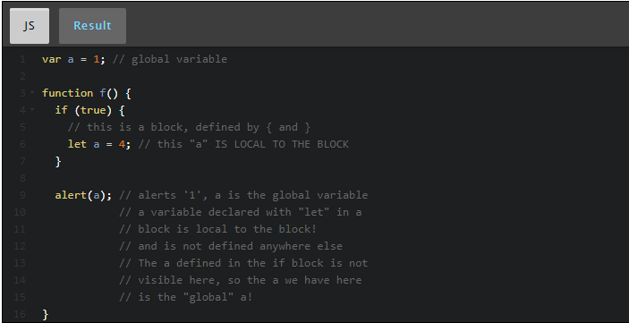

#### 3 - Recommended way to declare variables: var or let?

Well, all modern browsers support the let and const keywords, however, if you target old browsers such as:

* + Internet explorer 10 and below (no support)
  + Firefox 43 and below (no support)
  + Safari 9 and below (no support)
  + Opera Mini 8 and below (no support)
  + Android browser 4 and below (no support)
  + Opera 36 and below (partial support)
  + Chrome 51 and below (partial support)

... it's better to use the var keyword, or you can use some advanced tools called "transpilers" that will translate your JavaScript 6 / ES6 code into pure JavaScript 5 code (like [Traceur](https://github.com/google/traceur-compiler" \t "_blank) or [Babel](https://babeljs.io/)).

##### Current support for let/const(September 2017):

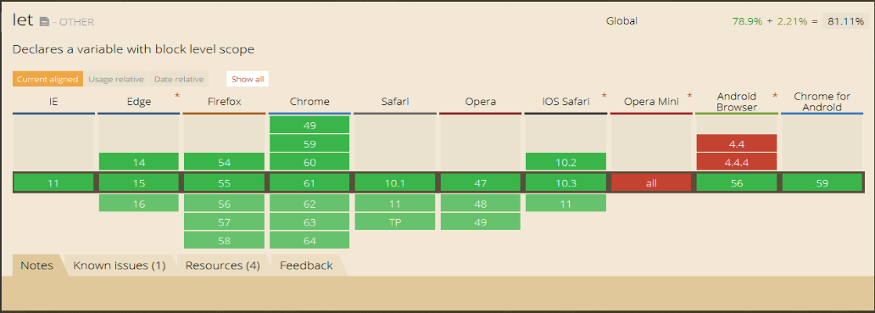

## JavaScript data types

### What kind of values can we assign to a variable?

Well, there are multiple possibilities:

* 1. What we call "primitive data types": for example a number, a string, etc. ex:   
     var x = 3; var name = "Buffa";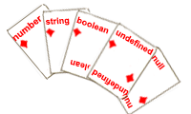
  2. Objects (everything that is not a  "primitive data type" is an object):   
     var michel = {firstName:'Michel', lastName:'Buffa'};
     + There is a set of "predefined objects" in JavaScript (arrays, functions, etc). We will come back on these later in the course.

**JavaScript has a small set of primitive data types**

* + **number**: 1,2,105,3.14 ...
  + **string**: 'a', "one", 'two' , 'World Wide Web' ...
  + **boolean**: true / false
  + **undefined**: absent or unknown value
  + **null**: special keyword, meaning no value or empty. The difference from undefined is that when a variable is null, it is still defined.

These are the simplest forms of data we can use in programming.

Anything that is not listed above is *an object*(JavaScript objects are covered later in Week 3)*.*

**You said JavaScript does not have types for variables?**

No! I said that JavaScript is weakly typed; you do not declare the type of variable. In some other languages (Java language syntax, for instance) instead of var x=2; or let name="Buffa"; you would write int x=2; or String name = "Buffa";, with the datatype explicit in the variable declaration.

**Knowing the type of a JavaScript variable: the typeof operator**

The next section of the course talks about "operators" but there is one that is better introduced in this section: the **typeof** operator, that is useful for knowing the type of a variable depending in its value (possible values: number, string, boolean, undefined, object, or function)

We will use it in lots of examples in the next three sections. 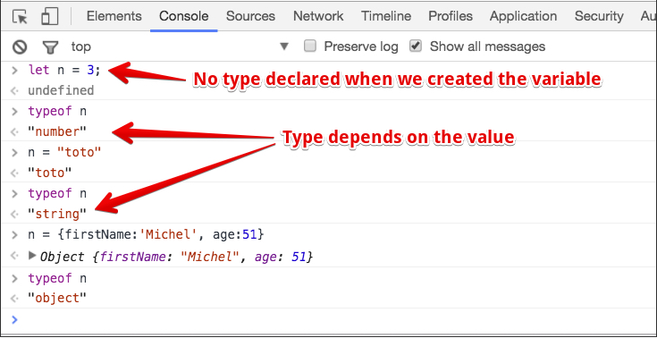

This operator is not often use in JavaScript programs, but it's useful for us, for explaining the data types.

### Numbers

#### Image of numbersNumber values can be:

* + **Integer**: 1, 4, 274929

Type 343 in the devtool console, and after you press the Enter key,  the  corresponding value (343) will be displayed.

* + **Signed integer**: -17
  + **Decimal**: 3.46, -466.8770

Examples of integer and decimals:

1. > var n=1;
2. undefined
4. > typeof n;
5. "number"
7. > n=1234;
8. 1234
10. > typeof n;
11. "number"
13. > n=1.23;
14. 1.23
16. > typeof n;
17. "number"
19. > typeof 123;
20. "number"
    * **Scientific notation**: 3.46e4, 5.3e+6, 5344000e-5

3.46e4 equals 3.46 x 10^4 equals 34600

Examples:

1. > 1e1;
2. 10
4. > 1e+1;
5. 10
7. > 2e+3;
8. 2000
10. > typeof 2e+3;
11. "number"
13. > 2e-3;
14. 0.002
16. > 123.456E-3;
17. 0.123456
19. > typeof 2e-3;
20. "number"
    * **Octal**: 010

**Be careful with this, don't start an integer with 0 (zero), JavaScript will understand it as an octal value.**

010 equals 8 which means 1 \* 8^1 + 0 \* 8^0

The number 0456 means 4 \* 8^2 + 5 \* 8^1 + 6 \* 8^0

**Question 1**: What's the result, as an integer, of the operation: 24 - 024?

**Explanation 1**: 24 is an integer which equals 24 but 024 is an octal value which equals 20.

**Question 2**: Which value will be displayed in the devtool console if you type 098 followed by the Enter key?

**Explanation 2**: 9 and 8 don't exist in base 8 (only 0 to 7), so the typed number will be considered as an integer.

* + **Hexadecimal**: 0xF3

0xFF equals 255, 0xF3 means 15 \* 16^1 + 3 \* 16^0 and the resulting value is 243

Examples of octal and hexadecimal data types:

1. > var n3 = 0377;
2. undefined
4. > typeof n3;
5. "number"
7. > n3;
8. 255
10. > var n4 = 0x00;
11. undefined
13. > typeof n4;
14. "number"
16. > n4;
17. 0
19. > var n5 = 0xFF;
20. undefined
22. > typeof n5;
23. "number"
25. > n5;
26. 255
    * **Special values**:
      + +Infinity
      + -Infinity
      + NaN (Not a Number)

The value Infinity (or +Infinity) represents all number values greater than 1.79769313486231570e+308 and -Infinity represents values smaller than -1.79769313486231570e+308.

Finally, Nan represents not-a-number values, for example if you try to divide 0 by 0 (type 0/0 in the devtool console).

1. > 0 / 0;
2. NaN
4. > 3 / 0;
5. Infinity

Examples:

Any operation with Infinity gives Infinity as a result:

1. > Infinity;
2. Infinity
4. > typeof Infinity;
5. "number"
7. > 1e309;
8. Infinity
10. > 1e308;
11. 1e+308
13. > var a = 6 / 0;
14. undefined
16. > a;
17. Infinity
19. > var i = -Infinity;
20. undefined
22. > i;
23. -Infinity
25. > typeof i;
26. "number"
27. > Infinity - Infinity;
28. NaN
30. > -Infinity + Infinity;
31. NaN
32. > Infinity - 20;
33. Infinity
35. > -Infinity \* 3;
36. -Infinity
38. > Infinity / 2;
39. Infinity
41. > Infinity - 9999999999999;
42. Infinity

Examples with NaN:

NaN is a special value and its type is "Number"!

1. > typeof NaN;
2. "number"
4. > var a = NaN;
5. undefined
7. > a;
8. NaN
9. > var a = 10 \* "f";
10. undefined
12. > a;
13. NaN
15. > 1 + 2 + a;
16. NaN

#### [ADVANCED] Optional explanations about numbers

In JavaScript, numbers are represented with a double-precision 64-bit format (IEEE 754). These 64 bits are used with this table:

|  |  |  |  |
| --- | --- | --- | --- |
| Total bits | Sign | Exponent | Significand |
| 64 | 1 | 11 | 52 |

What does it mean?

First, each number is represented as a float. For example, 1 equals 1.0. But there are approximation errors that are well-known in float calculations. One common example of errors due to the approximation of floating point numbers is that 0.1 + 0.2 does not equal 0.3.

1. > 0.1 + 0.2;
2. 0.30000000000000004

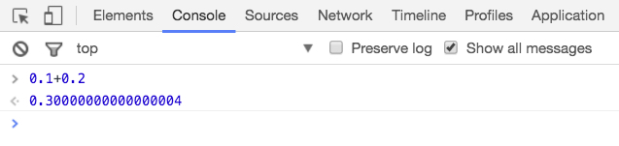

Second, an integer has 2^52 relevant bits, so the biggest integer is 2^53. There is one bit that determines the sign of the number, so the smallest signed integer is -2^53.

Note: Some arithmetic functions use only numbers with a 32-bit format. Larger numbers will be converted...

(Advanced) For more information about floating point numbers, [follow this link at Wikipedia](http://en.wikipedia.org/wiki/IEEE_floating_point)

**JavaScript operators and expressions**

**Introduction**

**An expression** is a small piece of code used to produce a value.

For example, the expression 3 + 5 produces the value 8, and the value 11 alone is also an expression. Within an expression, we can find values, variables, operators, and expressions. The first two have been already described above, so all that's left are **operators**.

In JavaScript, **an operator** can be unary or binary (plus one ternary operator). A unary operator is applied to one expression. It can be prefixed or suffixed.

**Unary operator example:**

1. typeof 'world';

A binary operator is applied to two different expressions, and is both prefixed and suffixed.

**Binary operator example:**

1. var x = 45 / 32;

The division operator is binary.

Within an expression, we can also use parentheses to force the execution of the expression inside. Parentheses can be used to indicate precedence.

For example, this is an expression: (3 + 2). And the expression (3 + 2) \* 4, which equals 20, depends on the expression within the parentheses.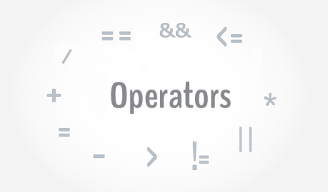

In JavaScript, expressions can evaluate to four types, which are: numbers, strings, booleans, and objects. For example, an expression with the operator - will evaluate to a number. But an expression with the operator + can evaluate to a number or a string (for addition or concatenation).

**Number operators**

#### Introduction

The following arithmetic operators are **binary**:

**+**,**-** ,**/**, **\***, **%** (modulo)

Example: 7 % 5 equals 2, which is the remainder of the integer division of 7 by 5

Note: (7 / 5 = 5 \* 1 + 2 ).

And there are also **unary** operators:

**++**,**--**, **-** (the opposite of a number)

**++** and **--** operators increment or decrement the value of a variable. They can be both prefixed or suffixed, which have different effects:

* Suffixed ++ adds one to the value of the variable, then returns the new value.
* Prefixed ++ also adds one to the value, but returns the old value. Both of these must be used with variables.

#### Examples typed in the devtool console of a browser:

1. > 1 + 2;
2. 3
4. > var a = 1;
5. undefined
7. > var b = 2;
8. undefined
10. > a + 1;
11. 2
13. > b + 2;
14. 4
16. > a + b;
17. 3
19. > var c = a + b;
20. undefined
22. > c;
23. 3
24. > 1 + 2;
25. 3
27. > 99.99 - 11;
28. 88.99
30. > 2 \* 3;
31. 6
33. > 6 / 4;
34. 1.5

##### Example of pre and post increments:

1. > var m = 0;
2. undefined
4. > m;
5. 0
7. > // regular use of the + operator
8. m = m + 1;
9. 1
11. > m;
12. 1
14. > m = m + 1;
15. 2
17. > m;
18. 2
20. > // post increment
21. m++;
22. 2
24. > m;
25. 3
26. > console.log(m++); // will display 3 but after that m is incremented
27. 3
29. > m;
30. 4

Image with explanations:

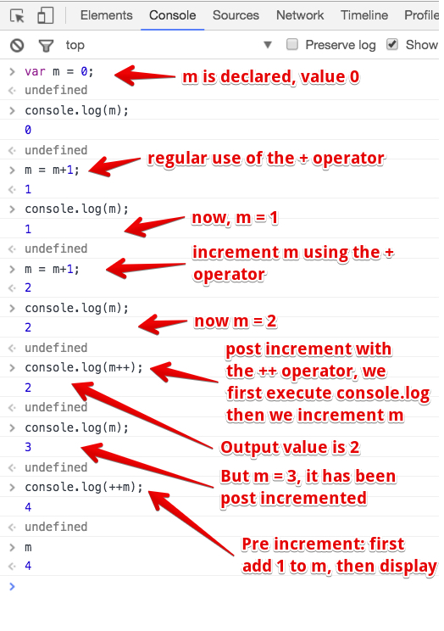

##### Other examples of post and pre increments:

1. > var a = 123; var b = a++;
2. undefined
4. > b;
5. 123
7. > a;
8. 124
10. > var a = 123; var b = ++a;
11. undefined
13. > b;
14. 124
16. > a;
17. 124
19. > var a = 123; var b = a--;
20. undefined
22. > b;
23. 123
25. > a;
26. 122

#### Short variant that mixes assignment and execution of an operator

Binary operators can be used with a shorter syntax when we want to assign the resulting value to a variable at the same time:

Example (try them in the devtool console of your browser)

1. > var a = 10;
2. > a \*= 5; // equivalent to a = a \* 5;
3. > console.log(a);
4. > 50

Other examples:

1. > var a = 5;
2. undefined
4. > a += 3 // equivalent to a = a + 3;
5. 8
7. > a -= 2; // equivalent to a = a - 2;
8. 6
10. > a \*= 10; // equivalent to a = a \* 10;
11. 60
13. > a /= 5; // equivalent to a = a / 5;
14. 12
16. > a %= 2; // equivalent to a = a % 2;
17. 0
19. > // this is normal, as a is even

**Strings (part 1)**

Introduction

To declare or manipulate strings you must write them with **single quotes ' or double quotes "** around them. Single quotes or double quotes are both accepted, and there is no difference between them in JavaScript. However, the community prefers to use single quote for string - this is not a convention, but a recommendation.

And finally, you cannot start a string with a single and end with a double quotes, or the opposite.

1. > "Hello World";
2. "Hello World"
4. > "JavaScript Course";
5. "JavaScript Course"
7. > 'With simple quotes';
8. "With simple quotes"
10. > "Do not mix double and simple quotes'; // here we opened the string with double and closed with simple quotes
11. VM24763:1 Uncaught SyntaxError: Invalid or unexpected token

Image from the devtool console, with the example above:

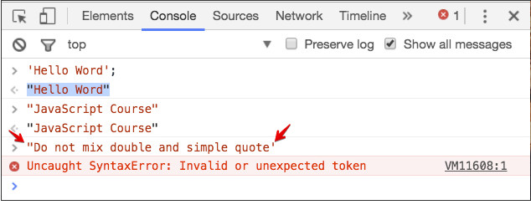

There are many reasons to use simple quotes when possible:

* + 1. Double quotes are used in HTML
    2. You must hold the Shift key to type "
    3. Single quotes are easier to read and to type
    4. To output HTML in JavaScript, single quotes are more useful

### String operators

#### The concatenation operator (+)

The operator (+) used with strings is called the concatenation operator, and it allows you to concatenate strings.

1. //the operator (+)
2. var s1 = 'one';
3. var s2= 'two';
4. var s = s1 + s2;
5. s;
6. // returns 'onetwo'
7. typeof s;
8. //'string'

#### The shorthand assignment operator (+=)

The shorthand assignment operator (+=) can also be used to concatenate strings.

1. //the assignment operator (+=)
2. var s1 = 'one';
3. var s2 = 'two';
4. s1+= s2; // or directly s1+='two'
5. s1;
6. //returns 'onetwo'

#### The method concat()

Another way to concatenate strings is the method concat().

1. //the 'concat' method
2. var s1 = 'one';
3. var s2 ='two';
4. var s = s1.concat(s2);
5. s;
6. //returns 'onetwo'

All the methods shown above can be used with a variable number of arguments:

1. var s1 = 'Hello';
2. s1 = s1 + ' World' + ' JavaScript';
3. var s2 = 'Hello';
4. s2+= ' World' + ' JavaScript';
5. var s3 = 'Hello';
6. s3.concat(' World' , ' JavaScript' );
7. //s1,s2 and s3 return 'Hello World JavaScript'

#### Converting strings

A String number in an arithmetic expression is converted to Number, unless the formula is a pure addition.

1. > var s = '1'; s = 3 \* s; typeof s;
2. "number"
4. > s;
5. 3
7. > var s = '1'; s++; typeof s;
8. "number"
10. > s;
11. 2
13. > var s = "100"; typeof s;
14. "string"
16. > s = s \* 1;
17. 100
19. > typeof s;
20. "number"
22. > var d = "101 dalmatians";
23. undefined
25. > d \* 1;
26. NaN

The above example is shown in the devtools console:

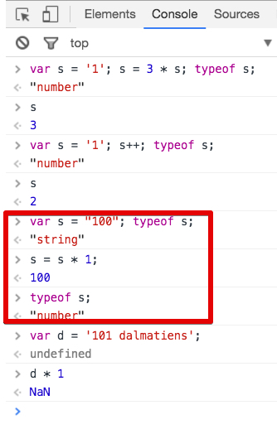

#### How to convert a Number into a String

There is trick for converting a Number into a String: we concatenate with an empty string, at the beginning of expression (type this in the devtools):

1. var n = 1;
2. typeof n;
3. // returns "number"
4. n = "" + n;
5. // returns "1"
6. typeof n;
7. // returns "string"

#### Special character: the "\"

The \ is useful for "escaping" special characters. Here are a few examples:

1. var s = 'I don\'t know';
2. var s = "I don\'t know"; // here the \ is useless
3. var s = "I don't know";  // same result as previous line
4. var s = '"Hello", he said.'; // ok, double quotes inside single one will be displayed
5. var s = "\"Hello\", he said."; // double quotes inside double quotes need to be escaped

#### Escaping the escape! Use a double "\"

1. var s = "1\\2"; s;
2. // returns "1\2"

#### Special characters starting with "\"

##### "\n" for "next line":

1. var s = '\n1\n2\n3\n';
2. s
3. // returns "
4. 1
5. 2
6. 3
7. "

##### "\r" for "carriage return":

1. var s = '1\r2';
2. var s = '1\n\r2';
3. var s = '1\r\n2';
4. // the three previous lines give :
5. "1
6. 2"

##### "\t" for "insert a tabulation":

1. var s = "1\t2"
2. // s is equal to
3. "1 2"

**Objects (part 1)**

**Introduction**

We have already encountered objects in different examples. You can easily recognize these objects:

* + They are declared using "{" and "}", such as in var p = {givenName:'Michel', familyName: 'Buffa'}, givenNameand familyName are called "properties" and Michel and Buffa are their respective values.
  + We are using the "." operator to access their properties or methods. Example : daysOfTheWeek.length (arrays are objects too - special ones, but objects), or document.body or window.innerWidth (try typing that in the devtool console). There are plenty of predefined objects in JavaScript (window, document, navigator, etc.). We have also used console.log(...), and indeed console is a predefined JavaScript object. With the object var p = {givenName:'Michel', familyName: 'Buffa'}, we can access the properties the same way, with: p.givenName and p.familyName

**Take a look at some common objects and properties!**

Open your devtool console (F12 or ctrl-alt-i or cmd-alt-i on Mac), go to the console tab and type "window" followed by a ".", normally you should see an auto-completion menu. Start typing "inne" and you should see some possible completions.

Try looking at the values of the size of the current browser window (type window.innerWidth followed by the "enter/return" key, type window.innerHeight, etc.).

Try looking at the vendor of your browser: type "navigator.vendor", try looking at the current URL displayed in your window: type window.location, etc.

We will study these objects later, but for the moment, just play with objects :-)

1. > window.innerHeight
2. 217
3. > window.innerWidth
4. 1704
5. > navigator.vendor
6. "Google Inc."

**You can define your own objects**

There are many ways to create your own JavaScript objects. For the moment, let's stick to the simplest one, "singleton objects", and for now all you need to know is that they can have properties that hold values. We will return to objects in Week 4 and cover them in further detail.

1. var student1 = {
2. fullName:'John Doe',
3. age: 23,
4. city: 'New York',
5. ssn: "11-22-33-44" // no comma at the end of the last property
6. }                      // declaration

Accessing an object's properties: we use the operator "."

1. > student1.ssn
2. "11-22-33-44"
3. > student1.age
4. 23
5. > student1
6. [object Object] {
7. age: 23,
8. city: "New York",
9. fullName: "John Doe",
10. ssn: "11-22-33-44"
11. }

**Arrays (part 1)**

**Definition: arrays are containers with indexes**

Arrays are a special datatype. You declare arrays using brackets, like this:

1. var daysOfWeek = [];

You can fill them at declaration time:

1. var daysOfWeek = ['Monday', 'Tuesday', 'Wednesday', 'Thursday', 'Friday', 'Saturday', 'Sunday'];
2. var gradesInMaths = [12, 7, 14, 18, 9, 11];

**Elements in an array can be accessed using *indexes***

Each element in an array has an index. **The first element's index is 0**, the second element's index is 1 etc.

To access an element, you use the array variable and "[" followed by the index value followed by "]", as shown in these examples:

1. > var daysOfWeek = ['Monday', 'Tuesday', 'Wednesday', 'Thursday', 'Friday', 'Saturday', 'Sunday'];
2. undefined
3. > daysOfWeek[0]
4. "Monday"
5. > daysOfWeek[1]
6. "Tuesday"
7. > daysOfWeek[2]
8. "Wednesday"
9. > daysOfWeek.length
10. 7

**Use the length property of an array to know its length**

1. > var daysOfWeek = ['Monday', 'Tuesday', 'Wednesday', 'Thursday','Friday', 'Saturday', 'Sunday'];
2. undefined
3. > daysOfWeek.**length**
4. **7**

Indeed, there are seven days in a week and the daysOfWeek array has seven elements, indexed from **0** to **daysOfWeek.length -1**

**This way of enumerating all elements (from 0 to the length of the array -1) is very, very common, and will prove to be very useful when you learn how to iterate on an array's elements (Week 2).**

**You can add elements to an array using a new index**

If you want to add a new element at the end of an array, use the index equal to the length of the array

1. > var daysOfWeek = ['Monday', 'Tuesday', 'Wednesday', 'Thursday', 'Friday', 'Saturday'];
2. undefined
3. > daysOfWeek.length
4. 6
5. > daysOfWeek[6]
6. undefined
7. // NO ELEMENT AT INDEX 6 in an array of 6 elements, first index is 0 // last 6-1 = 5
8. > daysOfWeek[6] = 'Sunday'
9. "Sunday"
10. > daysOfWeek.length
11. 7
12. // Sunday, the 7th day of week is at index 6 !

**Arrays are JavaScript objects!**

Well, this is not so important for the moment, but look:

1. > var a = [];
2. > **typeof a;**
3. **"object"**
4. > var a = [1,2,3];
5. > a
6. [1, 2, 3]
7. > a[0]
8. 1
9. > a[1]
10. 2

And indeed, when you write daysOfWeek.length, you are using the array as an object, and you are using the length property of array objects.

**Add an element at the end of an array using the push method**

Since arrays are objects, we can do much more with them - in particular, they have more properties and more methods than the push method. You will learn more about this in a later lesson (Arrays part 2), but for the moment, let's focus on the most useful features...

1. > var daysOfWeek = ['Monday', 'Tuesday', 'Wednesday', 'Thursday', 'Friday', 'Saturday'];
2. undefined
3. > daysOfWeek.length
4. 6
5. **> daysOfWeek.push('Sunday');**
6. 7
7. > daysOfWeek
8. ["Monday", "Tuesday", "Wednesday", "Thursday", "Friday", "Saturday", "Sunday"]
9. > daysOfWeek.length
10. 7

**Arrays and Strings**

Strings are arrays of characters!

Consequence:

* + 1. They are objects too!
    2. They have a length property,
    3. Each individual character can be accessed using an index.

Examples:

1. > var s = 'one';
2. > s[0]
3. "o"
4. > s[1];
5. "n"
6. > s[2];
7. "e"
8. > s.length;
9. 3

## Functions (part 1)

**Definition of a function**

A function allows you to group code, give it a name and be able to execute it by calling it by name.

Functions always return a value:

* + Explicitly, using the keyword return followed by the value (line 3 of the next example),
  + Implicitly, in which case the return value is undefined.

**Declaring a function**

1. function sum(a, b) {
2. var c = a + b;
3. return c;
4. }

**Calling a function**

1. var result = sum(1, 2);
2. //result is equal to 3
3. console.log(result)
4. > 3

**Function parameters**

If parameters are omitted during the call, JavaScript gives them the value undefined:

1. > sum(1)
2. NaN

**Functions with a variable number of parameters**

**An array named "argument" is created automatically in each function, it contains all the call parameters of the function:**

1. function f() {
2. return arguments;
3. }
4. ...
5. f();
6. // returns []
7. ...
8. f( 1, 2, 3, 4, true, 'Michel Buffa');
9. // returns [1, 2, 3, 4, true, "Michel Buffa"]

**Example of the sum with a variable number of arguments**

1. function newSum() {
2. var i, res = 0;
3. var numberOfParameters = arguments.length;
4. for (i = 0; i < numberOfParameters; i++) {
5. res += arguments[i];
6. }
7. return res;
8. }
9. ...
10. >>> newSum(1, 1, 1);
11. 3
12. >>> newSum(1, 2, 3, 4);
13. 10

Writing messages to the devtool console

## Functions and callbacks

### Two ways to declare a function

##### 1 - Standard function declaration

We've already seen that functions can be declared using this syntax:

1. function functionName(parameters) {
2. // code to be executed
3. }

A function declared this way can be called like this:

1. functionName(parameters);

**Notice that we do not add a semicolon at the end of a function declaration. Semicolons are used to separate executable JavaScript statements, and a function declaration is not an executable statement.**

Here is an example:

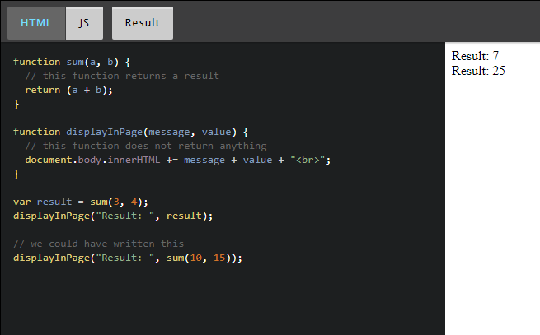

In the above example, the sum function returns a value, and the displayInPage function does not return anything.

##### 2 - Use a function expression

A JavaScript function can also be defined using an expression that can be stored in a variable. Then, the variable can be used as a function:

Here is a typical example: 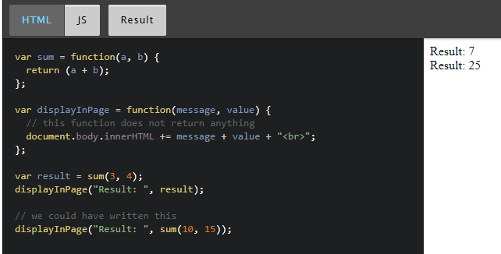

Notice how the sum and displayInPage functions have been declared. We used a variable to store the function expression, then we can call the functions using the variable name. And we added a semicolon at the end, since we executed a JavaScript instruction, giving a value to a variable.

The "function expression" is an "anonymous function", a function without a name, that represents a value that can be assigned to a variable. Then, the variable can be used to execute the function.

**We say that functions are "first class objects" which can be manipulated like any other object/value in JavaScript.**

**This means that functions can also be used as parameters to other functions. In this case they are called "callbacks".**

### Callbacks

Indeed, as functions are first-class objects, we can pass a function as an argument, as a parameter to another function and later execute that passed-in function or even return it to be executed later. When we do this, we talk about *callback functions* in JavaScript: a function passed to another function, and executed inside the function we called.

All the examples of event listeners that you've seen used callback functions. Here is another one that registers mouse click listeners on the window object (the window objects represent the whole HTML document):

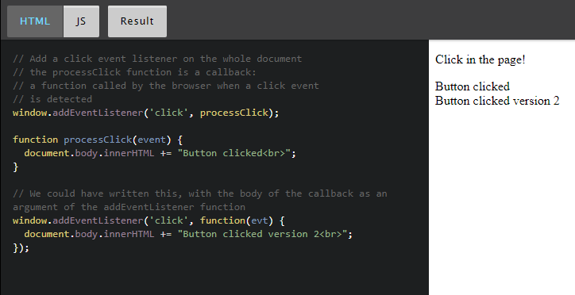

In this case, the processClick function is passed as a parameter to the addEventListener method/function.

Callback functions are derived from a programming paradigm known as functional programming. They are very, very common in JavaScript. We'll use them a lot in the next section of the course, called "Handling events".

## Handling Event Introduction

Adding interactivity to a Web application can only be achieved with CSS, using the :hover pseudo CSS class, for instance. For example:

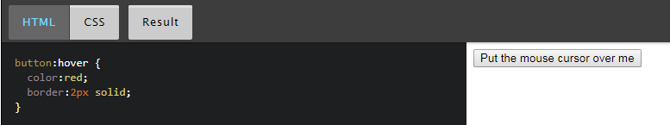

However, firing a specific action when the button is clicked, knowing which mouse button has been used, computing the (x, y) mouse pointer position in the button system coordinate, or executing more complex tasks can only be done through JavaScript.

With JavaScript, a button click, a move of the mouse, a resized window, and many other interactions create what are called "events".  The timing and order of events cannot bepredicted in advance. We say that "event processing" is asynchronous. Web browsers detect events as they occur, and may pass them to JavaScript code. They do this by allowing you to register functions as event listeners, also called handlers or callbacks for specific events.

Each time an event occurs, the browser puts it in a "queue of events".

Then the browser looks at a list of "Event Listeners" and calls the ones that correspond to the type of event "they listen to".

### Adding and removing event listeners

**Event listeners: a typical example**

Here is one possible syntax for registering an event listener that listens to "click" events on any part of the window (clicks anywhere on a web document will be processed by this event handler):

1. <script>
2. addEventListener('click', **function(evt) {**
3. **document.body.innerHTML += 'Button clicked!';**
4. **}**);
5. </script>

Try it below by clicking anywhere on the document:

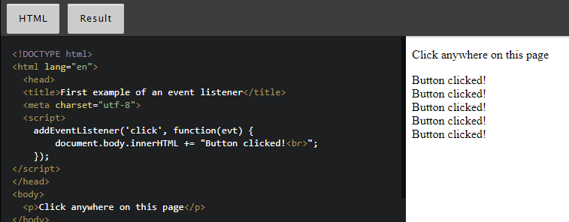

The addEventListener function is one possible syntax for registering a function to be called when a given type of event occurs.

1. addEventListener(type\_of\_event, callback\_function)

In the example below, the type of event is a 'click', and the callback function is the part in bold:

1. function(evt) {
2. console.log("Button clicked!");
3. }t

When this function is small (a few lines of code), it's common practice to put its body as the second parameter of the addEventListenerfunction.

In other words, this:

1. <script>
2. addEventListener('click', **function(evt) {**
3. **document.body.innerHTML += 'Button clicked!';**
4. **}**);
5. </script>

... is the same as this (the function called when a click occurs has its body "outside" of the addEventListener parameters, and we use its name as the second parameter):

1. <script>
2. addEventListener('click',**processClick**);
3. function**processClick**(evt) {
4. console.log("Button clicked!");
5. }
6. </script>

**Adding an event listener to specific HTML elements**

Instead of listening to event on the whole document (using addEventListener is the same as using window.addEventListener), we can listen to specific DOM elements.

For example, here is how we can listen to clicks on a specific button (whereas clicks on the rest of the document will be ignored).

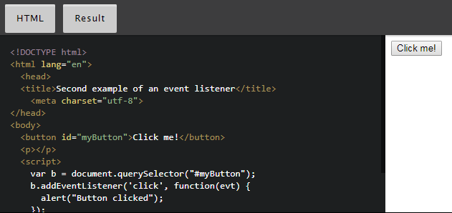

In this example, instead of using the addEventListener method directly, we used it on a DOM object (the button):

* 1. Get a reference of the HTML element that can fire the events you want to detect. This is done using the DOM API that we'll cover in detail later this week. In this example we used one of the most common/useful methods: var b = document.querySelector("#myButton");
  2. Call the addEventListener method on this object. In the example: b.addEventListener('click', callback)

Every DOM object has an addEventListener method. Once you get a reference of  any HMTL element from JavaScript, you can start listening to events on it.

**An alternative method for adding an event listener to an HTML element: use an "on" attribute (ex: onclick = "....")**

Instead of using b.addEventListener('click', callback), it's possible to use an onclick='doSomething();' attribute directly in the HTML tag of the element:

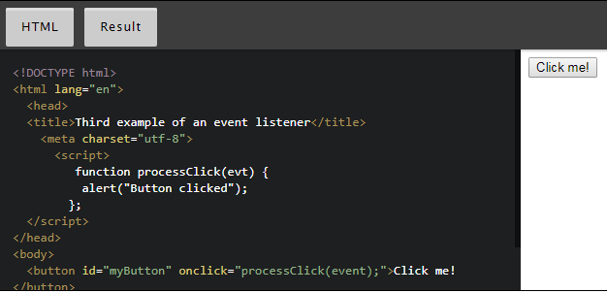

This syntax:

1. <button id="myButton" **onclick="processClick(event);**">Click me!</button>

... is ok when you only need a single event listener to click events for this button, as there can be only one onclick attribute per element.

Using the b.addEventListener('click', callback) syntax,  you can register more than one event listener. You'll need rarely to do this, so in my opinion it's fine to choose whichever syntax you like.

Remember that for big projects, it's always better to separate the HTML, CSS and JavaScript code. In this case, I'd recommend that you put all your event listener definitions in a separate JavaScript file, and use the addEventListener syntax in preference to the "on" attributes syntax.

**Removing event listeners**

When we click on the button, we execute the processClick(evt) callback function, and inside we remove the listener we previously registered. Consequence: if we click on the button again, nothing happens as there is no longer a click event listener attached to it.

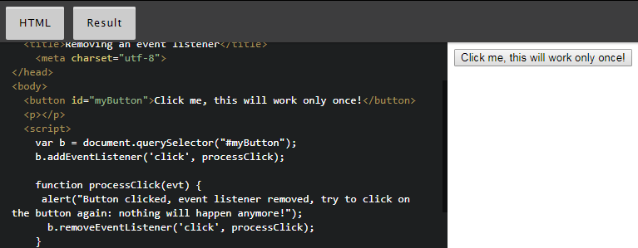

Note that to remove an event listener, you should have added it with its named function, so that we can pass it to both **addEventListener** and **removeEventListener**.

### The event object

#### The event object is the only parameter passed to event listeners

Typical example:

1. function processClick(**evt**) {
2. alert("Button clicked!");
3. }

Each event listener has a single parameter that is  a "DOM event object". It has various properties and methods that can be very useful.

For example, with a 'keyup', 'keydown' or 'keypress' event, the event object contains the code of the key that has been pressed/released, with a 'mousemove' listener we can get the relative position of the mouse in the DOM element that has generated the event, etc.

The event object contains some important properties and methods that are common to all types of events:

* + **evt.type**: the name of the event
  + **evt.target:** for example, is the HTML element that has fired the event. In our previous examples with the click listeners on a button, **evt.target** in the event listener is the button itself.
  + **evt.stopPropagation()**: will not propagate the event to all other elements that listen to it. If several elements are registered for a click event - for example, you have a click listener on a button and on the window (the whole page). If you click on the button, and if in its click event listener you call evt.stopPropagation(); then the click event listener on the window object will never be called.
  + **evt.preventDefault()**: the default browser behavior will not be executed. For example, in a 'contextmenu' event listener attached to an object, if you call **evt.preventDefault()**, instead of having the right click default context menu of your browser displayed, you'll be able to display your own context menu, like [in this example](http://jsbin.com/kuyorac/edit?html,css,js,console,output).

It also contains properties that are associated with the type of the event, for example:

* + **evt.button**: the mouse button that has been used in the case of a mouse event listener
  + **evt.keyCode**: the code of the key that has been used
  + **evt.pageX**: coordinate of the mouse relative to the page
  + etc.

In the subsequent sections of this course we will look at the most common types of events in detail.

#### Reference table

The most useful common properties are:

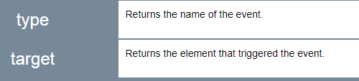

The most useful common methods are:

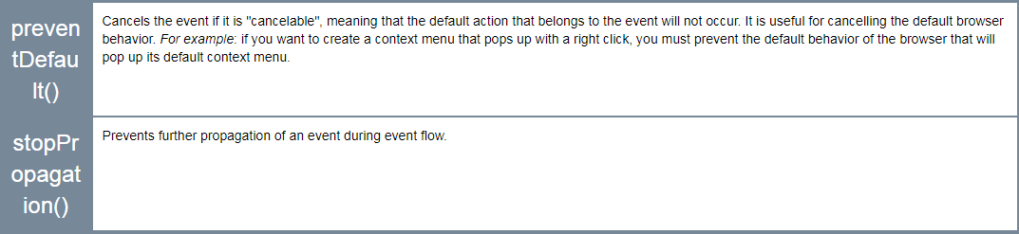

## One common way to debug your code: write messages to the devtool console!

Using the console.log(...) instruction, you can write messages to the devtool console of your browser.

For example, let's say you added a button to your Web page, but nothing happens when you click on it. Without using the devtool console and console.log(...) it can be very difficult to spot your error.

#### Example: check that some parts of the code you wrote are executed correctly

Normally, when the button is clicked, we should call the addXToThePage() function, which in turn should display the value of the variable xinside an HTML paragraph.

Let's check if the function is really executed. We need to add a console.log("In the addXToThePage function"); as the first instruction of the function:

And let's execute this with the devtool console open (use F12 on Windows, or Cmd-Alt-i on a Mac, or control-shift-i). First, as the provided example is located on codepen, an online IDE, it's better to execute it in "debug mode": the online IDE will just display a page with the code running:

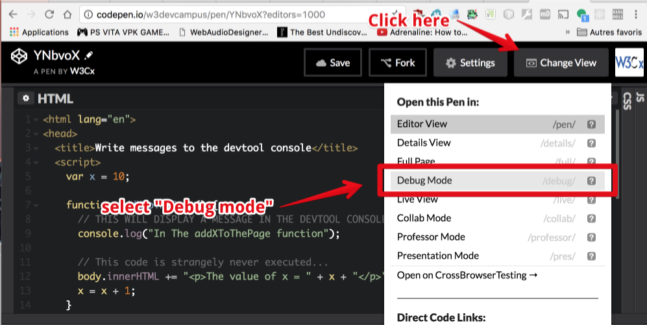

This will open a new tab with only your code running in it (not the whole codepen IDE + your code!). Open the devtool console (F12 or control-shift-i or cmd-alt-i on Mac), and you should see this:

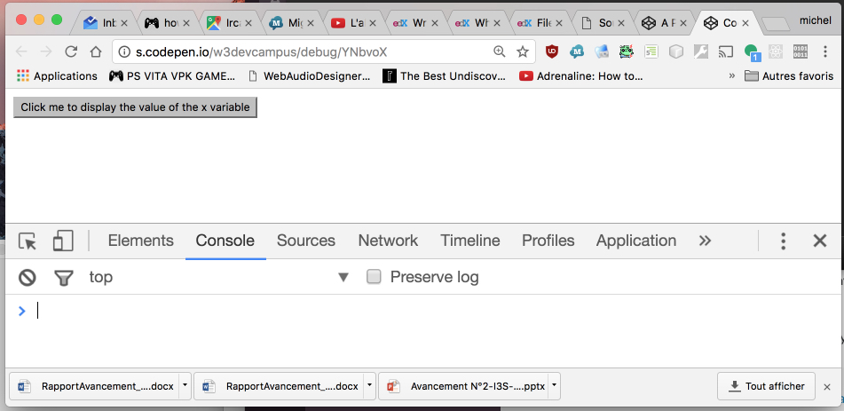

Now, press the button! An error message appears:

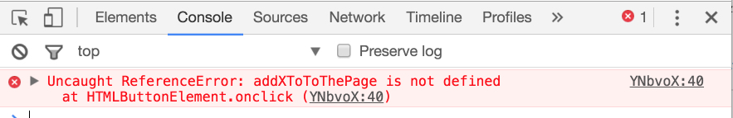

Apparently the function name is wrong, addXToToThePage does not exist. We can check the source code by clicking on the YNbvoX:40 link on the right:

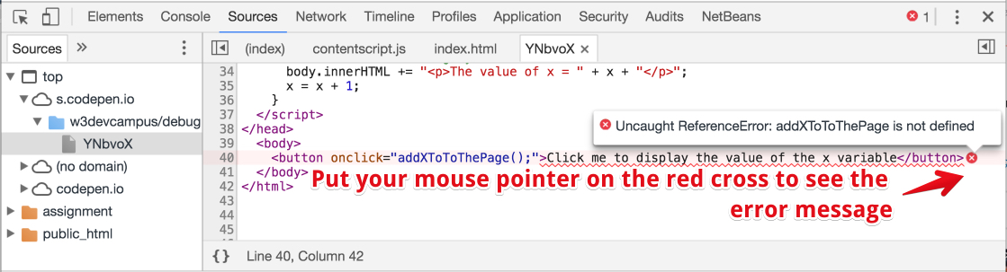

Ok, so our first error was that we typed the wrong name in the onclick="...", the name we used : AddXToToThePage has "ToTo" instead of "To". Let's fix that now and try again:

Let's try again (after we've changed the name of the function to the correct one), go in debug mode, open the devtool console and click the button. Here is what we get:

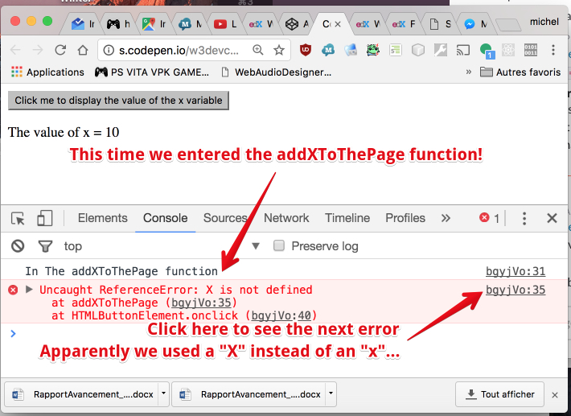

Ok, you understand the principle... by using console.log(...) with a string message as parameter, you can make the message appear in the devtool console, confirming that you have executed your code without error at least to this point...

Let's fix this "X"! We'll replace it with an "x" and everything should be ok now:

You can click the button now....

#### Going further with console.log

##### Displaying variable values

Instead of just displaying pure string messages, you can also use the "+" operator to concatenate variable values to the pure character strings. Example :

1. var x = 2;
3. console.log(**"The value of x is " + x + " and it's ok like that."**);

We typed this code in the devtool console to check what it does:

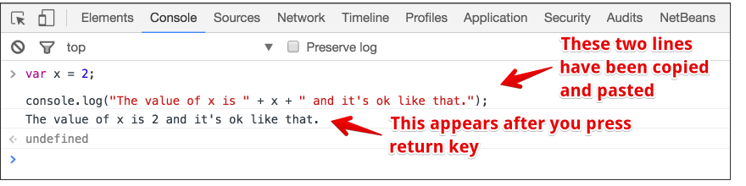

You can use as many "+" as you like, the part right after the "+" will be turned into a string if the part in front is a string...

You can also use parentheses in order to display results of simple calculations:

1. var x = 2;
2. var y = 4;
3. console.log("x = " + x);
4. console.log("y = " + y);
6. console.log("The value of (x+y) is " + (x+y) + " and it's ok like that.");

Result:

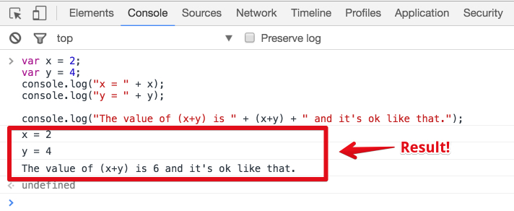

You can use any operator (+, -, /, \*, etc.), you are not limited to using the "+" operator.

And of course you can use such code in your programs, not only in the devtool console :-)

## Modifying the content of an HTML document

## Modifying the content of a document dynamically

The browser comes with some very powerful APIs (Application Programming Interfaces - a set of predefined objects/functions/variables you can use):

* 1. "The selection API" is used for "selecting elements in the document". It uses the same syntax as CSS selectors.
  2. The "DOM API" for "Document Object Model" API. When we used document.body.innerHTML += "<p>The value of x is " + x + "</p>"; in a previous example, we used the DOM API for adding content to the body of the page (page = document).
  3. Another API is called the HTML Table JavaScript API, and is useful for building tables on the fly,
  4. etc.

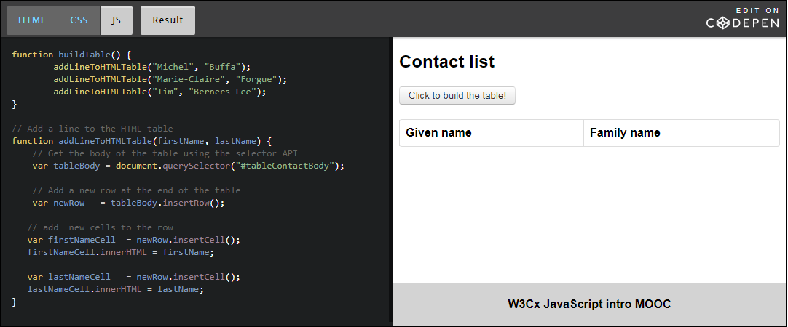

Just click the button to build the HTML table dynamically. You should see this:

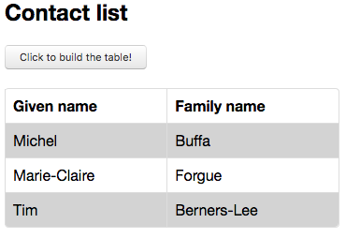

## Modifying CSS styles on the fly

We've already seen some examples in which we modify the style of some parts of a document using JavaScript. Here we show another example of what can be done.

### Example 1: change common properties (color, border, background color)

### Example 2: change the background image property using an external image

### Example 3: Use the background image as a sprite sheet -animate Mario!

Notice how the CSS properties change when we use them from JavaScript:

* + background-color (CSS) becomes backgroundColor (JS)
  + margin-left (CSS) becomes marginLeft (JS)
  + etc.

And the positions, widths and heights are always string values. In our example we used pixel units and a percentage, so we need to add the "px" and "%" character(s) when we manipulate these properties from JavaScript.

## Handling events

### Introduction

With JavaScript, you can react to user interactions (keyboard, mouse, gamepad), to changes in the lifecycle of your document (page has just loaded or resized, screen has been rotated on a mobile device), or to be notified when a long process has been completed (loading a large image or sound from the network).

We've already seen how we can make a <button> react to a mouse click with <button onclick="...">Click me</button>

Here we outline some extra examples. In the next course module, we will go into detail about events, and in the following modules we will study some of the most useful events in even greater depth.

### Example 1: use input events on an HTML input field

### Example 2: listen to mouse events in an HTML5 canvas

The HTML5 canvas is useful for drawing and animating at 60 frames/second. Very detailed tutorials are provided in the [W3Cx HTML5 Coding Essentials and Best Practices course](https://www.edx.org/course/html5-part-1-html5-coding-essentials-w3cx-html5-1x-2), while the [W3Cx HTML5 Apps and Games course](https://www.edx.org/course/html5-apps-games-advanced-techniques-w3cx-html5-2x) addresses how to write video games using the canvas 2D API.

In this JavaScript intro course, we will use it for drawing curves, for making a small game, and also on diverse, small examples for illustrating some JavaScript data structures such as Arrays or Objects (weeks 2/3/4).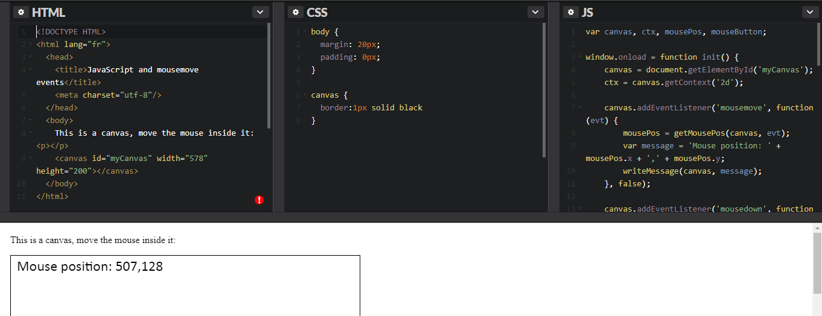

### Example 3: a paint program - click and drag mouse, then release

### Example 4: move a monster in an HTML5 canvas using left and right arrow keys

## Using built-in HTML5 APIs

### Introduction

Your browser comes with a lot of standard W3C APIs. By standard, we mean "parts of HTML5" or real Web standards that will still work in 10 years. In contrast to "industry standards", W3C standards are meant to be supported by browsers for years to come. These standards are a joint effort by the industry, the community, and W3C to develop stable, reliable standards.

The following example uses some of these APIs, simply to "show the possibilities". Others will be discussed later on in the course, or in other W3Cx courses.

### Using the WebCam (does not work yet with Safari, and is not supported by Internet Explorer)

Look at the JavaScript tab! The [W3Cx HTML5 Coding Essentials and Best Practices course](https://www.edx.org/course/html5-part-1-html5-coding-essentials-w3cx-html5-1x-2) will provide many other examples that use the WebCam.

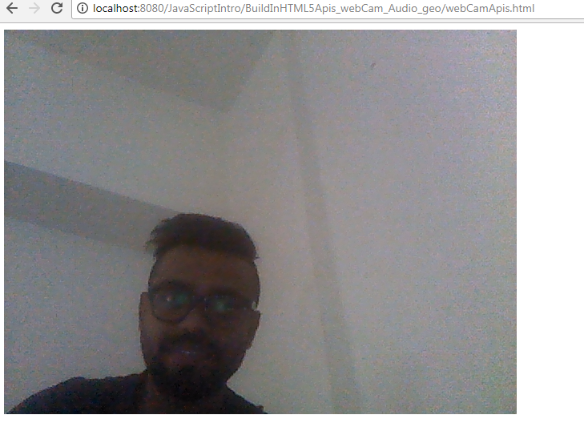

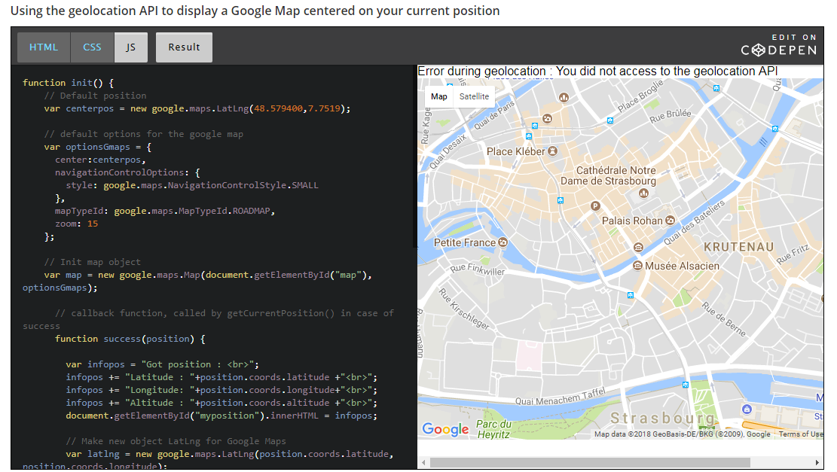 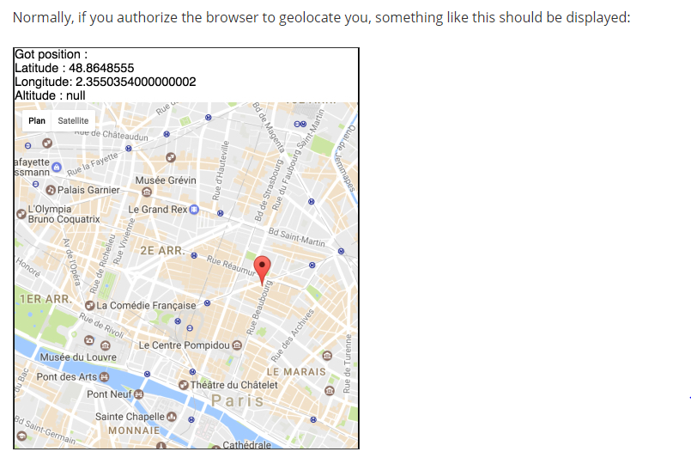

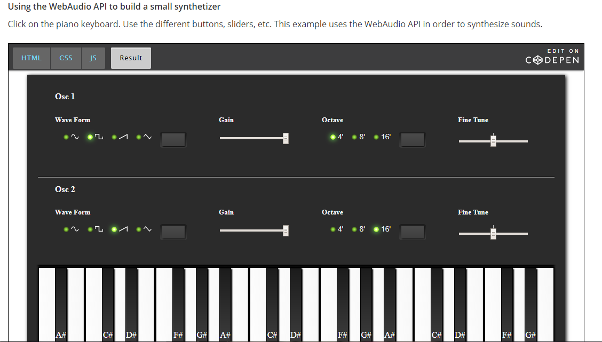

## Using third-party JavaScript libraries

### Introduction

Thousands of JavaScript libraries exist. Their purposes range from making it easier to plot a math function, playing chiptune music, animating objects, through to visualizing data and much more. Below, we provide some examples, but feel free to look on the Web for other external libraries.

### Example 1: plot mathematical functions using the [function plot JavaScript library](https://mauriciopoppe.github.io/function-plot/)

There are numerous libraries for plotting math functions, but this one is pretty easy to use and very powerful. Here is an example that plots f(x) = x^2, then f(x) = sin(x) and finally a mix of fours functions : f(x) = x^2 (in red), f(x) = 3\*x (in green), f(x) = cos(x) (in blue) and f(x) = -3\*x^2 + x^2 (dashed)

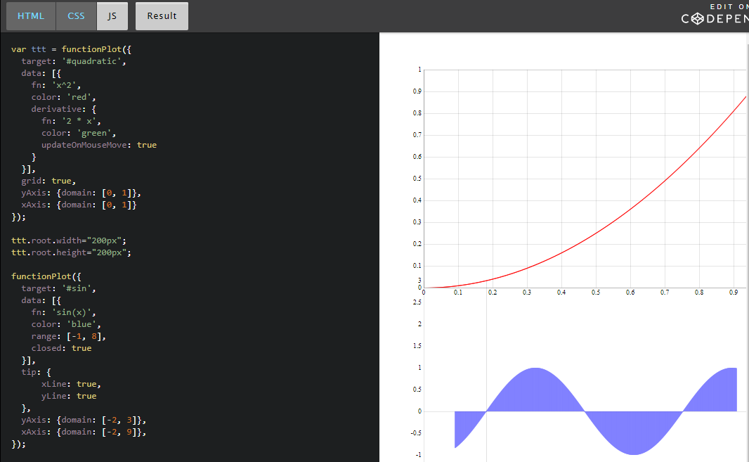

### Example 3: play chiptune songs (songs that sound like they come straight from the 8bit computer/console music era of the late 70's to mid 80's), using the chiptune.js library

I really like this example, as it takes me back to my youth playing games on the Commodore 64, the Nintendo NES console, etc. In that prehistoric age, there weren't a lot of kilobytes available in the memory, and most sounds were synthetized, not audio samples. The audio resolution was low as CPUs were rather weaker than today. Musicians used tools called "mod players/editors" for creating the music score (you can [try a re-creation on the browser of a mod editor](http://mod.haxor.fi/Necros/point_of_departure.s3m) to see how it looked in the late 80's).

To try the example below, click on "load demo song", then on the play button. If you want to try other compatible songs, look for any .mod, .it, .xm song on the Web and drag and drop it into the example page. A good resource for such files is [The Mod Archive](https://modarchive.org/), you can download plenty of chiptune files from there.

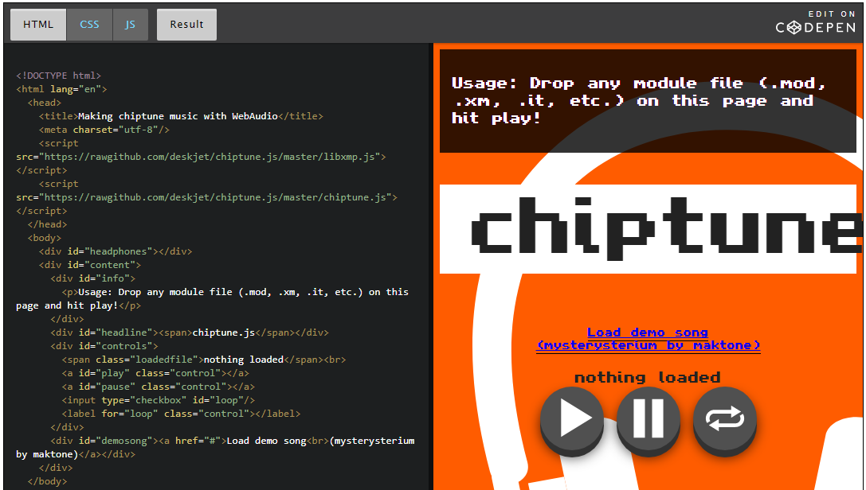

## Working with remote data

### load and decode remote sounds for use in a video game

This example just shows how to use the HowlerJS external library to load remote sounds, decode them and play them as samples in memory (useful for video games):

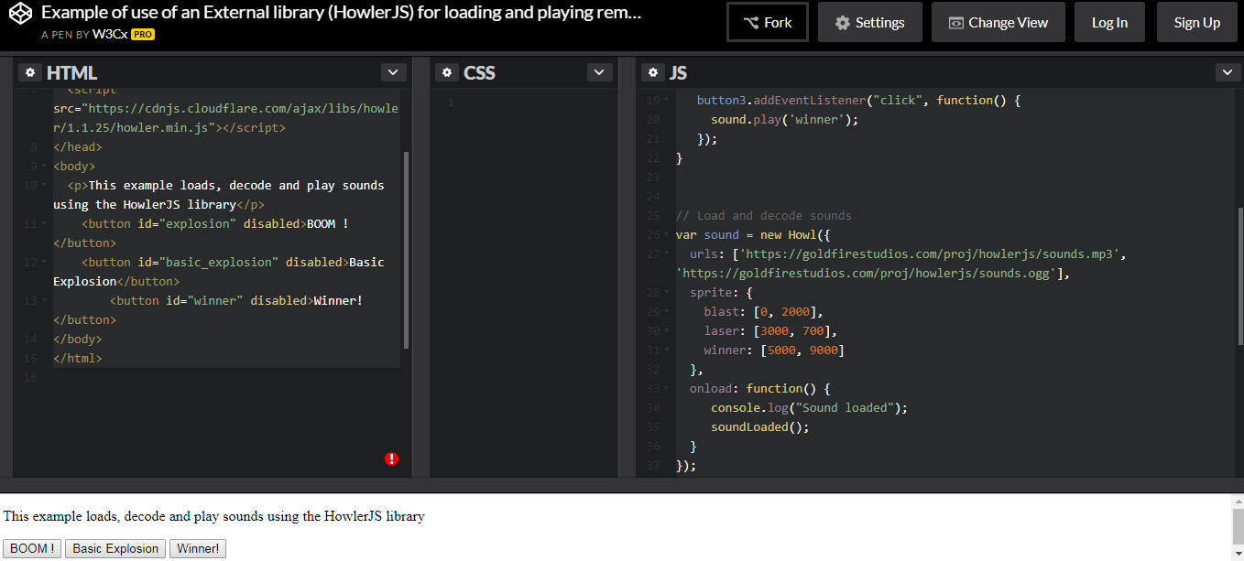

* **Boolean values and logical operators**

**Introduction**

Before talking about how your JavaScript program can make decisions, such as "*if this condition is fulfilled then I'll do this, otherwise I'll do that...*", we need to define a few more concepts.

We will start with "boolean values" and "logical operators".

**Boolean values**

The **boolean** type represents a logical entity having two values: true and false.

Use of the keywords true and false:

1. var b = true;
3. var b = false;

A boolean variable should not be enclosed in quotation marks, otherwise it becomes a string variable:

1. var b = 'true'; // b is not a boolean but a string

**Undefined and null values**

**Undefined**

undefined is returned when a variable has not been assigned:

1. var foo;
2. > foo
3. undefined
5. > typeof foo;
6. 'undefined'
8. >if (foo === undefined) {
9. console.log('The variable foo has no value and is undefined');
10. }
11. 'The variable foo has no value and is undefined'

The above example shows how we can test whether a variable has a value (*line 8* uses a conditional statement).

The keyword "**undefined**" is part of the JavaScript language, so you can assign the undefined value to a variable:

1. > var foo = undefined; // equivalent to var foo; without giving any value
2. undefined
4. > foo;
5. undefined

var foo; and var foo = undefined; are equivalent but we recommend that you use the first version to declare the variable (it is shorter, and that reduces the code).

If you try to access a variable that has not been declared before, a ReferenceError will be raised. But the typeof operator will return "undefined":

1. > bar;
2. ReferenceError
4. > typeof bar;
5. 'undefined'

**Logical operators**

The logical operators are as follows:

* **&&** (AND)    
  usage example : **if ((x  > 0) && (x < 10)) {**  
  **console.log('x is strictly positive and less than 10');**  
  **}**
* **||** (OR)   
  usage  example : **if ((x  > 0) || (x == -5)) {**  
  **console.log('x is positive or equal to -5');**  
  **}**
* **!** (NOT)   
  usage example : **if (!(x  > 0)) {**  
  **console.log('x is not positive (x is less or equal to 0');**  
  **}**
* **&&**, **||** operators are binary, **!** is unary.

1. var b = !true;
2. b; //false
4. var b = !!true;
5. b; //true
7. var b = "one";
8. !b;   false // implicit conversion of "one" to a boolean value
10. var b = "one"; // implicit conversion of "one" to a boolean value
11. !!b; //true

 In an expression with logical operators, as shown in *lines 8*and*11* of the previous example, non-boolean values are implicitly converted to boolean.

**Lazy evaluation or short-circuit evaluation:**

Logical expressions are evaluated from left to right. JavaScript uses a mechanism known as "short-circuit evaluation" to prevent the second, third, and nth conditions from being tested in certain cases:

* + false && something (an expression)  is always false, and the part to the right of && operator is not tested.
  + true || something (an expression) is evaluated to true, and the part to the right of the || operator is not tested.

Examples:

1. var b = 5;
2. var c = 6;
4. if ((b === 5) || (b === 6))  { //the second part is never tested
5. console.log('b is equal to 5 or equal to 6');
6. }
8. if ((b === 5) && (c === 6)) {  // second part is evaluated
9. console.log('b  is equal to 5 and c is equal to 6');
10. }
12. if ((b === 15) && (c === 6)) {  // second part is never evaluated
13. console.log('b  is equal to 5 and c is equal to 6');
14. } else {
15. console.log('b not equal to 15 or c not equal to 6');
16. }

**Implicit conversions of non boolean values in expressions**

Used with logical operators or within statements, **non-boolean values are implicitly converted to booleans**.

**All the following values are evaluated as false :**

* + **false**
  + **undefined**
  + **null**
  + **0**
  + **NaN**
  + **the empty string ''**

**Everything else is evaluated as true!**

1. var boo = 'hello' && 'world';

boo equals 'world' because 'hello' is a string value that is evaluated as true.

1. var boo2 = (0/0) || 43.2 ;

 boo2 equals 43.2 because the expression 0/0 equals NaN, which is evaluated as false.

**Question:**

What is the value of the variable myNumber after the execution of this code?

1. var myNumber = !1;
3. if(myNumber == null){
4. myNumber = 3;
5. }
7. myNumber = myNumber || 2;

**Explanation**: after the first line, myNumber equals false. In the if statement, at line 3, false does not equal null. Therefore, the value 3 is not assigned to the var myNumber. In the last line, myNumber is evaluated as false, then the value 2 is given to the variable myNumber.

#### Comparison Operators

* + Equal **==**
  + Not equal **!=**
  + Greater than **>**
  + Greater than or equal **>=**
  + Less than **<**
  + Less than or equal to **<=**
  + Strict equal **===**
  + Strict not equal **!==**

#### What is the difference between ****==**** and === in JavaScript?

##### Equal (==)

Returns true if the operands are strictly equal **with type conversion**.

##### Strict equal (===)

Returns true if the operands are strictly equal **with no type conversion**.

The triple-equals operator never does type coercion. It returns true if both operands reference the same object, or in the case of value types, have the same value.

Some examples :

1. 1 == 1 ;
2. //true
4. 1 == 2 ;
5. //false
7. /\* Here, the interpreter will try to convert the string ‘1’
8. into a number before doing the comparison \*/
10. 1 == '1';
11. //true :

14. //with strict equal, no conversion:
16. 1 === 1;
17. //true
18. 1 === '1';
19. //false

**Depending on the context, generally strict equal (or strict not equal) is preferred.**

**Best practice for beginners: always use === or !== for comparisons.**

**Specific case of NaN**

As we have already seen, JavaScript has some special values. One of them is NaN: “Not-a-Number”.

NaN has this special property :

1. NaN == NaN;
2. // false
4. NaN === NaN;
5. // false

**Nan is equal to nothing - not even to itself!**  But you do have a function to check the NaN value:  isNaN(expr)

* isNaN: returns true if the argument coerces to NaN, and otherwise returns false.

1. isNaN(NaN);
2. // true
4. isNaN(0/0);
5. // true
7. isNaN(12);
8. // false
10. isNaN('foo');
11. // true

"A reliable way for ECMAScript code to test if a value X is a NaN, is an expression of the form X !== X. The result will be true if, and only if, X is a NaN. " (see the [isNan documentation](http://www.ecma-international.org/ecma-262/5.1/" \l "sec-15.1.2.4" \t "_blank)).

**A complete example with isNaN:**

1. var num =0/0;
3. if(isNaN(num)){
4. num = 0;
5. }
6. //shortened version with the conditional operator
7. var num = isNaN(num) ? 0 : num
9. //version with logical operator (implicit conversion)
10. var num = num || 0;
12. /\*
13. <=> num = NaN || 0
15. <=> num = false || 0
16. \*/
18. num;
19. //returns 0 in this three cases

Of course 0/0 rarely happens, but there are other cases where NaN can appear, for example:

* parseInt('foo');  returns NaN   //parseInt tries to convert a String to a Number
* Math.sqrt(-1); return NaN

**Conditional statements**

**What are statements?**

JavaScript source code is a set of statements. There are a couple of different statement types. We have already seen one of them, the variable statement:

1. var myVar = 'hello ' + 'world';

We've also seen the expression statement:

1. 3 + 4;
3. // more often like this
4. var x = (3 + 4);
5. var y = (5 + x);

A statement closes with a semicolon, but we will see later that missing semicolons are automatically inserted (for readability reasons, we highly recommend systematically adding a semicolon at the end of all statements).

Statements are generally executed sequentially from top to bottom of the script. However, this flow can be modified by statements such as conditional statements and iteration statements.

**The block statement**

The block statement is a simple statement which allows us to group a set of statements wrapped in curly braces.

Block statement:

1. {
2. var i = 0;
3. var result = false;
4. console.log('i = ' + i);
5. }

The block statement is used by other statements such as the if-statement or for-statement. We will see these statements below.

**Conditional statements are used to execute a unit of code   
only if a condition is evaluated as true.**

#### The if statement

**Syntax:**

**if** ( Expression ) Statement **else** Statement

**if** ( Expression ) Statement

**The expression may include:**

* + logical operators ( **! && ||** )
  + comparison operators ( **==**, **===**, **>**, **>=**, **<**, **<=** )
  + any values or expressions which can be converted to boolean

##### **Example: if-statement**

1. var num = 10;
3. **if** (num === 10) **{**
4. num = 20;
5. **}**
7. // num equals 20

##### **Example: if-else statement**

1. var num = 10;
3. **if** (num > 10) **{**
4. num = 20;
5. **}** **else** **{**
6. num = 0;
7. **}**
9. // num equals 0

**Reminder:**

The following values will evaluate to false:

* + **false**
  + **undefined**
  + **null**
  + **0**
  + **NaN**
  + **""** (empty string)

**All other values, including all objects, evaluate to true when passed to a conditional statement.**

#### The if-then-else ternary operator

This ternary operator is a shortcut version of if...then...else.

Let's look at this code example:

1. var max;
2. var min = 2;
4. if (min < 10) {
5. max = min + 10;
6. } else {
7. max = min;
8. }

Explanation: You can replace this "if-then-else" statement with the ternary operator that uses a syntax with "?" and ":"

1. var max;
2. var min;
3. max = (min < 10)? min+10 : min;

Line 3 can be read as if (min < 10) then max = min+10, else max = min. The "then" part is after the "?" and the "else" part is after the ":" part.

This "short" version is not recommended except for very simple statements that involve a very obvious block of instructions for the "then" and the "else". Usually this syntax is much harder to read for beginners.

#### Curly braces

Should we use them in if-then-else statements? There are examples without curly braces on the Web: what does this mean?

Here are two versions of the same code.

**Version 1: no curly braces**

1. **if** (a > 2)
2. result = 'a is bigger than 2';
3. **else**
4. result = 'a is not bigger than 2';

**Version 2: with curly braces for delimiting the "then" and "else" blocks**

1. **if** (a > 2) **{**
2. result = 'a is bigger than 2';
3. **} else {**
4. result = 'a is not bigger than 2';
5. **}**

Version 1 and version 2 are equivalent. Indeed, version 1 is correct: you can omit curly braces if the "then" or "else" blocks are made of only one statement (one line of code).

But version 2 is cleaner and more readable, and, in particular, it is much better for maintainability (because you can add a statement just by pressing the enter key. And you can add some extra lines of code without worrying about adding curly braces because you broke the "1 line statement rule").

**So it is strongly recommended that you always use if-statements   
enclosed in curly braces.**

Of course, one-line if-statements like this :

1. if (true) doSomething();

...are really fast to write, but if you want to add a second statement later it will become more time consuming.

**Conclusion: always use curly braces!**

**The switch statement**

In order to avoid having a series of ifs and elses, it is possible to use a **switch** statement.

The syntax of the switch statement is:

1. **switch** (expression) **{**
2. **case** value1:
3. statement
4. **break**;       // break can be omitted in that case
5. // the second test case will be executed
6. // most of the time we add a break; at the end
7. // of a "case"
9. **case** value2:
10. statement
11. **break**;
13. **case** value3:
14. statement
15. **break**;
17. **default**:         // if no case tested true
18. statement
19. **break**;
20. }

If the value of an expression equals one of the cases (the equality operator evaluated is**===**), all the statements next to this case block are executed sequentially until the keyword **break** is reached.

**Example 1: a common switch/case/default example.**

1. var gear = '';
3. **switch** (cloudColor) **{**
4. **case** 'green':
5. gear = 'spacesuit';
6. break;
8. **case** 'black':
9. gear = 'boots';
10. **break**;
12. **case** 'grey':
13. gear = 'umbrella';
14. **break**;
16. **case** 'white':
17. gear = 'jacket';
18. **break**;
20. **default**:
21. gear = 'watch';
22. **break**; // useless if in the last case
23. **}** // end of the switch statement

In this example, if the clouds are grey, then my gear will be just an umbrella. If they are white, I'll wear only a jacket, if they are black I'll be nude with just boots (!), and if they are green I'll get a spacesuit. And if the cloud color is none of these, then I'll only wear a watch. The presence of the **break** keyword at the end of the different cases make the choices 100% exclusive. Only one case can be executed!

**Example 2: a switch without "breaks" at the end of each case.**

1. var gear = '';
3. **switch** (cloudColor) **{**
4. **case** 'green':
5. gear += 'spacesuit';
6. **break**;
8. **case** 'black':
9. gear += 'boots, ';
11. **case** 'grey':
12. gear += 'umbrella, ';
14. **case** 'white':
15. gear += 'jacket, ';
17. **default**:
18. gear += 'watch';
19. **}** // end of the switch statement

*Explanation*: if the clouds are black, then my gear will be 'boots, umbrella, jacket, watch'. If the clouds are green, my gear is a spacesuit (because of the break keyword, other cases will not be tested). If the cloud color is not in the listed colors, then my gear is only a watch (default case).

### Loop Statements

## A loop in the skyLoops

A loop is used to run the same block of code several times while a condition is satisfied.

If you have trouble with loops, the online tool [slowmoJS](http://toolness.github.io/slowmo-js/" \t "_blank) can be really useful: you just have to copy and paste an example into it to run it step by step and see how your program executes loops.

### The while statement

With a **while** statement, a block of code is executed repeatedly while the specified condition is satisfied (evaluates to true).

Syntax:

1. while ( condition ) statement

The condition is an expression, and the statement can be a block statement.

Typical example of a while statement:

1. var i = 1, j = 1;
3. **while ( i < 4 ) {**
4. j += i;
5. i += 1;
6. **}**
7. ...

The block inside the while (lines 4 and 5) will be executed three times:

* + Line 1 initializes i with a value of 1.
  + We enter the while statement at line 3. Is the value of i strictly less than 4?
  + Yes, the variable i is equal to 1, we enter the statement inside the while.
  + **Run 1:**
    - We execute line 4: j += i; (equivalent to j = j + i). As j was set to 1 at line 1, j is now equal to 2.
    - We execute line 5 and increment i by one. The variable i is now equal to 2.
    - We go back to the while at line 3. Is i < 4? Yes, we execute lines 3 and 4 again.
  + **Run 2:**
    - Now at the end of line 5, j is equal to "old j value" + "new i value", so j = 2 + 2 = 4, i has been incremented and is now equal to 3.
    - We go back to the while at line 3. Is i < 4? Yes, we execute lines 3 and 4 again.
  + **Run 3:**
    - Now at the end of line 5, j is equal to "old j value" + "new i value", so j = 4 + 3 = 7, i has been incremented and is now equal to 4.
    - We go back to the while at line 3. Is i < 4? No! The value of i is now 4, which is not less than 4. We continue the execution of the program at line 7 with i = 4 and j = 7.

Of course, if the condition never evaluates to false, the block will be executed infinitely until the machine crashes... a test like while (i > 0) { .....} will never stop and will eat all the CPU.

Try this example now with [slowmoJS](http://toolness.github.io/slowmo-js/?code=var%20i%20%3D%201%2C%20j%20%3D%201%3B%0A%20%0Awhile%20(%20i%20%3C%204%20)%20%7B%0A%20%20%20%20j%20%3D%20j%20%2B%20i%3B%0A%20%20%20%20i%20%3D%20i%20%2B%201%3B%20%0A%7D&filterrange=65-65" \t "_blank) !

### The do-while statement

The do-while statement is very similar to the while statement, but its syntax is different:

1. do statement while ( condition )

Typical example:

1. var i = 0;
3. **do {**
4. **console.log('i = ' + i);**
5. i++;
6. **} while(i < 20);**
8. console.log('Value of i after the do-while statement: ' + i);

The **do-while statement executes the content of the loop once before checking the condition of the while**, whereas a **while statement will check the condition first before executing the content**.

A do-while is used for a block of code that must be executed at least once.These situations tend to be relatively rare, thus the simple while-statement is more commonly used.

### The for statement

This statement adds some things to the while and do-while statements: an initialization expression and an incrementing expression.

Its syntax is:

1. for (initialization; condition; incrementation) statement

The three expressions within the parentheses are optional. If the condition is omitted, it is replaced by true (infinite loop).

Typical example (counting from 0 to 10):

1. for (var i = 0; i <= 10; i++) {
2. console.log('i = ' + i);
3. }

We can have more than one instruction in the "initialization part", and more than one instruction in the "incrementation part". Here is another example:

1. for (**var i = 1, j = 1;** i <= 10;**i++, j+=2**) {
2. console.log('i = ' + i + ' j = ' + j);
3. }

In this example, two variables are defined and assigned within the initialization expression. Before each execution of the block statement, the condition is checked; here we need i <=10. After each execution of the block statement, the incrementation expression is executed to increment the variables i by 1 and j by 2.

Open the devtool console of your browser and copy and paste the above code, or [look at the slowmoJS execution](http://toolness.github.io/slowmo-js/?code=for%20(var%20i%20%3D%201%2C%20j%20%3D%201%3B%20i%20%3C%3D%2010%3B%20i%2B%2B%2C%20j%2B%3D2)%20%7B%0A%20%20%20%20console.log(%27i%20%3D%20%27%20%2B%20i%20%2B%20%27%20j%20%3D%20%27%20%2B%20j)%3B%0A%7D&filterrange=0-89).

### The for-in statement

The for-in statement is used to iterate through an object (or through an array, which is also an object).

Its syntax is:

1. for ( variable in expression ) statement

Typical example:

1. var michel = {              // michel is an object
2. familyName:'Buffa',     // familyName, givenName, age
3. // are its properties
4. givenName: 'Michel',
5. age: 51
6. }
8. **for(var property in michel) {**   // the for-in will
9. // enumerate properties
10. console.log(property);      // will print "familyName",
11. // "givenName",
12. // "age"
13. console.log(michel[property]);  // michel['givenName'] same
14. // as michel.givenName
15. **}**

Before each execution of the block statement, the variable named "property" is assigned with the name of one of the properties (the keys) of the object.

We will see further examples of this statement in module 4, which is devoted to the study of JavaScript objects.

### [ADVANCED] Other statements

#### The continue statement

The continue statement is used to stop the execution of a block and start the next iteration of the loop. The difference from the "break" statement is that the loop continues.

Syntax:

1. continue [label]

The label is optional.

Typical example:

1. for(var i = 1, k = 0; i < 5; i++) {
2. if (i === 3) {
3. continue;
4. }
6. k += 2\*i;
7. console.log('k += ' + (2\*i));
8. }
9. console.log('Final k value:' + k)

Copy and paste this example in your devtool console, but first, try to guess what the value of k will be!

Hint: lines 2-4 mean that line 6 will never be executed for i = 3. That means that i\*2 will only be added to k for i = 1, 2 and 4...

#### The break statement

The break statement is used to stop an iteration, a switch or a labelled statement.

Syntax:

1. break [label]

Typical example:

1. var tab = ['michel', 'john', 'donald', 'paul']; // johh at index = 1
3. function isNameInTheArray(name, theArray) {
4. console.log("Number of elements in the array : " + theArray.length);
5. for(var i=0; i < theArray.length; i++) {
6. console.log('comparing with element in the array at pos ' + i);
8. if(theArray[i] === name) {
9. console.log('the name ' + name +
10. ' is in the array at pos: ' + i);
11. **break;**
12. } else {
13. console.log(name + ' is not at pos ' + i);
14. }
15. }
16. }
18. // Execute the function
19. isNameInTheArray('john', tab);

Copy and paste in the devtool console. You'll see that the function that compares each element in the array passed as the second parameter with the name 'john', will stop looping after 'john' has been found at index = 1.

**Detailed explanations:**

* + Line 20 executes the function
  + Line 6: The for statement loops on all existing indexes in the tab, from 0 to tab.length
  + Line 9: if the condition is true, we enter the block and execute lines 10-12
  + The break statement at line 12 will exit from the loop, it "breaks" the loop.
  + The different console.log(...) will never display the message "comparing with elements..." with indexes greater than 1: the loop exists when 'john' is found at index 1 (i equal to 1).

## page 'load' event and the event object

### Page lifecycle events

These events detect when the page is loaded and when the DOM is ready.

Events related to the page lifecycle

There are many other events related to the page life cycle. The most useful ones for an introduction course are shown below:

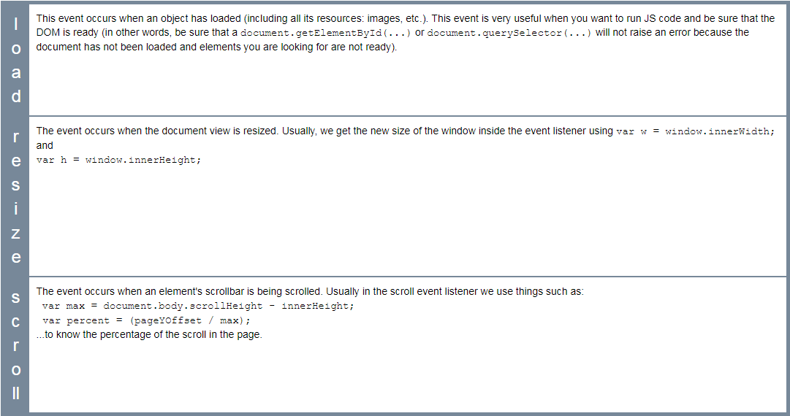

#### Page event properties

There are no particular properties that need to be mentioned here. Usually, the load event listener corresponds to a JavaScript function that can be seen as "the main" function of your Web application. It is a best practice to start everything after the page has been completely loaded. In the resize listener, you get the new size of the window, or the new size of some HTML elements in the page (as they might have been resized too when the window was resized), and then you do something (redraw a graphic in an HTML canvas that takes into account the new canvas size, for example).

#### Example 1: wait until the page is loaded (when the DOM is ready) before doing something

This first variant that uses <body onload="init();">

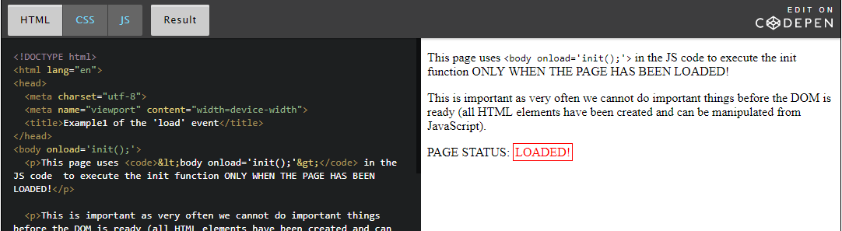

This second variant: using window.onload = init; in the JavaScript code...

This way is better than first as you can separate javascript from HTML

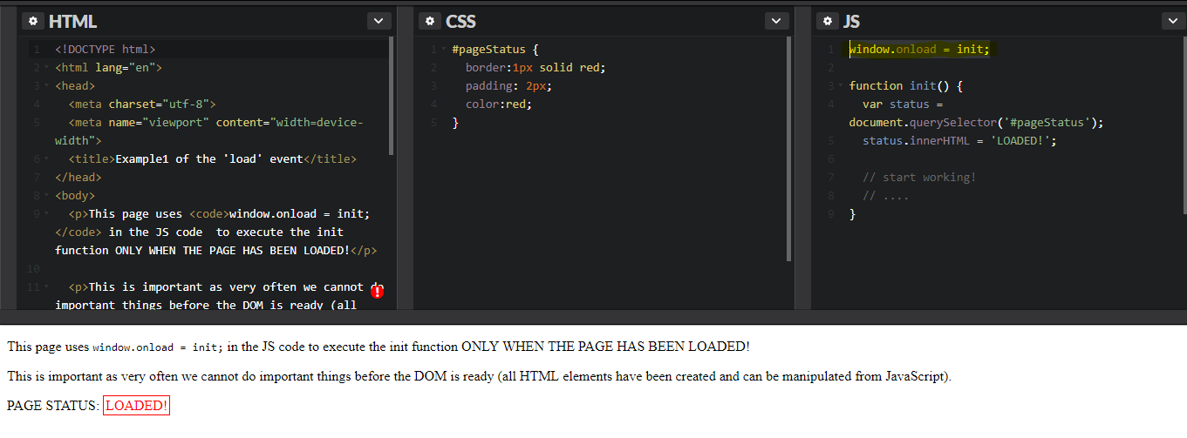

**Example 2: detect a resize of the window**

In this example, we're listening to page load and page resize events. When the window is loaded for the first time, or resized, we call theresize() callback function. The window.innerWidth and window.innerHeight properties are used to display the updated size of the window. We also use screen.width and screen.height to display the screen size.

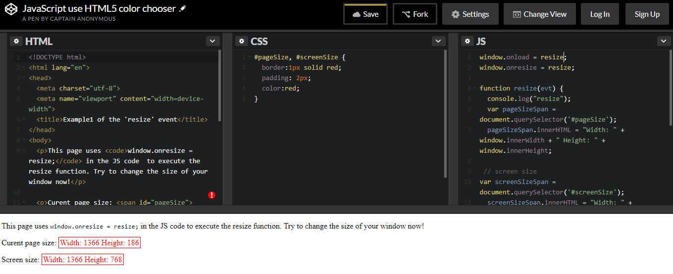

**Example 3: do something as the page is being scrolled up or down**

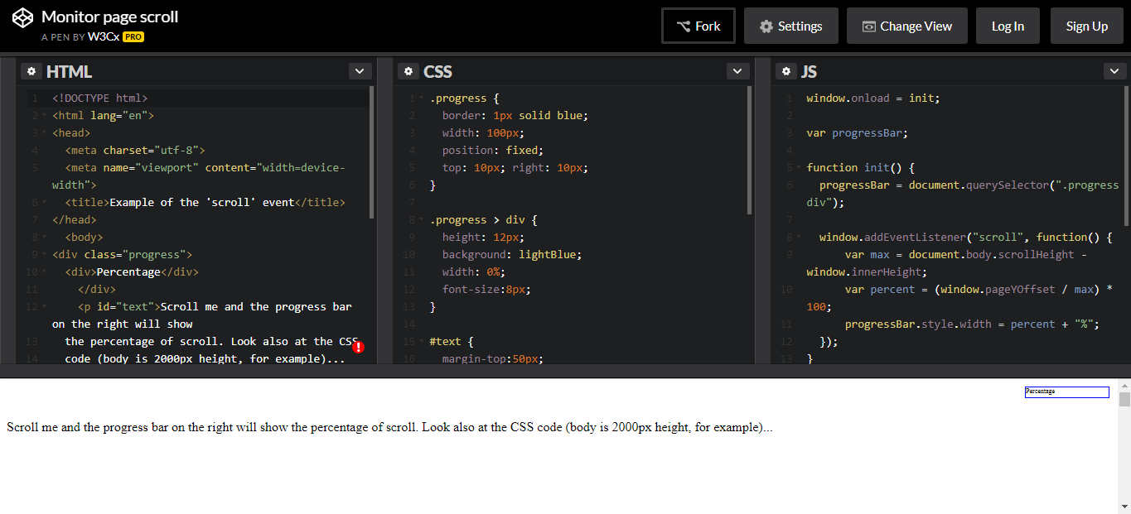

## Key events: legacy API

Dealing with key events

### Introduction

This has been a bit of a nightmare for years, as different browsers have had different ways of handling key events and key codes ([read this](http://unixpapa.com/js/key.html) if you are fond of JavaScript archeology). Fortunately it's much better today, and we are able to rely on methods that should work on any browser.

When you listen to keyboard related events (keydown, keyup or keypressed), the event parameter passed to the listener function will contain the code of the key that fired the event. Then it is possible to test which key has been pressed or released, like this:

1. window.addEventListener('keydown', function(event) {
2. if (**event.keyCode === 37**) {
3. //left arrow was pressed
4. }
5. });

At line 2, the value "37" is the key code that corresponds to the left arrow. It might be difficult to know which codes represent which real keyboard keys, so here are some handy pointers:

* Try key codes with this interactive example: <http://www.asquare.net/javascript/tests/KeyCode.html>
* And find a list of keyCodes (taken from: <http://css-tricks.com/snippets/javascript/javascript-keycodes/>) below:

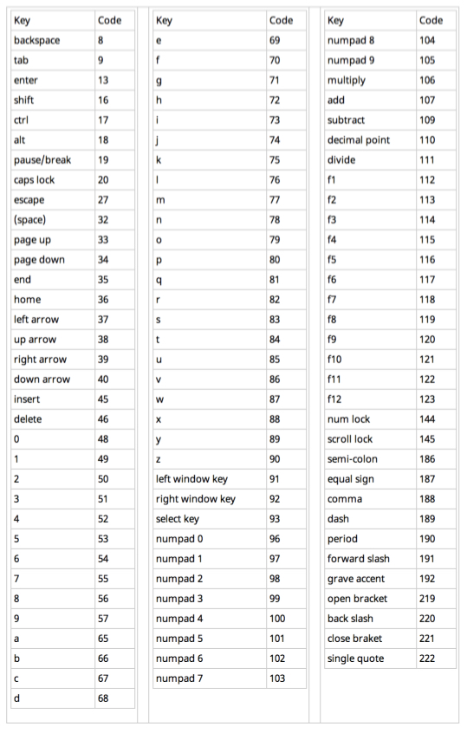

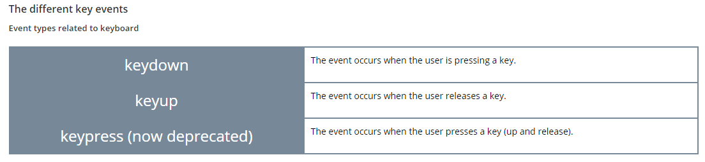

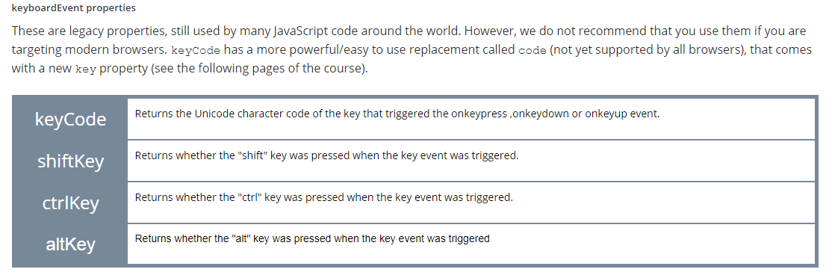

### Example 1: use keyup and keydown on the window object

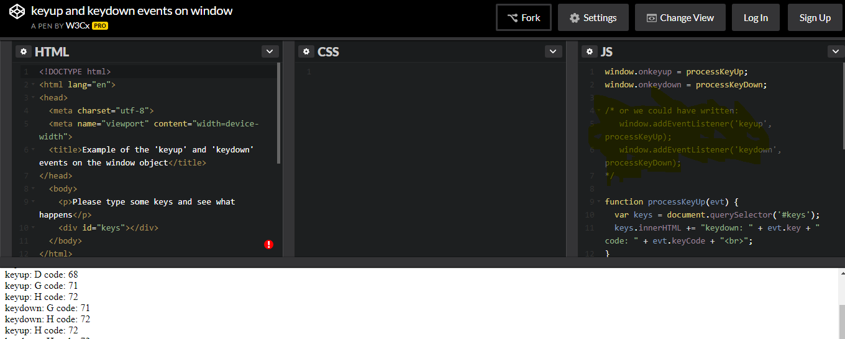

### Example 3: detect a combination of keys + modifier keys (shift, ctrl, alt)

Try to type shift-a for example, ctrl-shift-b or alt-f...

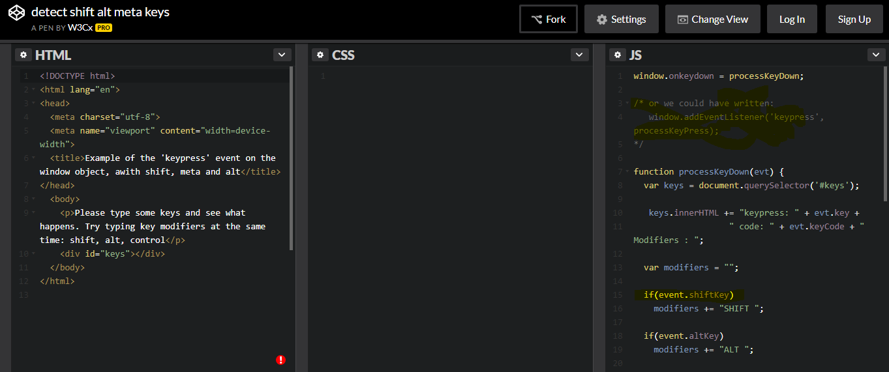

## Mouse events

### Mouse interaction, mouse events

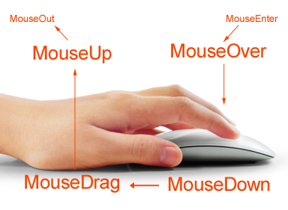

#### Introduction

***Important note***: Remember that many people do not use the mouse and rely on the keyboard to interact with the Web. This requires keyboard access to all functionality, including form controls, input, and other user interface components ([*learn more*](https://www.w3.org/WAI/intro/people-use-web/principles#operable)).

Detecting mouse events in a canvas is quite straightforward: you add an event listener to the canvas, and the browser invokes that listener when the event occurs.

The example below is about listening to mouseup and mousedown events (when a user presses or releases any mouse button):

1. canvas.addEventListener('mousedown', function (evt) {
2. // do something with the mousedown event
3. });
5. canvas.addEventListener('mouseup', function (evt) {
6. // do something with the mouseup event
7. });

The event received by the listener function will be used for getting the button number or the coordinates of the mouse cursor. Before looking at different examples, let's look at the different event types we can listen to.

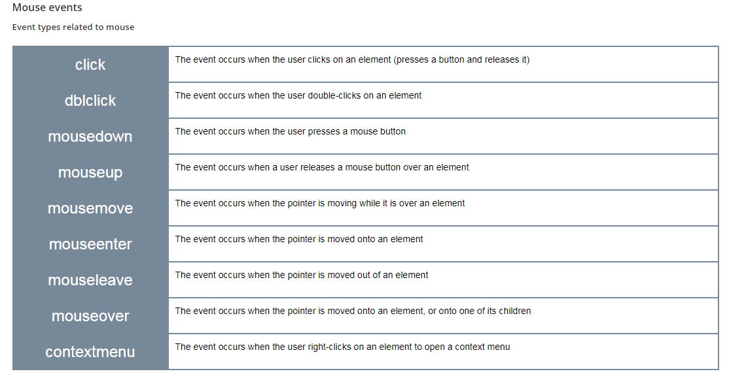

#### MouseEvent properties

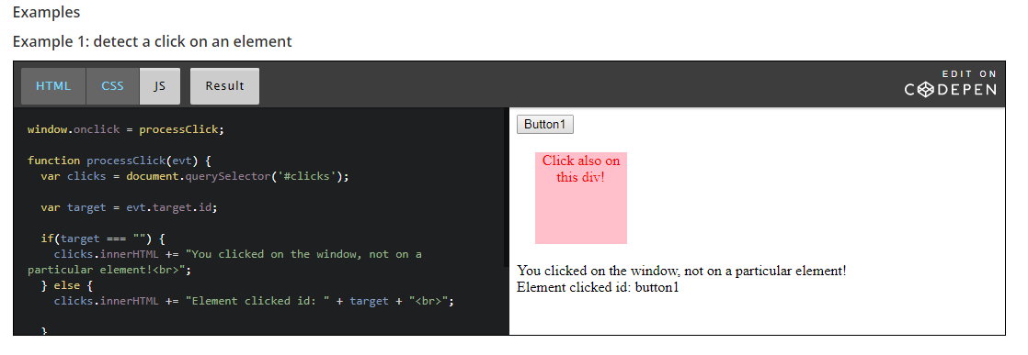

#### Example 2: see the differences between clientX/clientY and pageX/page

The source code is not meant to be understood. It uses the jQuery lib and comes from [a stackOverflow thread](http://stackoverflow.com/questions/9262741/what-is-the-difference-between-pagex-y-clientx-y-screenx-y-in-javascript). But it's interesting: move the mouse pointer, look at the different properties. Then scroll the page (the table at the top will not move), and look at the properties again; notice how pageX/pageY change, since they are relative to the top of the page, even if they are not visible

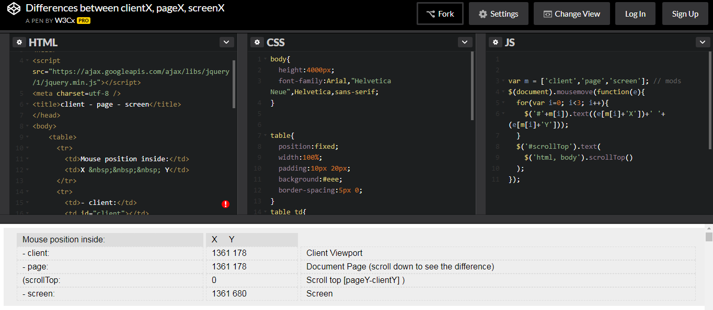

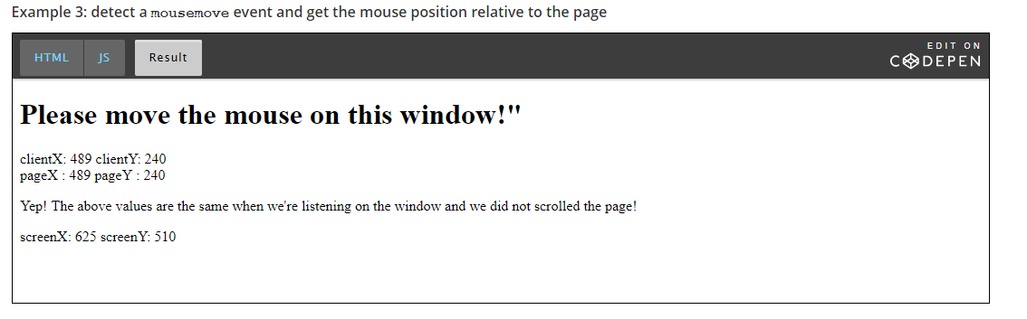

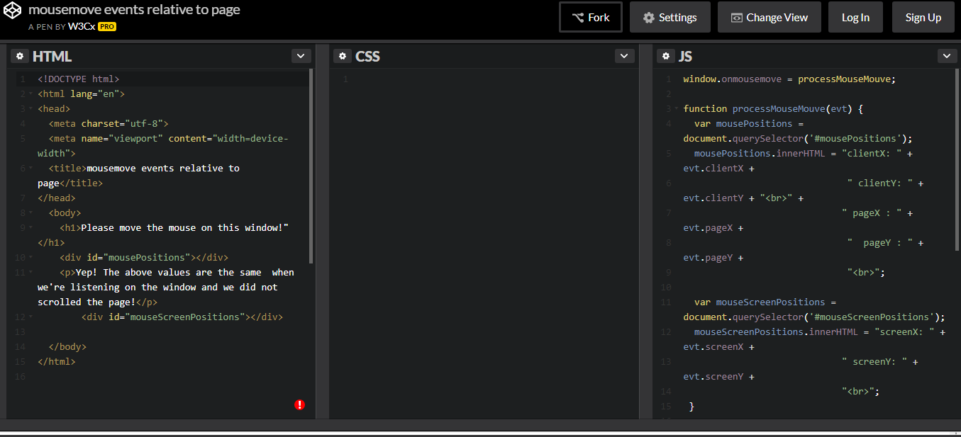

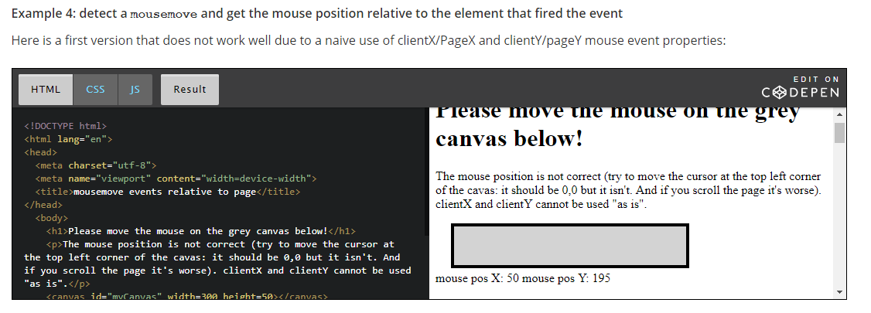

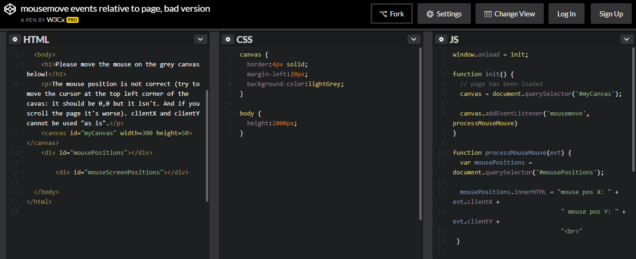

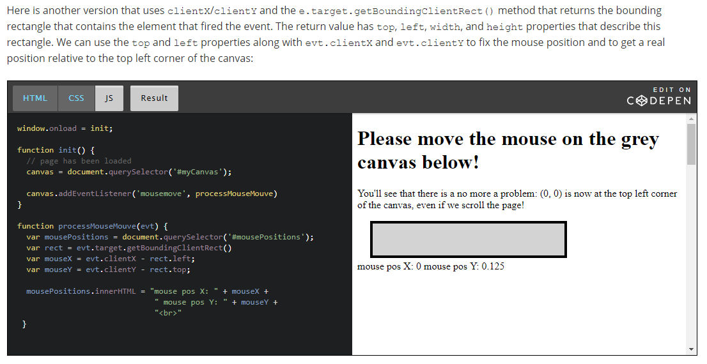

JavaScript source code extract:

1. function processMouseMouve(evt) {
2. var mousePositions = document.querySelector('#mousePositions');
3. // adjust mouse position relative to the canvas
4. **var rect = evt.target.getBoundingClientRect()**
5. **var mouseX = evt.clientX - rect.left;**
6. **var mouseY = evt.clientY - rect.top;**
7. mousePositions.innerHTML = "mouse pos X: " + mouseX +
8. " mouse pos Y: " + mouseY +
9. "<br>"
10. }

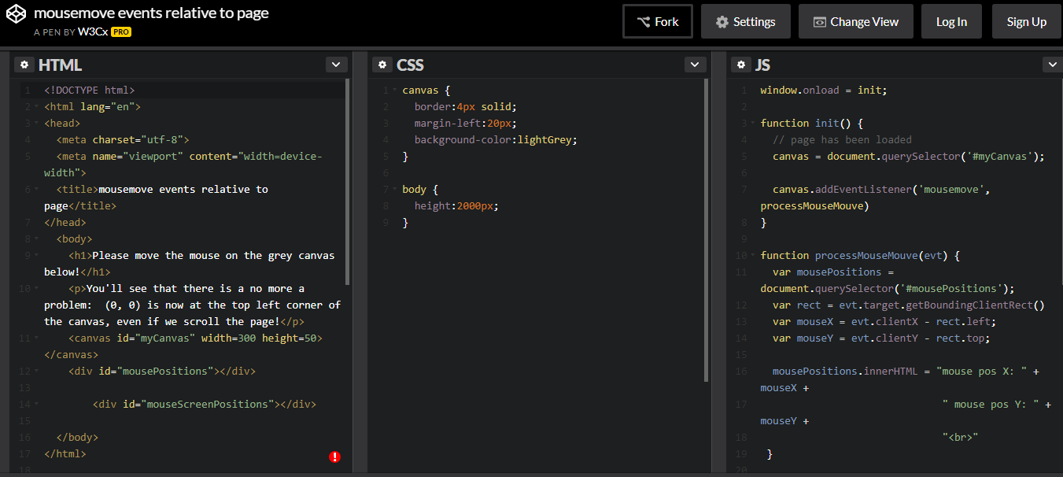

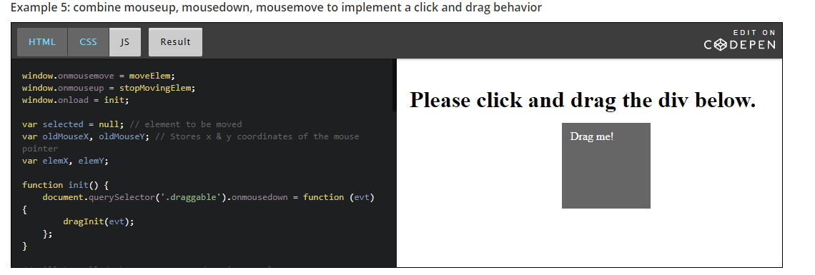

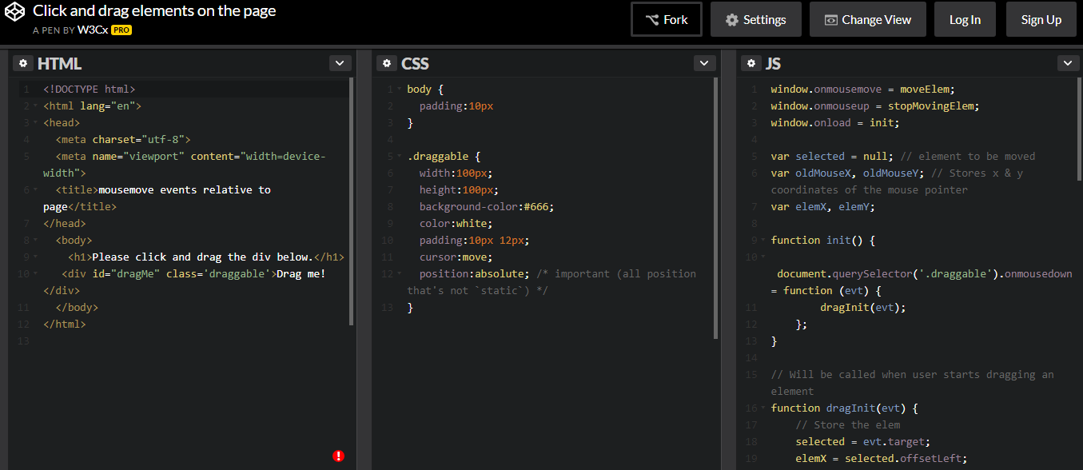

Javascript file –

window.onmousemove = moveElem;

window.onmouseup = stopMovingElem;

window.onload = init;

var selected = null; // element to be moved

var oldMouseX, oldMouseY; // Stores x & y coordinates of the mouse pointer

var elemX, elemY;

function init() {

document.querySelector('.draggable').onmousedown = function (evt) {

dragInit(evt);

};

}

// Will be called when user starts dragging an element

function dragInit(evt) {

// Store the elem

selected = evt.target;

elemX = selected.offsetLeft;

elemY = selected.offsetTop;

oldMouseX = evt.clientX;

oldMouseY = evt.clientY;

}

// Will be called when user dragging an element

function moveElem(e) {

// new mouse ps

var newMouseX = e.clientX;

var newMouseY = e.clientY;

if(oldMouseX !== undefined) {

// how many pixels did we move the mouse?

var dx = newMouseX - oldMouseX;

var dy = newMouseY - oldMouseY;

}

if (selected !== null) {

// move the selected element dx, dy pixels hozontally/vertically

changePosOfSelectedElement(dx, dy);

}

// update the old position of the mouse

oldMouseX = newMouseX;

oldMouseY = newMouseY;

}

function changePosOfSelectedElement(dx, dy) {

// update the old position of the selected element

elemX += dx;

elemY += dy;

// change the pos on screen of the element

// by modifying its CSS left/top properties

selected.style.left = elemX + 'px';

selected.style.top = elemY + 'px';

}

// Destroy the object when we are done

function stopMovingElem() {

selected = null;

}

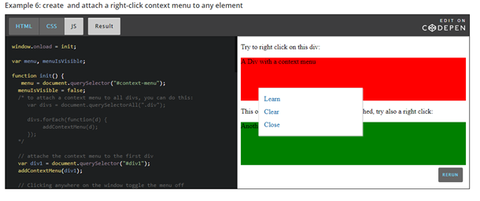

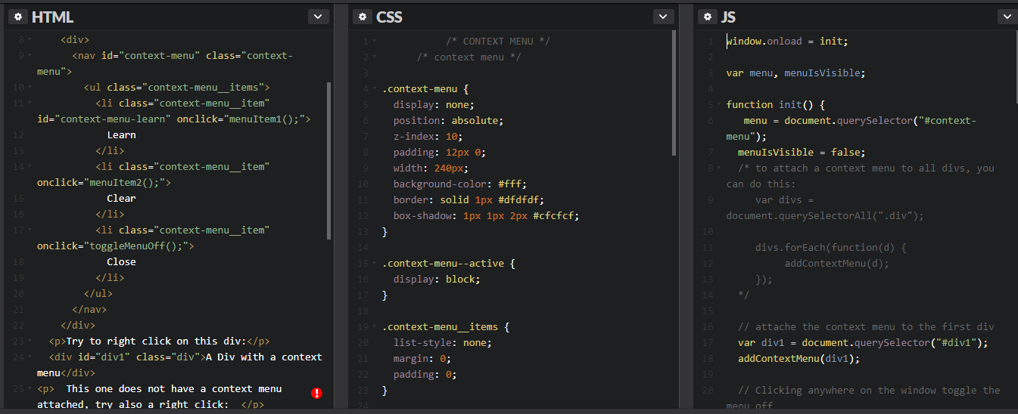

JavaScript code –

window.onload = init;

var menu, menuIsVisible;

function init() {

menu = document.querySelector("#context-menu");

menuIsVisible = false;

/\* to attach a context menu to all divs, you can do this:

var divs = document.querySelectorAll(".div");

divs.forEach(function(d) {

addContextMenu(d);

});

\*/

// attache the context menu to the first div

var div1 = document.querySelector("#div1");

addContextMenu(div1);

// Clicking anywhere on the window toggle the menu off

window.addEventListener('click', toggleMenuOff);

}

function addContextMenu(elem) {

elem.addEventListener("contextmenu", function(e) {

//console.log("contextmenu activated");

e.preventDefault(); // avoids default right click menu

toggleMenuOn();

positionMenu(e);

});

}

function toggleMenuOn() {

if(!menuIsVisible) {

menuIsVisible = true;

menu.classList.add("context-menu--active"); // see further in the DOM section of the course

}

}

function toggleMenuOff() {

if(menuIsVisible) {

menuIsVisible = false;

menu.classList.remove("context-menu--active");

}

}

function positionMenu(e) {

// Mouse position is relative to the element clicked

// We make the coords absolute in the page

var clickCoordsX = e.pageX;

var clickCoordsY = e.pageY;

var menuWidth = menu.offsetWidth + 1;

var menuHeight = menu.innerHeight + 1;

var elementWidth = e.target.offsetWidth;

var elementHeight = e.target.offsetHeight;

if ((elementWidth - clickCoordsX) < menuWidth) {

menu.style.left = elementWidth - menuWidth + "px";

} else {

menu.style.left = clickCoordsX + "px";

}

if ((elementHeight - clickCoordsY) < menuHeight) {

menu.style.top = elementHeight - menuHeight + "px";

} else {

menu.style.top = clickCoordsY + "px";

}

}

// Actions called when a menu item is choosen

function menuItem1() {

console.log('learn');

toggleMenuOff();

}

function menuItem2() {

console.log('clear');

toggleMenuOff();

}

## Form and input field events

Forms

### Events related to forms

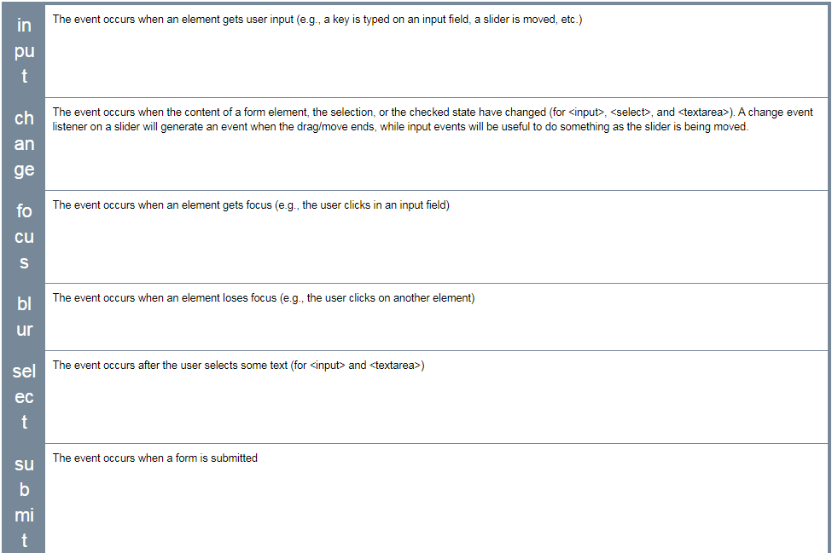

### FormEvent properties

There are no particular properties that need to be mentioned here. Usually, on a form event listener, we check the content of the different input fields, using their value property

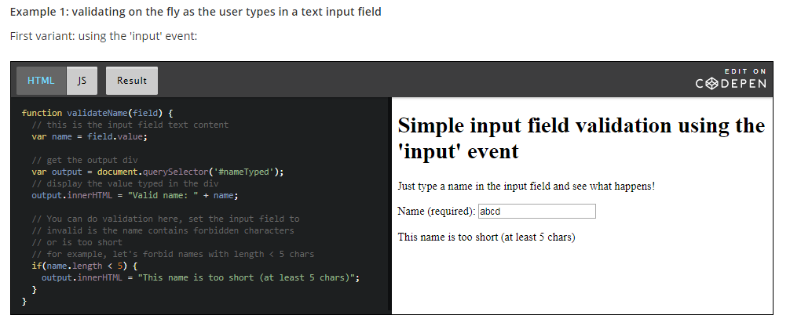

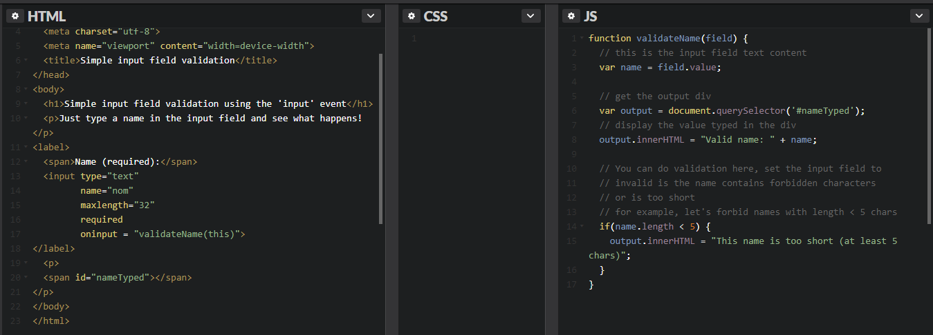

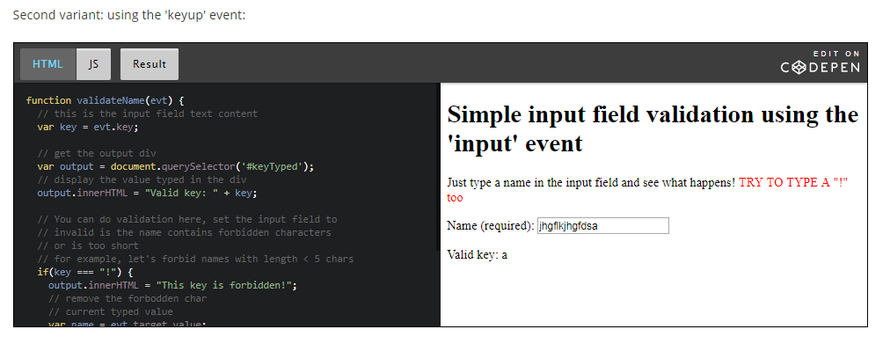

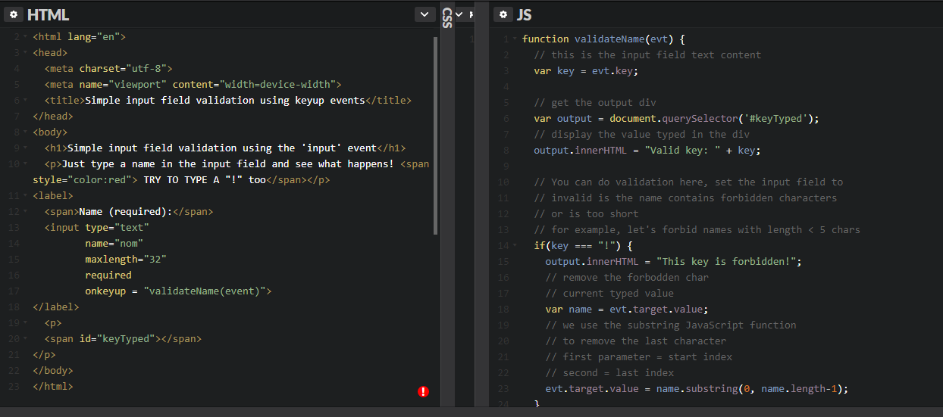

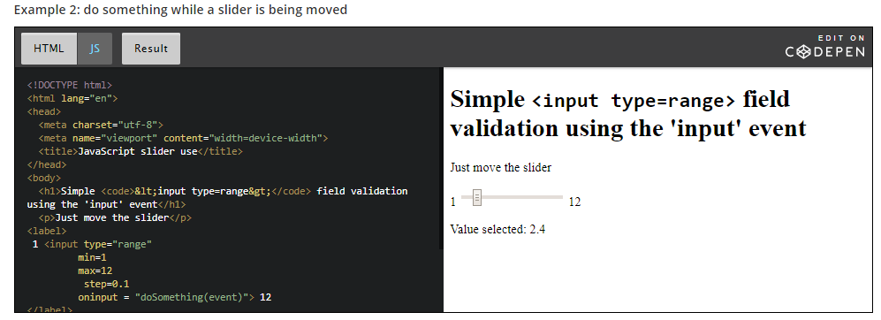

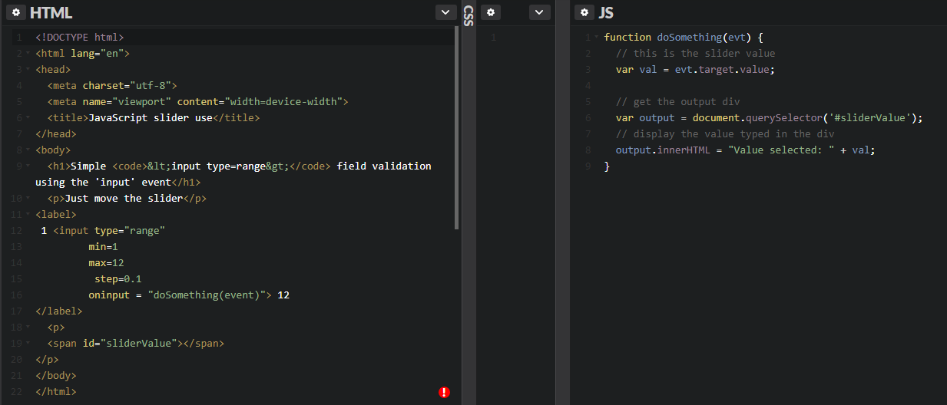

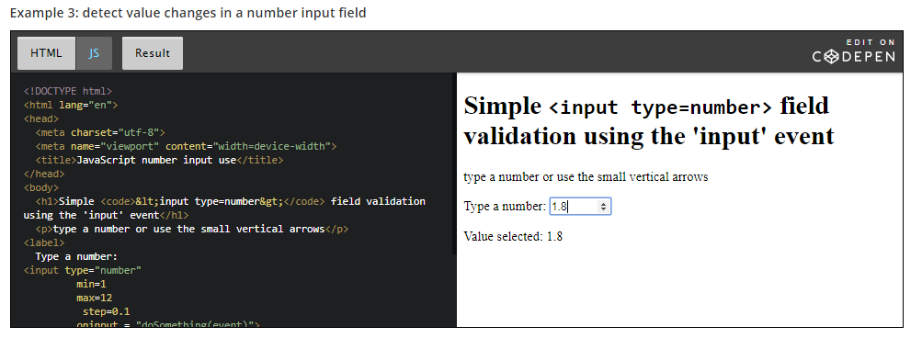

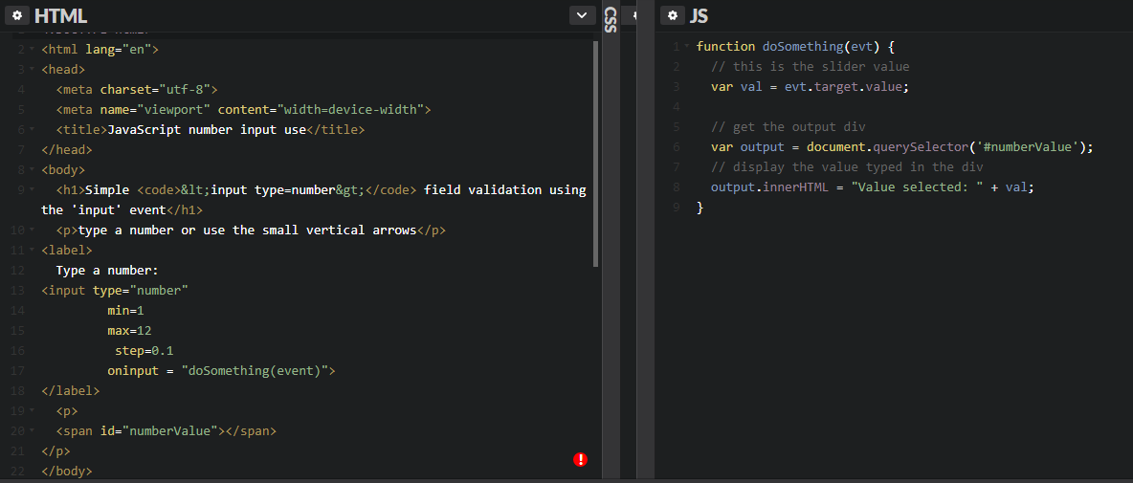

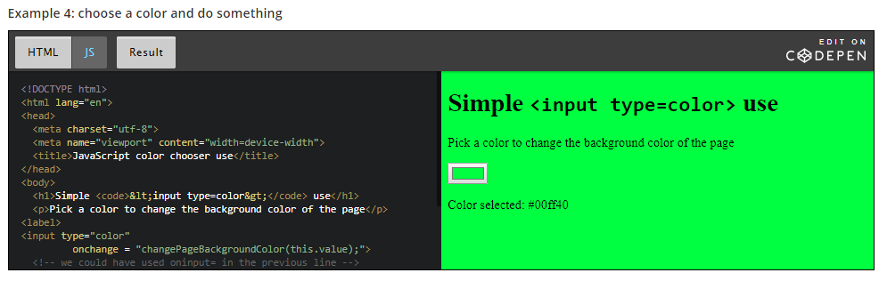 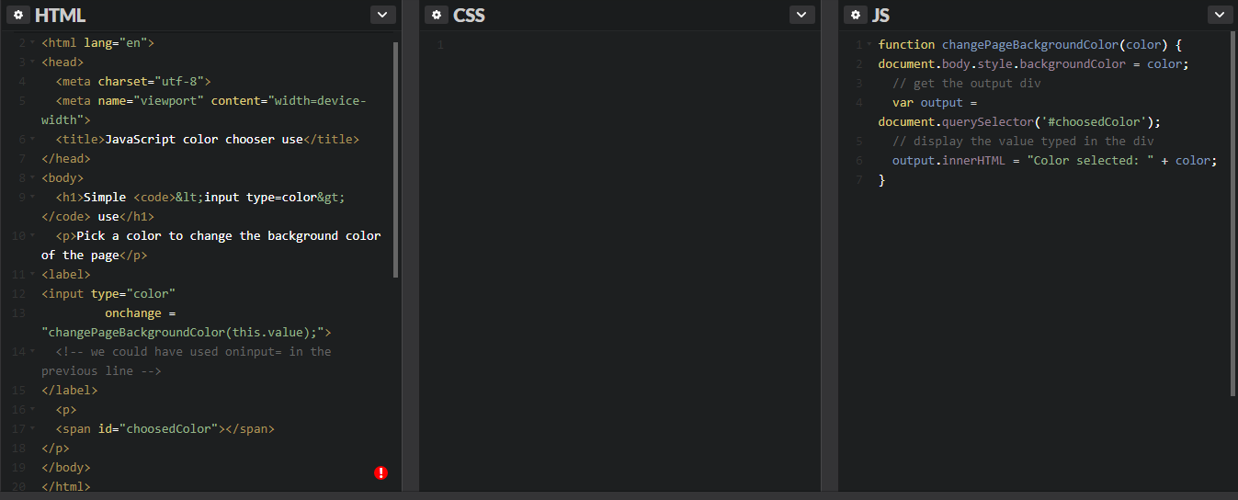

**Reference tables**

### Quick summary of event management in JavaScript

#### HTML5 EVENTS

There is no input or output in JavaScript. We treat events caused by user actions as inputs, and we manipulate the DOM structure as output. Usually in a JavaScript application, we will get info such as the key strokes, the mouse button clicks and the mouse position, and we will refer to these variables when determining what action to perform.

In any case, the events are called DOM events, and we use the DOM APIs to create event handlers.

#### HOW TO LISTEN TO EVENTS

There are three ways to manage events in the DOM structure. You could attach an event inline in your HTML code like this:

##### **Method 1: declare an event handler in the HTML code**

1. <div id="someDiv" **onclick**="alert('clicked!')"> content of the div </div>

This method is very easy to use, but it is not the recommended way to handle events. Indeed, although it currently works, it is deprecated (will probably be abandoned in the future). Mixing 'visual layer' (HTML) and 'logic layer' (JavaScript) in one place is really bad practice and causes a host of problems during development.

##### **Method 2: attach an event handler to an HTML element in JavaScript**

1. document.getElementById('someDiv').**onclick**= function() {
2. alert('clicked!');
3. }

This method is fine, but  you will not be able to attach multiple listener functions. If you need to do this, use the version shown below.

##### **Method 3: register a callback to the event listener with the addEventListener method (preferred  method)**

1. document.getElementById('someDiv').**addEventListener**('click', function() {
2. alert('clicked!');
3. }, false);

Note that the third parameter describes whether the callback has to be called during the captured phase. This is not important for now, just set it to false or ignore it (you can even pass only two parameters to the addEventListener function call and do not set this boolean parameter at all).

#### Details of the DOM event are passed to the event listener function

When you create an event listener and attach it to an element, the listener will create an event object to describe what happened. This object is provided as a parameter of the callback function:

1. element.addEventListener('click', function(**event**) {
2. **// now you can use event object inside the callback**
3. }, false);

Depending on the type of event you are listening to, you will consult different properties from the event object in order to obtain useful information such as: "which keys are pressed down?", "what is the location of the mouse cursor?", "which mouse button has been clicked?", etc.

In the following lessons, we will remind you how to deal with the keyboard and the mouse.

### Further reading

In Method 1 (above), we mentioned that "mixing 'visual layer' (HTML) and 'logic layer' (JavaScript) ... is bad practice", and this is similarly reflected in many style features being deprecated in HTML5 and moved into CSS3. The management philosophy at play here is called "the separation of concerns" and applies in several ways to software development - at the code level, through to the management of staff. It's not part of the course, but professionals may find the following references useful:

* [Separation of concerns - Wikipedia, the free encyclopedia](https://en.wikipedia.org/wiki/Separation_of_concerns)
* [Chapter 5. Separation of Concerns](http://chimera.labs.oreilly.com/books/1234000000262/ch05.html) from Programming JavaScript Applications, by Eric Elliott, O'Reilly, 2013.
* [The Art of Separation of Concerns](http://aspiringcraftsman.com/2008/01/03/art-of-separation-of-concerns/) by derekgreer, January 3, 2008

### Reference tables for events and properties/methods

These tables are provided as a reference. They are a compilation of the most common event types sorted by domain (key, mouse, forms, etc.). For each domain you will see the most useful event types and their properties.

In the following sections, we will show  examples that use most of the events displayed in these tables.

#### Event object

Most useful common properties:

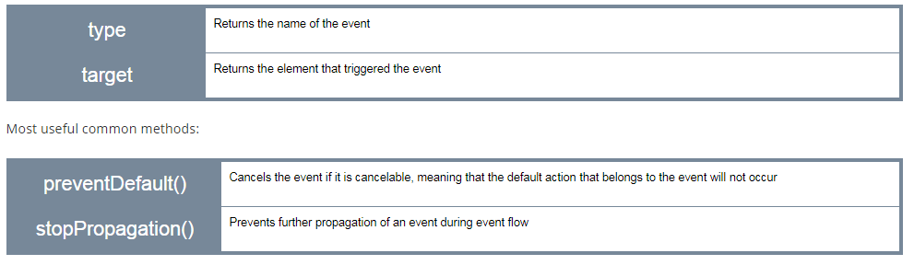

#### Page

##### Events related to the page lifecycle

There are many other events related to the page life cycle. Below are the most useful ones for an intro course:

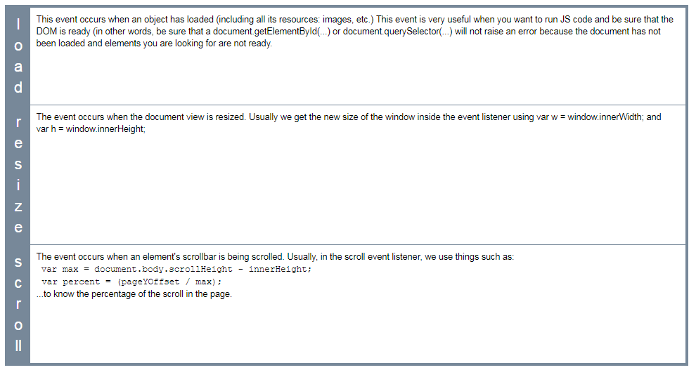

##### Page event properties

There are no particular properties that need to be mentioned here. Usually, the load event listener corresponds to a JavaScript function that can be seen as "the main" function of your Web Application. It is good practice to start everything after the page has been completely loaded. In the resize listener, you get the new size of the window, or the new size of some HTML elements in the page (as they might have been resized too when the window was resized) and then you do something (redraw a graphic in an HTML canvas that takes into account the new canvas size, for example).

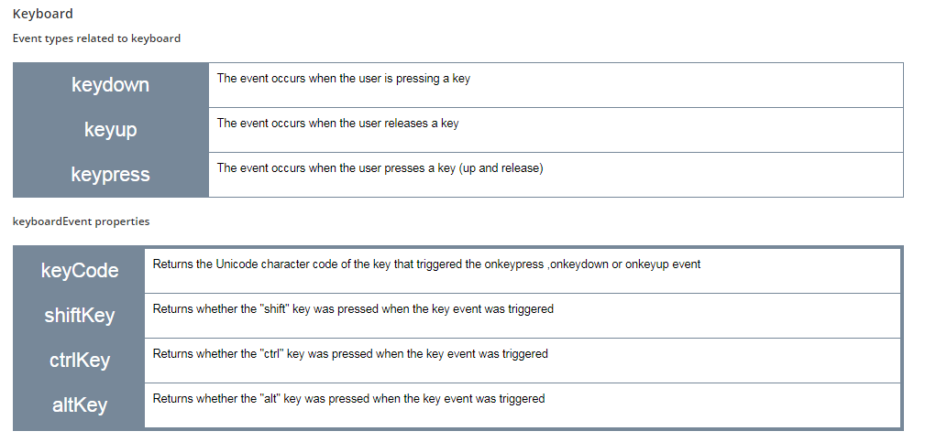

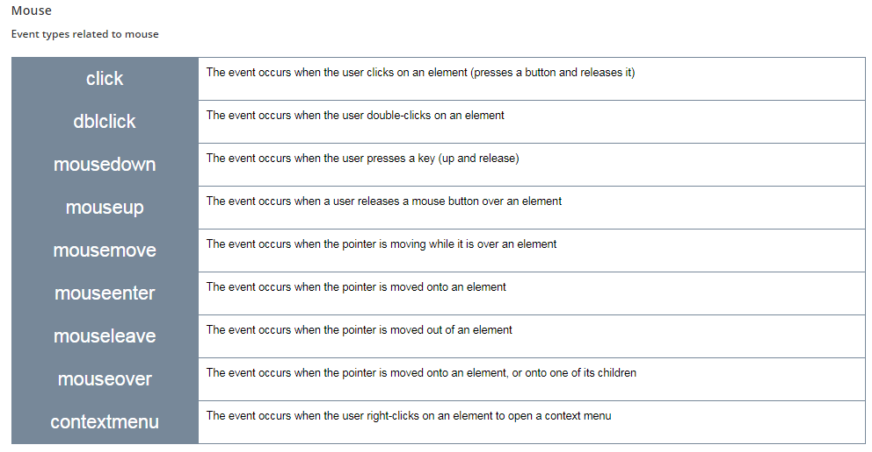

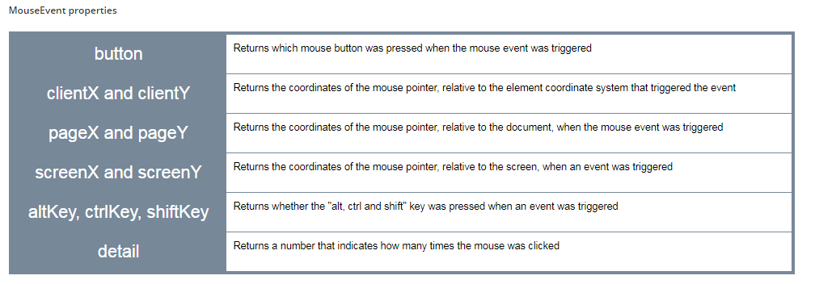

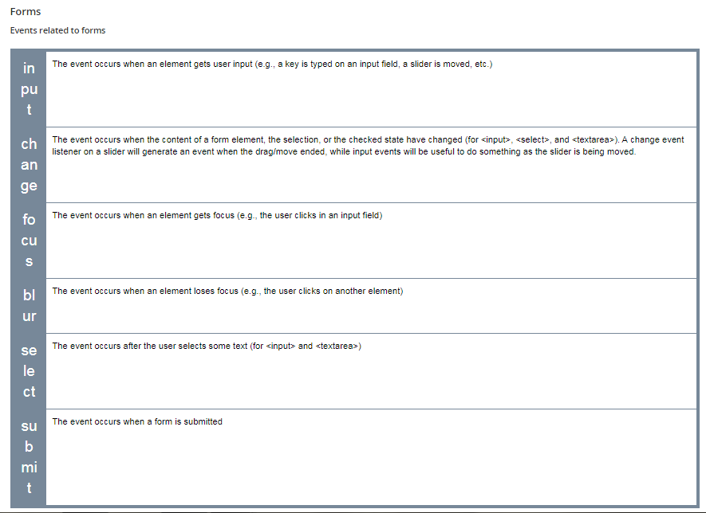

##### FormEvent properties

There are no particular properties that need to be mentioned here. Usually, on a form event listener, we check the content of the different input fields, using their value property.

## Discussion and project

**Suggested topics**

* Did you know the differences between clientX, pageX, etc. when dealing with mousemove events? Did you know the method we showed for getting the mouse position relative to the elements you're moving the mouse on?
* Did you know the different keyboard layouts, and the code and key event properties?

**Optional project**

* Try to write a small game that will display a word taken from an array, randomly, and you will have to type the letters of this word as fast as you can. A bit like the "type of the dead" game (look on YouTube). You can imagine the evolution such as choosing the level, start with 3 letter words, 4 letter words, etc.   
  Choose a topic (medicine, with very difficult words to spell, etc.). If you look at the end of the module, you will see how to work with graphics and animation, you can also imagine a graphic version of this game.

Find this game in Code folder – try to do it.

Some Discussion on the topic –

#### clientX vs pageX

with clientX / clientY we get the mouse position relative to the viewport ( the visible area of the page) , or we get the mouse position relative to the element that fired the event

with pageX/pageY we get the mouse position relative to entire document or window

#### Get the right mouse position with getBoundingClientRect() method

for getting the right mouse position relative a specific element , than we should use : event.clientX - event.target.getBoundingClientRect().left and event.clientY - event.target.getBoundingClientRect().top

### The DOM standard - exploring the DOM of a document

#### [Introduction](https://courses.edx.org/courses/course-v1:W3Cx+JS.0x+3T2017/courseware/6a5f041bfc2f49b7b28095ced1e8d9c3/eb07da2208384bf393e3124d8806f347/?child=first)

When a user clicks on a link or enters a URL in the address of your Web browser, it downloads the page’s HTML text and builds up a model of the document’s structure called the DOM (Document Object Model). This model is used to render the HTML page on the screen.

The DOM is a standard  that describes how a document must be manipulated. It defines a “language- and platform neutral interface”. So, **every browser offers the same JavaScript DOM API**.

The DOM API is a programming interface the JavaScript programmer can use to modify the HTML content or the CSS style of HTML elements on the fly.

The DOM API provides the document object as a structured object, a group of nodes represented as a tree. We saw this in Module 1 when we revised the basic principles of HTML .

The document object also exposes a large set of methods to access and manipulate the structured document. Through the DOM, look for nodes (html elements that compose the page), move nodes, delete nodes, modify nodes (attributes, content), and also handle their associated events.

In JavaScript, the DOM is accessible through the property document of the global object window. We rarely manipulate the window object directly as it is implicit: window.document is the same as document.

So by using this object, we can access and manipulate our page from JavaScript as a structured document.

**There are different types of nodes in the DOM**

There are different types of nodes, but don't worry - the most useful ones are highlighted in bold.

* + **Element (example: <ul></ul>)**
  + **Text (example: <p>the text within the element p is a node of type text</p>)**
  + Document, DocumentFragment, DocumentType (example: <!doctype html> for html5), Comment (example: <!-- left column -->), ProcessingInstruction (example: <?php echo $name ?>)

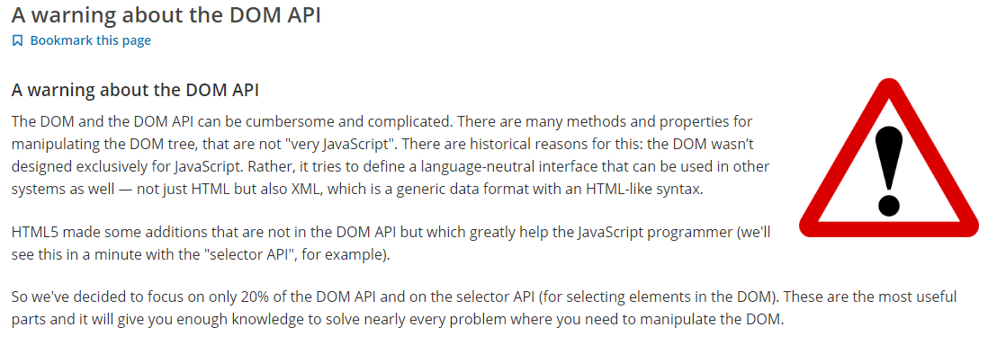

### Accessing HTML elements

#### 1 - With the selector API (recommended)

Extract from [HTML5 selectors API – It’s like a Swiss Army Knife for the DOM](http://www.webdirections.org/blog/html5-selectors-api-its-like-a-swiss-army-knife-for-the-dom/) : "One of the many reasons for the success of JavaScript libraries like[*jQuery*](https://jquery.org/) and [*Prototype*](http://prototypejs.org/), on top of their easing the pain of cross-browser development was how they made working with the DOM far less painful than it had previously been, and indeed how it was with the standard DOM. Being able to use arbitrary CSS selector notation to get matching elements from a document made the standard DOM methods seem antiquated, or at the very least, far too much like hard work.

Luckily, the standards and browser developers took notice. The W3C developed the Selectors API, a way of easily accessing elements in the DOM using standard CSS selector concepts, and browser developers have baked these into all modern browsers, way back to IE8."

#### The querySelector(CSSSelector) and querySelectorAll(CSSSelector) methods

Ah... these methods owe a lot to [jQuery](https://jquery.org/)! They introduce a way to use CSS selectors (including CSS3 selectors) for requesting the DOM, like jQuery introduced ages ago.

Any CSS  selector can be passed as a parameter for these methods.

* + While **querySelector(selector)** will return the first element in the DOM that matches the selector (and you will be able to work with it directly),
  + **querySelectorAll(selector) returns a collection of HTML elements corresponding to all elements matching the selector**. To process the results, it will be necessary to loop over each of the elements in the collection.

Example1-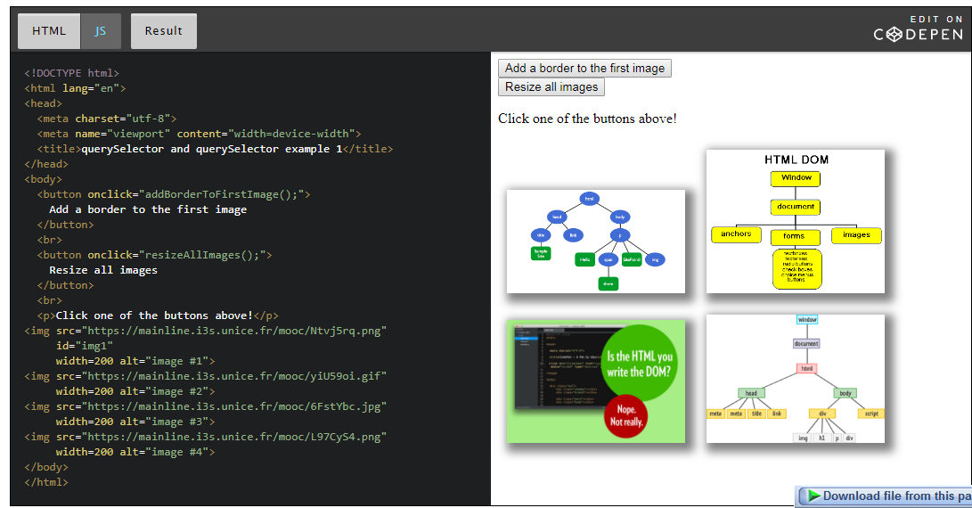

**JavaScript part**: the init function is executed as soon as the page is loaded (and the DOM is ready), in this function we add a shadow and margins to all images (lines 3-21). The two other functions are called when one of the HTML buttons is clicked (line 23 and line 31).

1. **window.onload = init; // run init once the page is loaded**
3. **function init()** {
4. // we're sure that the DOM is ready
5. // before querying it
6. // **this function runs once the page is loaded**
7. // add a shadow to all images
8. // **select all images**
9. var listImages =**document.querySelectorAll("img");**
11. // change all their width to 100px
12. listImages.forEach(function(img) {
13. // img = current image
14. // add a shadow 5px left, 5 pixel down, 15px blur, 5px spread
15. // grey
16. img.style.boxShadow = "5px 5px 15px 5px grey";
17. // add a margin 10px on each side
18. img.style.margin = "10px";
19. });
20. }
22. **function addBorderToFirstImage()** {
23. // select the first image with id = img1
24. var img1 =**document.querySelector('#img1');**
26. // Add a red border, 3px wide
27. img1.style.border = '3px solid red';
28. }
30. **function resizeAllImages()** {
31. // select all images
32. var listImages = document.querySelectorAll("img");
34. // change all their width to 100px
35. listImages.forEach(function(img) {
36. // img = current image, we resize it by changing its
37. // width attribute
38. img.width = 100;
39. });
40. }

#### Miscellanous examples of use of querySelector(CSSSelector) and querySelectorAll(CSSselector)

Here are some other examples that use more complicated CSS selectors. If you are not familiar with their syntax, we recommend that you follow the CSS basics, and HTML5 and CSS fundamentals courses from [W3Cx](https://www.edx.org/school/w3cx).

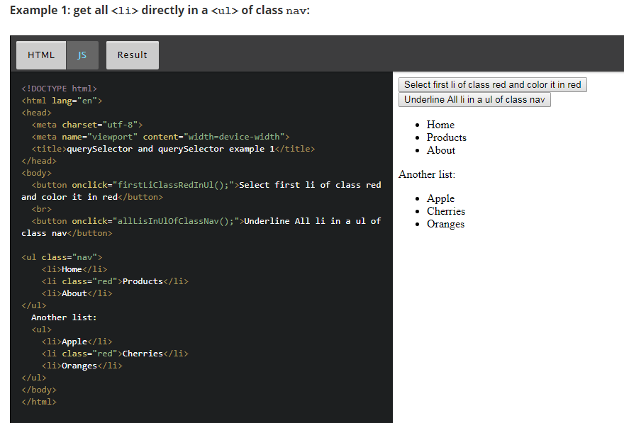

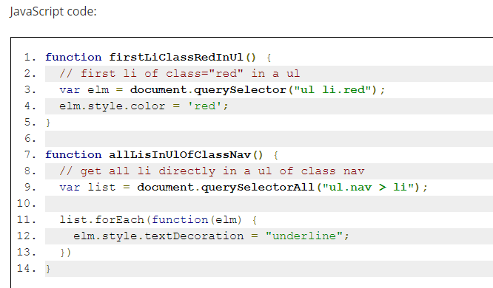

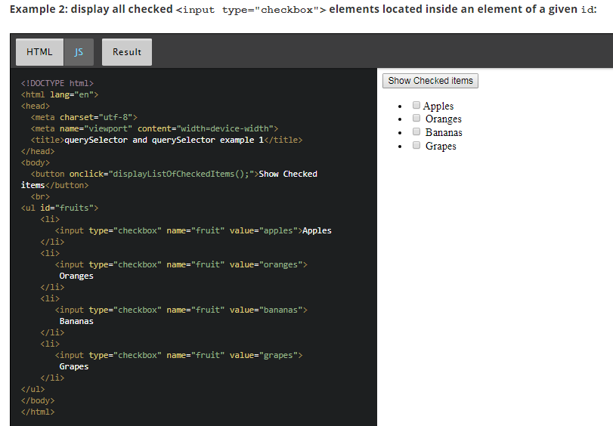

JavaScript code: we select all elements of type input that have an attribute checked equal to true, and located inside an element whose id is "fruits". Notice the use of document.querySelectorAll, for selecting more than one element (line 6), then, we iterate on the list (line 8) and concatenate to the string variable listOfSelectedValues the value of each element (located in its value attribute). This is done in line 9.

Lines 9-12 use the parentNode property of the selected nodes in order to change the color of the <li> (parents of <input> elements selected) in red. In the DOM tree, we selected input elements that are each a child of a <li> element. The text displayed: "Apples", "Oranges" etc. belong to the <li> element. In order to access it from the <input> child we selected, we use elm.parentNode.

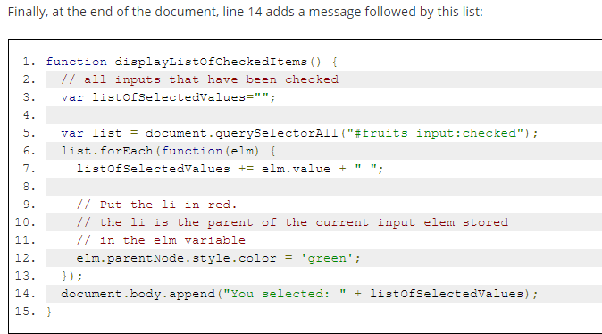

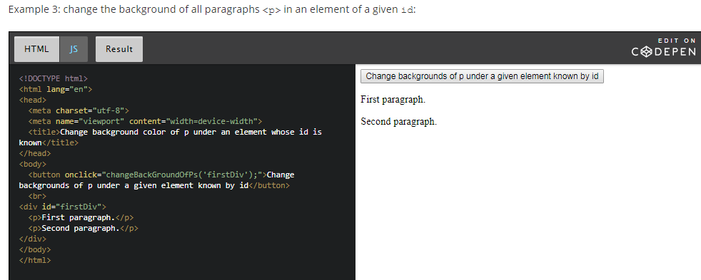

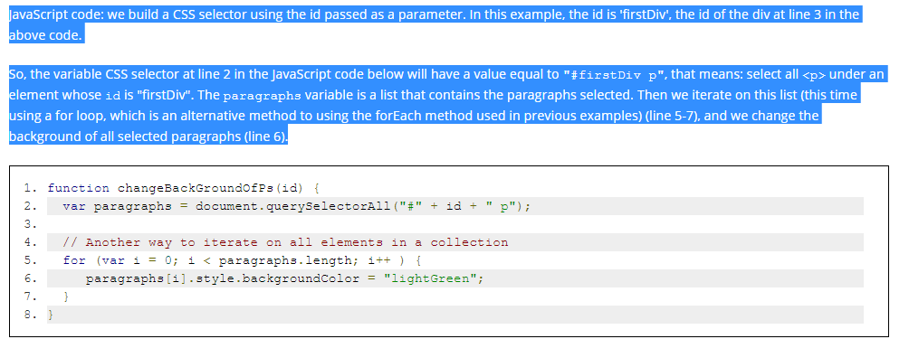

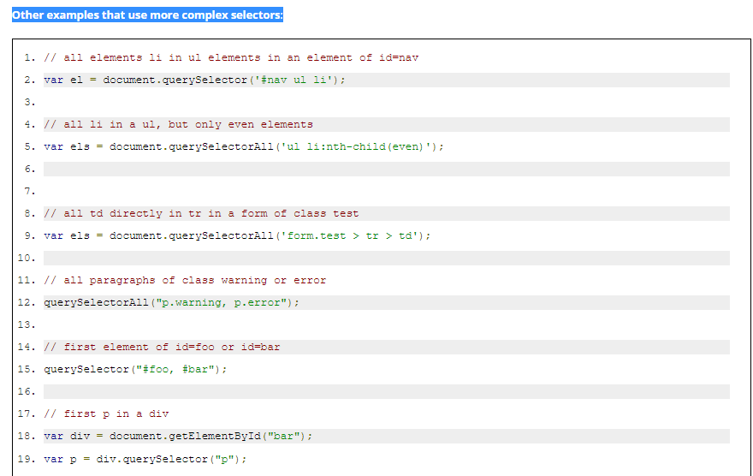

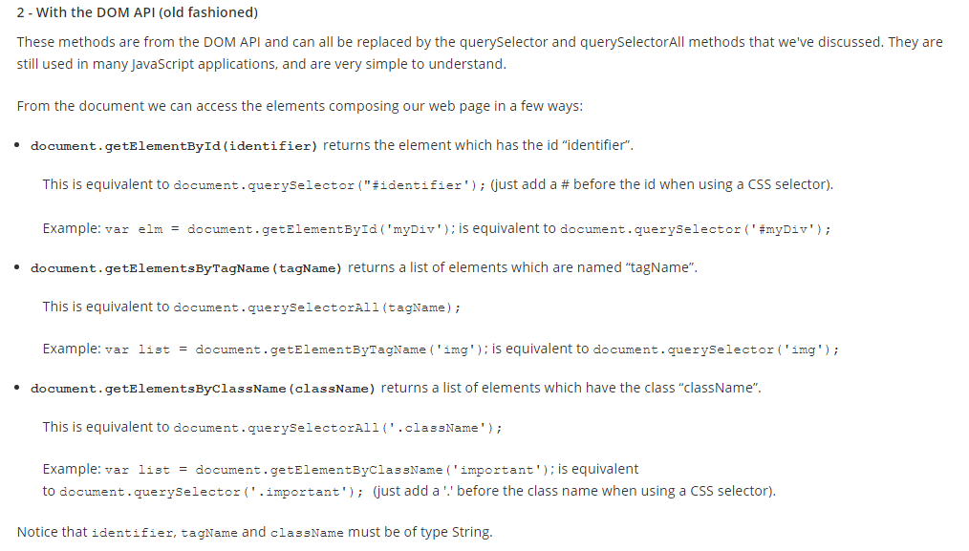

**Changing the style of selected HTML elements**

**The style attribute: how to modify an HTML element's CSS properties from JavaScript**

The most common way to modify the CSS style of one of several elements you selected using the DOM or Selector API, is to use the styleattribute.

Typical use:

1. // select the paragraph with id = "paragraph1"
2. var p = document.querySelector('#paragraph1');
4. // change its color
5. p.style.color = 'red';

*Warning*: with the style attribute, you can modify (or read) any CSS property, but be careful: the syntax changes a little due to the fact that in JavaScript the "-" is a math operator, while in CSS it is used to separate properties made of multiple words, such as background-color.

When using such properties from JavaScript, the rule is simple:

* 1. Remove the "-" sign,
  2. Capitalize the word after the "-" sign!

Simple, isn't it?

Examples:

* + text-align becomes style.textAlign
  + margin-left becomes style.marginLeft
  + etc.

The most useful CSS properties (we do recommend that you follow the W3Cx courses CSS basics, CSS and HTML5 fundamentals from W3Cx to learn more about CSS):

* + color: changing the color of the text content of selected element(s),
  + background-color: same but this time the background color,
  + margin and padding properties (external and internal margins), including their variants: margin-left, margin-top, margin-right, margin-bottom, also padding-left, etc.
  + border and border-radius: change the border, type (plain, dashed), color, thickness, rounded corners etc.
  + box-shadow to add shadows to selected elements,
  + font, font-style: font characters and style (italic, bold, plain)
  + text-align (centered, etc.

#### Using the ClassList interface to change more than one CSS property simultaneously

External resources:

* + [The W3C specification about the classList DOM interface](http://www.w3.org/TR/dom/#dom-element-classlist)
  + [An article from the Mozilla Developer's web site](https://hacks.mozilla.org/2010/01/classlist-in-firefox-3-6/)

Until now, to manipulate CSS classes of an HTML element was a bit complex, both for verifying the presence of a class name in an element, and for adding or removing classes associated with a given element.

The ClassList interface simplifies it all by acting as a container object and by providing a set of methods to manipulate its content.

The classList property applies to an HTML element, and returns a collection of class names:

1. var elem= document.querySelector("#id1");
3. var allClasses = elem.**classList**;

##### The classList API

The list of methods usable on a classList object are add(), remove(), toggle() and contains().

1. // By default, start without a class in the div: <div class=""/>
2. // Set "foo" as the class by adding it to the classList
3. div.classList.add('foo'); // now <div class="foo"/>
4. // Check that the classList contains the class "foo"
5. div.classList.contains('foo'); // returns true
6. // Remove the class "foo" from the list
7. div.classList.remove('foo'); // now <div class=""/>
8. // Check if classList contains the class "foo"
9. div.classList.contains('foo'); // returns false: "foo" is gone
10. // Check if class contains the class "foo",
11. // If it does, "foo" is removed, if it doesn't, it's added
12. div.classList.toggle('foo'); // class set to <div class="foo"/>
13. div.classList.toggle('foo'); // class set to <div class=""/>

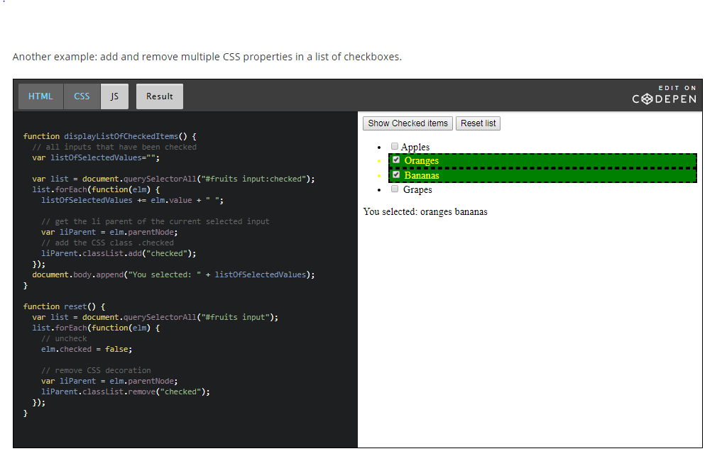

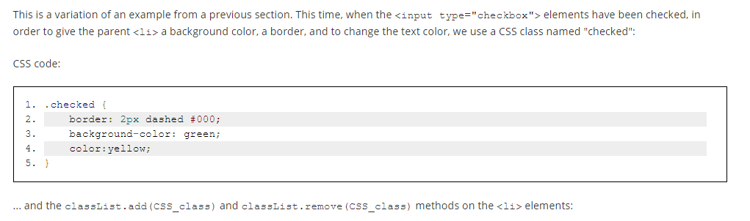

## Changing the content of selected HTML elements

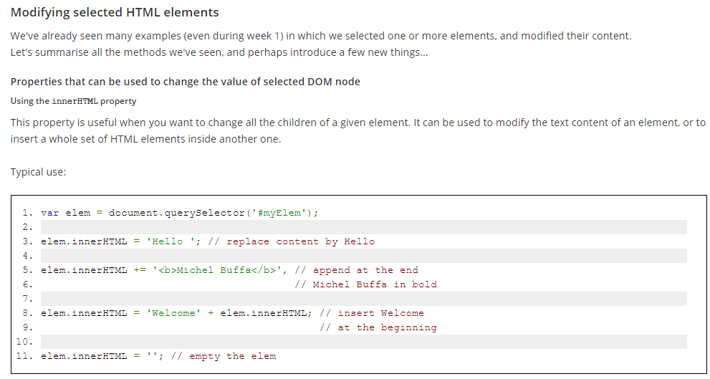

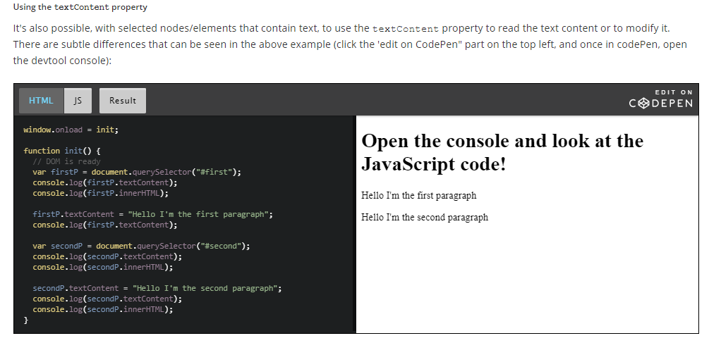

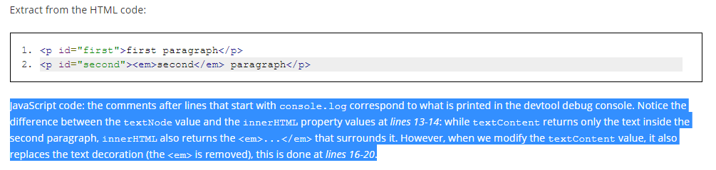

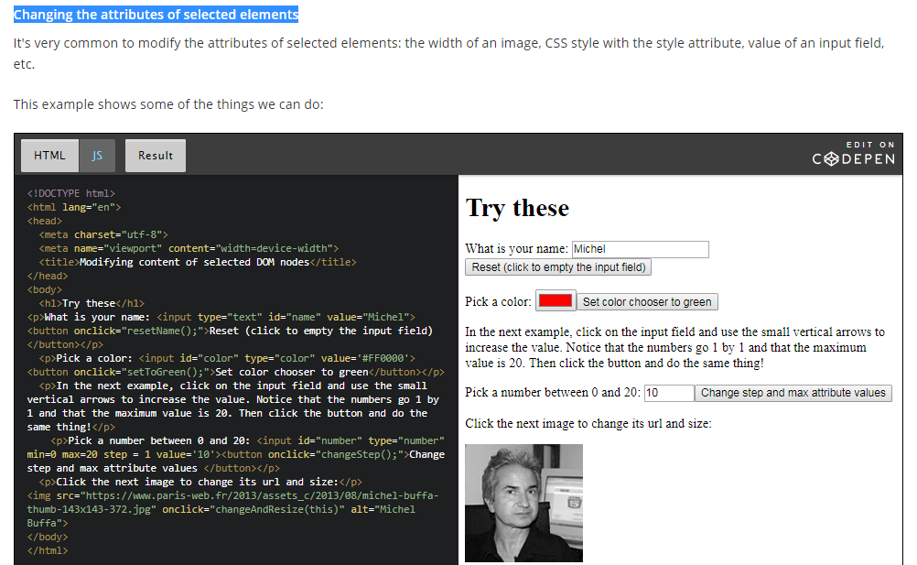

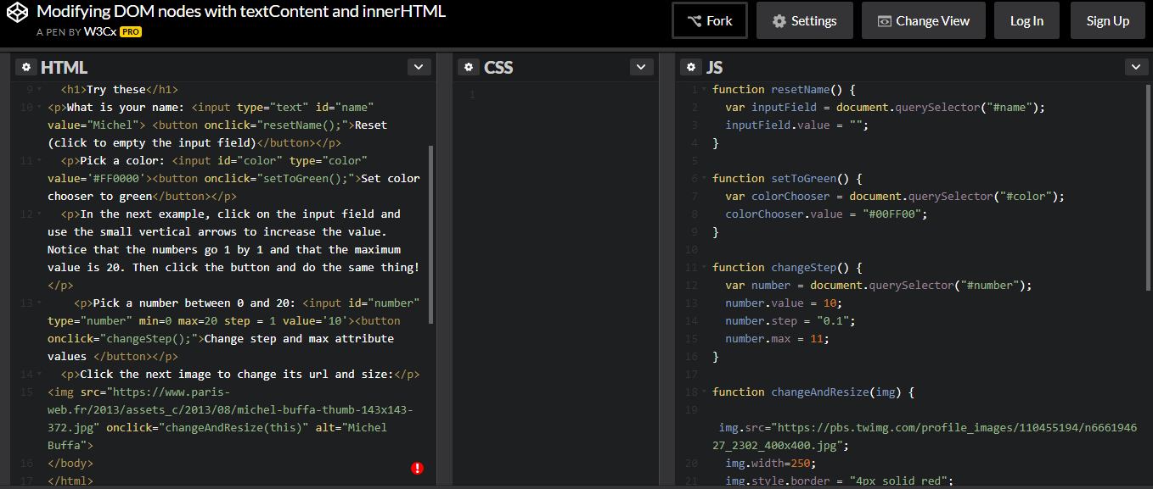

### Adding new elements to the DOM

The DOM API comes with a set of methods you can use on DOM elements.

In general, to add new nodes to the DOM we follow these steps:

* 1. Create a new element by calling the createElement() method, using a syntax like:
     1. var elm = document.createElement(name\_of\_the\_element).

Examples:

* + 1. var li = document.createElement('li');
    2. var img = document.createElement('img'); etc.
  1. Set some attributes / values  / styles for this element.   
       
     Examples:   
       
     1. li.innerHTML = '<b>This is a new list item in bold!</b>'; // can add HTML in it
     2. li.textContent = 'Another new list item';
     3. li.style.color = 'green'; // green text
     4. img.src = "http://..../myImage.jpg"; // url of the image
     5. img.width = 200;

* 1. Add the newly created element to another element in the DOM, using append(), appendChild(), insertBefore() or the innerHTMLproperty  
       
     Examples:
     1. var ul = document.querySelector('#myList');
     2. ul.append(li); // insert at the end, appendChild() could also be used (old)
     3. ul.prepend(li); // insert at the beginning
     4. ul.insertBefore(li, another\_element\_child\_of\_ul);// insert in the middle
     5. document.body.append(img); // adds the image at the end of the document

#### A warning about append vs appendChild, prepend, etc...

**If the examples do not run on your browser (Edge, IE, old browsers), read this!**

The DOM specification recently added some jQuery like methods that are similar to the ones proposed by the [jQuery](https://jquery.org/) library (that was designed a long time ago to simplify DOM manipulations).

For a long time, developers used document.appendChild to add an element to the DOM. Now you can use document.append, which is shorter, along with some other methods such as document.prepend etc. All these methods are supported by recent browsers except Microsoft Edge (but support is coming soon). See [this table for compatibility](http://caniuse.com/#feat=dom-manip-convenience).

**In the course, we recommend that you use document.append, but if you are looking for maximum compatibility, you can either use document.appendChild instead of document.append (just search and replace all occurrences of document.appendwith document.appendChild in the examples), or add to your JavaScript code**[**this polyfill**](https://developer.mozilla.org/fr/docs/Web/API/ParentNode/append#Polyfill)**.**

Just copy and paste the 10 lines of JavaScript from the polyfill to your code and append will work on browsers that do not yet implement it.

Here is [an example in JsBin that uses all these new methods, and that includes the polyfill](http://jsbin.com/sodeheh/edit?html,js,output) for append and prepend at the end of the JavaScript code.

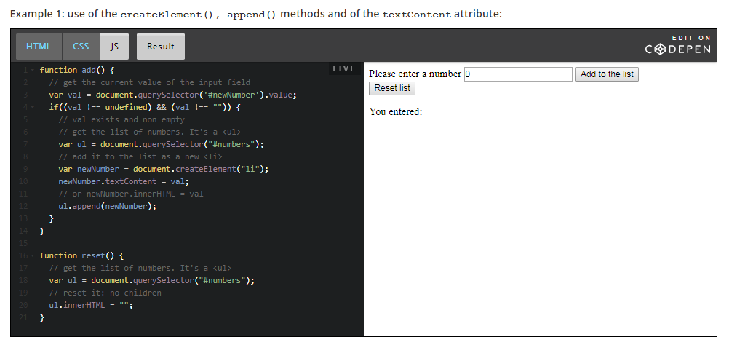

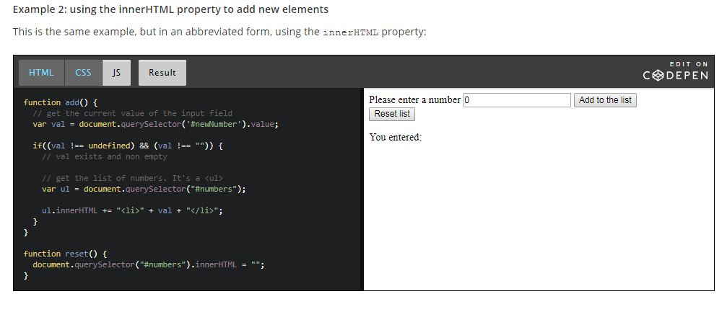

### Moving DOM elements within a document

The append(), appendChild() methods normally adds  a new element to an existing one, as shown in this example:

1. var li = createElement('li');
2. ul.append(li); // adds the new li to the ul element

One interesting thing to know is that if we do not create the new element, but rather get it from somewhere else in the document, it is then removed from its parents and added to the new parent.

In other words: it moves from its original location to become a child of the targetElem.

Look below Javascript code – the elem is the current DOM element that was clicked, so if we append an element which is already a part of DOM then it removes from previous parent and added to new parent.

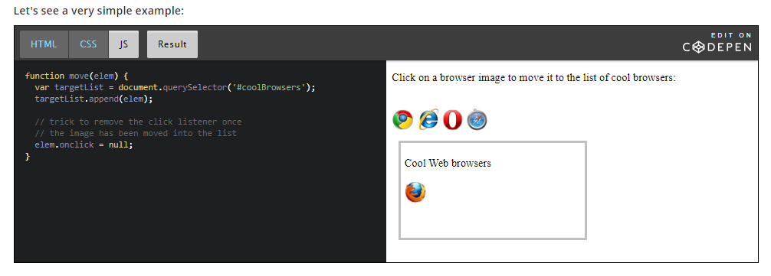

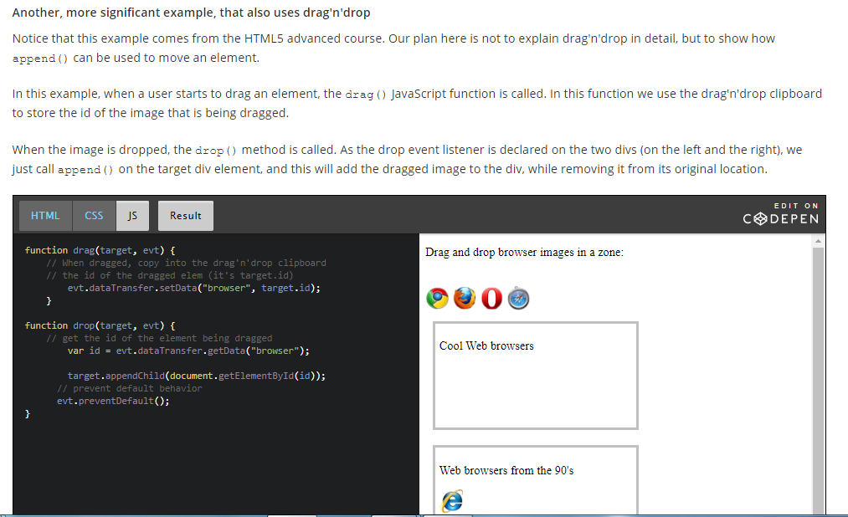

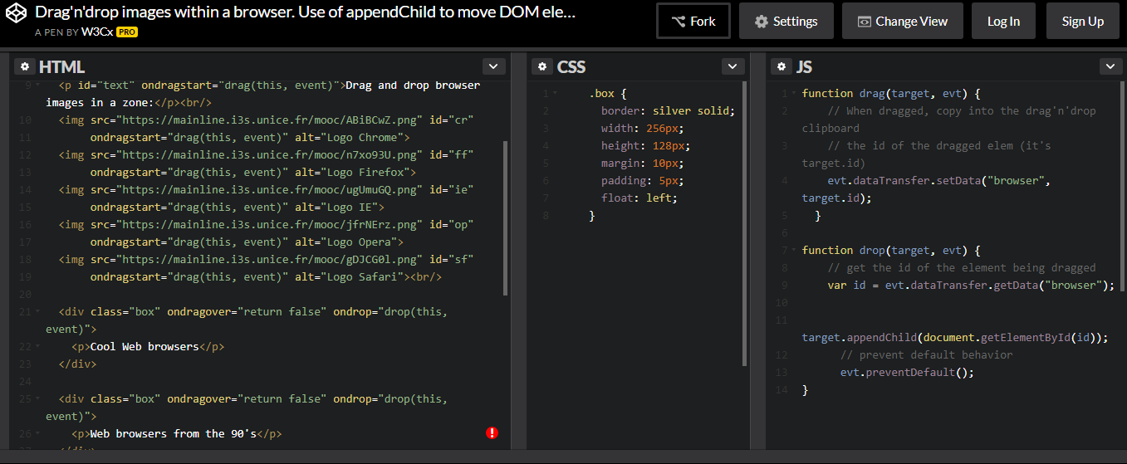

**Removing elements from the DOM**

**Removing elements using the removeChild() method**

